CCJ Guest Speaker Series
Bureau of Prisons Complex Warden (Terre Haute) and ISU Alumni Jeff Kruger
October 11, 2017, Hulman Memorial Student Union—Dede I, 11-11:50AM
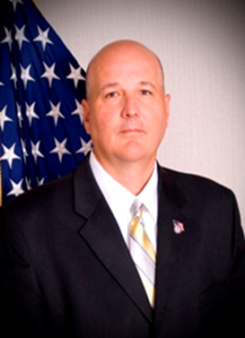
Complex Warden Krueger graduated from Indiana State University with a BS degree in Business Administration in 1987. He began his career with the Federal Bureau of Prisons in 1989 as a Correctional Officer at the United States Penitentiary in Terre Haute, Indiana. He moved on to positions of increasing responsibility to include Lead Foreman (UNICOR) at the Federal Medical Center in Lexington, KY; Computer Services Manager at the Federal Detention Center in Oakdale, LA; Computer Services Manager at the Federal Correctional Institution in Pekin, IL; Management Analyst - Program Review Division, Central Office, Washington, D.C.; Regional Computer Services Manager, at the North Central Regional Office, Kansas City, MO; Associate Warden at the Federal Correctional Institution in Milan, MI; Associate Warden at the United States Penitentiary in Marion, IL; and Associate Warden at the United States Medical Center for Federal Prisoners in Springfield, MO. Mr. Krueger was selected as Warden at the Federal Prison Camp in Duluth, MN in July 2011. Warden Krueger was selected to the Senior Executive Service as Warden at the Federal Correctional Institution in Schuylkill, PA, in January 2013. He served as Warden at the Federal Correctional Institution in Pekin, IL, from May 2014 until his selection as Complex Warden at Federal Correctional Complex, Terre Haute, IN, in March 2017.
This event is sponsored by the Department of Criminology and Criminal Justice.
It is free to attend and open to everyone.

