Criminology and Criminal Justice Guest Speaker Series
Cyber Threats & Security Panel

November 1, 2017—Hulman Memorial Student Union, Dede I, 9:00AM and 11:00 AM—Both session will present the same information.

ISU Criminology and Criminal Justice Associate Professor Bill Mackey will moderate a panel discussion on cyber threats and security.
Chetrice L. Mosley, Cybersecurity Program Director—State of Indiana Office of Technology
Indiana Department of Homeland Security

Nicholas Sturgeon​, MS—Indiana State University Graduate
IN-ISAC & SOC Manager (Indiana information sharing and analysis center)(security operations center) and IIFC Deputy Director Cyber (Indiana Intelligence Fusion Center​)​

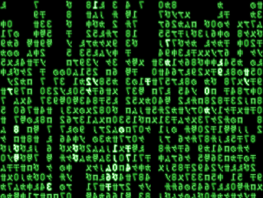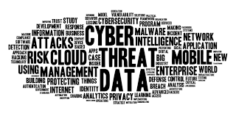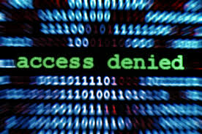

This event is sponsored by the Department of Criminology and Criminal Justice.
It is free to attend and open to everyone.

