Bakos & Gövert present at
NWAV
What is NWAV?
NWAV is an acronym for “New Ways of Analyzing Variation”. The conference is academically based and is held annually for sociolinguistics.
What was the presentation?
The presentation was presented in the form of a poster and was called “Hoosier Talk”. Bakos and Gövert studied the dialect of the Midwest, specifically in Terre Haute, IN and neighboring counties. They researched how people in this area use their vowels.
When/where was it?
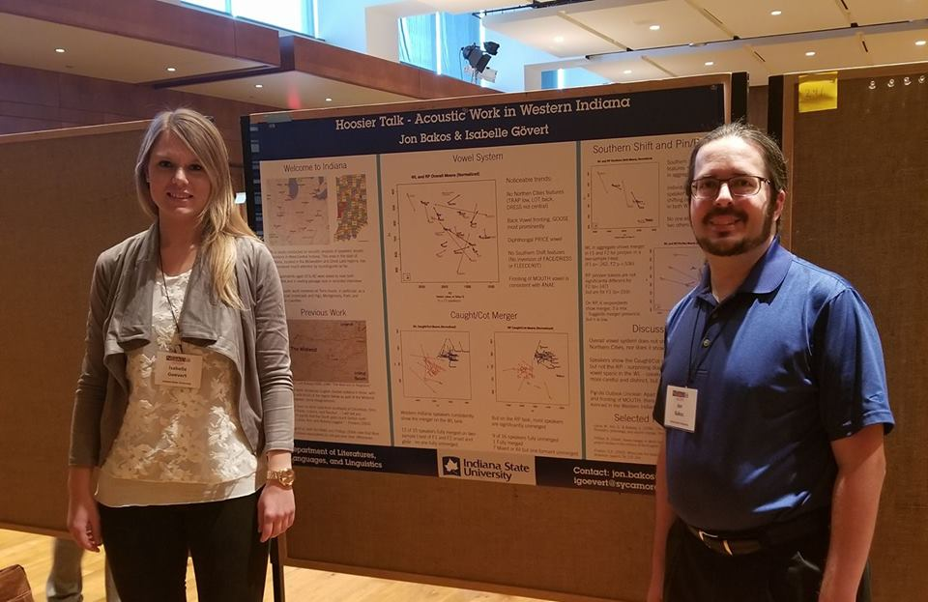
NWAV took place at University of Madison in Wisconsin from Thursday, November 2nd to Sunday, November 5th. Their “Hoosier Talk” presentation took place on Friday, November 3rd.
What research was presented?
Everything from the caught/cot merger to the pen/pin merger as well as the vowel system and acoustic analysis were researched and presented. These mergers determine whether you have a southern or a northern shift based off of a person’s pronunciation of words, specifically vowels. “You can figure out which shift you have, if any, based off of acoustic analysis,” said Dr. Bakos. For example, a “southern drawl” can be determined since there is an inversion of the vowels “i” and “e”. If a person with a southern shift would say “creek”, it may come out as “crik”.
What were the results?
The results for the caught/cot merger as well as the pen/pin merger were determined inconclusive. They believe that the merger indeed does exist but the sample size for participants was too small for specific results.
What was the audience?
There were approximately 30 posters set up for individual presentations during the NWAV conference. Each presentation was based off of a different topic with different findings. People travel from across the globe to come to this conference. One person in particular was Ms. Isa Gövert’s professor from her home country, Germany. A great deal of the guests who participate at NWAV are sociolinguists: professors, graduate students, etc.

