Rika Nanjo presentation at IFLTA 2017

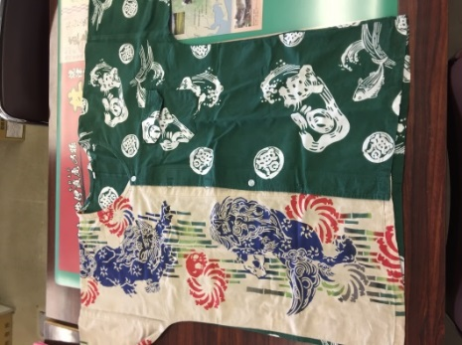**What was the presentation over?**

The topic of the presentation was the traditional Uogashi shirt from Japan. She discussed the history and the purpose of the traditional shirt, how it’s made, as well as how to properly wear it. She also pointed out specific locations as to where the shirts are popular and spoke about brands that sell them.

**When & where did the presentation take place?**

The presentation took place on Saturday, November 4th, 2017 in Indianapolis, IN at IFLTA 2017.

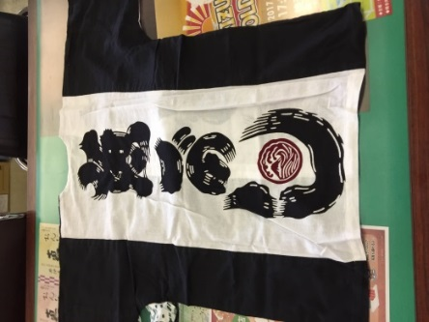**What’s the purpose of the shirt?**

The purpose of the shirt was originally for Japanese fisherman to keep cool, because the temperature is Japan is hotter and more humid, especially during summer months. Since the temperatures are such a big factor in Japan, the shirt has started to become more popular, especially during the summer months. It is even worn in Yaizu city hall as countermeasure during the summer.

**How did it get its start?**

The Uogashi got its start in Shizuoka, Japan and has been around for decades. The name originally started off as “Tenugi Juban”. The shirt(s) finally got introduced into the consumer market in 2004. Fisherman’s wives would tailor and hand dye each shirt for their husbands to make sure they had a cool shirt to wear while out on the water all day. The shirts are made from traditional Japanese towels which are 100% cotton and very thin material so they are good at absorbing sweat and dry at a fast rate. The Tenugi was originally a gift for celebrating festivals, the gift for “Oribraki” (after party) of the festivals and were traditionally gifted among the fish market.

**Who attended?**

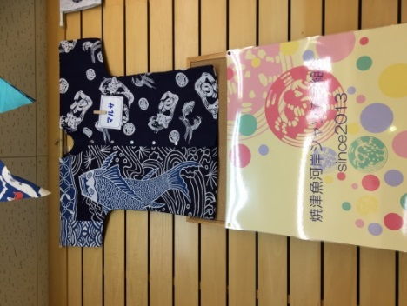A professor from Ball State University in Muncie, IN who teaches Japanese, was a presider of the presentation and gave Rika positive feedback regarding her presentation. He was very interested in the information given and was very excited to share the mutual love for the culture.

**What is interesting about the topic?**

Even though these unique shirts are catching on fast, they’re still not wide spread just yet. Although, the shirts are becoming more popular in Japan as a more “everyday” type shirt during warmer months rather than just for fishing because of the material being able to keep you cooler due to the excessive heat and humidity.