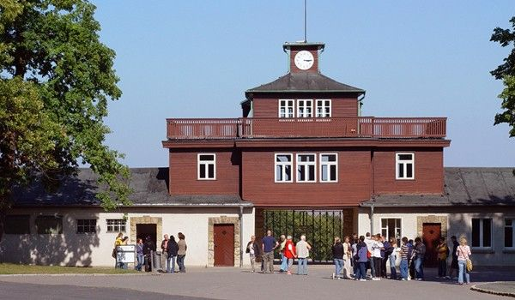
Faculty-Led Study Abroad
Visit Germany and Poland on this faculty-led study abroad experience designed for students to learn more about the Holocaust on site. Cities include Frankfurt, Weimar, Berlin in Germany and Krakow and Oswiemcim in Poland.
Features of trip include:
- Meet with German students to discuss Holocaust remembrance
- Visit Buchenwald Concentration camp and engage in workshop about forced labor
- Learn about medical participation in the Nazi euthanasia program to murder “life unworthy of life” during workshop using primary documents.
- Visit Auschwitz
Dates: May 14 – 23, 2019 Cost: $3,791.00

Travel, room and board for this study abroad experience is conducted by Explorica Travel. Payment can be made in installments. Registration by Dec. 1, 2018
$700 grants to students enrolled in GH 301, Critical Studies of the Holocaust. $100 rebate for enrollment by Nov. 8th.

Led by Drs. Ann Rider and Ralph Leck
For more information contact Dr. Ann Rider ann.rider@indstate.edu
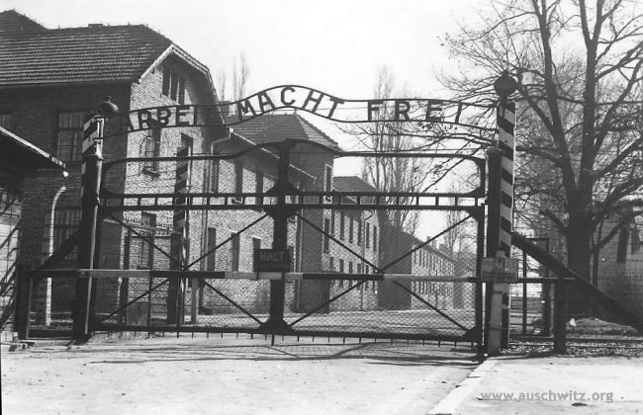
Faculty-Led Study Abroad to Germany and Poland
May 14, Day 1 Start tour, travel from Indianapolis to Frankfurt, Germany

Day 2 Guten Tag Frankfurt
Walk in the footsteps of Terre Haute’s Walter Sommers, who was forced to emigrate from Frankfurt in 1939.
Meet students from the Frankfurt Musterschule to discuss Holocaust remembrance today.

Day 3 Weimar
Travel to Weimar
Sightseeing in the classical German city of Weimar, home of Franz Liszt, Goethe and Schiller
Visit the Gauforum, information site of the Nazi Party in Weimar

Day 4 Weimar
Buchenwald Concentration Camp visit & Workshop on forced labor

Day 5 Weimar—Berlin
Travel to Berlin
Berlin guided sightseeing tour,includes: Checkpoint Charlie, Potsdamer Platz, Berlin Wall, Brandenburg Gate, Reichstag, Victory Column

Day 6 Berlin
Gestapo Headquarters, "Topography of Terror" museum, Holocaust Memorial
Free time in Berlin to research specific topics (list of sites provided)

Day 7 Berlin
Memorial for Victims of Nazi Euthanasia tour and Workshop on medical ethics in Brandenburg

Day 8 Berlin—Krakow, Poland
Travel to Kraków
Kraków city walk, including Jewish Quarter

Day 9 Kraków
Auschwitz-Birkenau Memorial & Museum guided excursion
Traditional Polish dinner

May 23, Day 10 Flight home from Krakow

For more information, contact Dr. Ann Rider at ann.rider@indstate.edu

To register, to go explorica.com/INDSTATE-3250
$50 registration fee required at time of registration.

