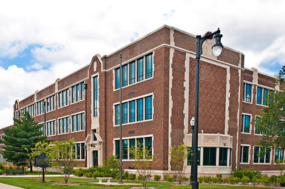
Bayh College of Education

Teacher Education Committee
Tuesday, April 30, 2019
3:30 PM
UH Conference Room 215

Agenda

- Call to Order
- Approval of Minutes for April 16, 2019

- Old Business

- New Business
- Proposals
  - FREN-201 Intermediate French I (Ann Rider)
  - FREN-202-Intermediate French II (Ann Rider)
  - GERM-201-Intermediate German I (Ann Rider)
  - GERM 202-Intermediate German II (Ann Rider)
  - LAT-201-Intermediate Latin I (Ann Rider)
  - LAT-202-Intermediate Latin II (Ann Rider)
  - MATH-241-Principles of Statistics (Liz Brown)
  - MATH 308-Middle School Mathematics from an Advanced Perspective (Liz Brown)
  - MATH-410-Introduction to Analysis (Liz Brown)
  - SPAN-201-Intermediate Spanish I (Ann Rider)
  - SPAN-202-Intermediate Spanish II (Ann Rider)

- Dean’s Report – Janet Buckenmeyer

- Associate Dean’s Report – Linda Sperry

- Assistant Dean’s Report – Judy Sheese

- Assessment Director’s Report-Malea Crosby

- Adjournment

All TEC agendas, meeting dates, minutes, members, and other materials may be viewed at: http://www.indstate.edu/education/department/governance/teacher-education-committee-tec

