How to: Download mp3 files
Tegrity allows you to download your class recordings in a mp3 format. Doing so gives you the ability to store them on your computer or mp3 device and listen to them at any time, even without an internet connection or on-the-go. To access the mp3s do the following:
1. Access a specific course from your “My Tegrity”. From the course tasks menu, select “Podcast”
2. Dependent on which browser you are using you should see a page similar to this one. (Suggested browsers for PC are IE and Firefox, suggested browser for MAC is Firefox)
- If you “Subscribe to this feed” all new recordings will appear in your RSS Feeds making it easy to keep track when new recordings are available
- Mp3s are listed separately below their class titles. Clicking the class title will open the recording in its original Tegrity player streaming format.
- To download the mp3 simply click on the hyper-linked mp3 format sound file and you will be prompted to “Open” or “Save” the file, do as you please.
- If clicking on the hyper-link does not prompt you, try right-clicking on the link and selecting “Save Link As”
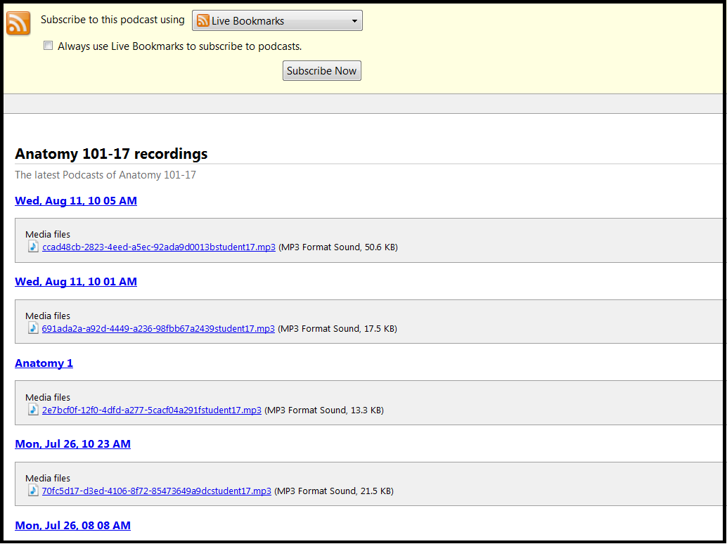

3. Upon completion of download your recording will now appear in the location you specified when saving. You can play this file with any standard media player that plays mp3s or even load it on to an mp3 player and take it with you to-go.

