If you are having problems installing the Tegrity Recorder please attempt the following:

1. Make sure the Windows user account has “Administrator” User Privilages.
Click on Start > Control Panel > User Accounts > Your Account Name Here > Change Your Account Type
2. Temporarily disable any Anti-Virus solutions that may be running (Symantec, McAfee, etc.). Anti-Virus can be re-enabled after installation.
3. Add your Tegrity institution URL to the list of trusted sites in Internet Explorer (click HERE for instructions).
4. Confirm ActiveX Controls have not been disabled in the browser settings. If ActiveX Controls are disabled, temporarily enable them for the install process or set them to “Prompt” which will allow prompt you to allow.
Access Internet Explorer Browser > Tools > Internet Options >Security Tab > Internet > Custom Level
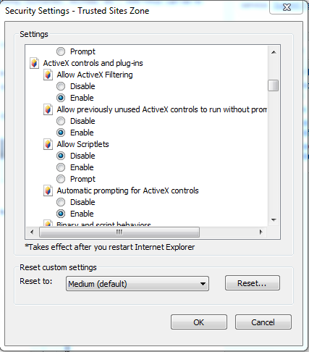

Repeat step 4 for “Trusted Sites” zone:
Access Internet Explorer Browser > Tools > Internet Options >Security Tab > Trusted Sites> Custom Level
5. Turn off User Account Control.
Click on Start > Control Panel > User Accounts > Your Account Name Here > Change User Account Control Settings >Set to “Never Notify” (Circled in Red).
Note: A Restart is required for chages to be applied.
The User Account Control Setting can be reverted back after the installation has been completed.
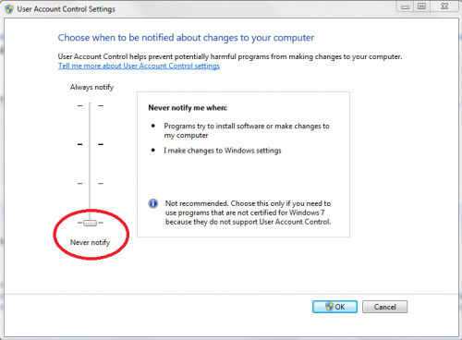
6. After restarting the computer, attempt to install the recorder again from the “Start a Recording” button from My Tegrity (Instructions HERE).
7. If the installation completes successfully, proceed to Revert settings (User Account Control, ActiveX Controls, etc.) back to your liking or leave as is.
8. If installation fails and you are an Instructor or Student, contact your Institution Help Desk. If you are a Tegrity Admin User attempt to install from the local package (Instructions HERE).

