Tegrity: Test Proctoring for Students
Tegrity test proctoring allows you to take a test from anywhere, as long as you have a computer and internet connection. Your professor may choose to activate this feature. This allows you to take an online test that the professor can watch via Tegrity.
Before beginning your recording, go through the Respondus checklist and be prepared to launch Respondus Lockdown Browser immediately after beginning the Tegrity recording.

Taking a test
1. Once in your course, move the mouse over the course tasks button, a dropdown menu will appear, select “Start a Test”
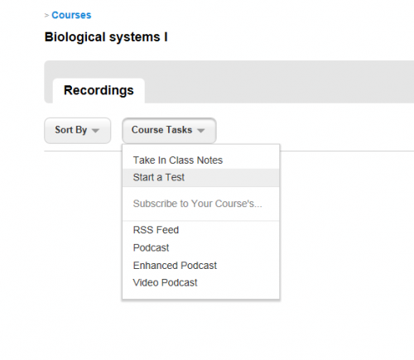

2. The box that appears is the institution’s testing policy (if your institution has chosen to write and publish one). Students will need to read and accept. If the institution does not have a testing policy published, this box will not appear. Students will still need to select “Accept” to continue.
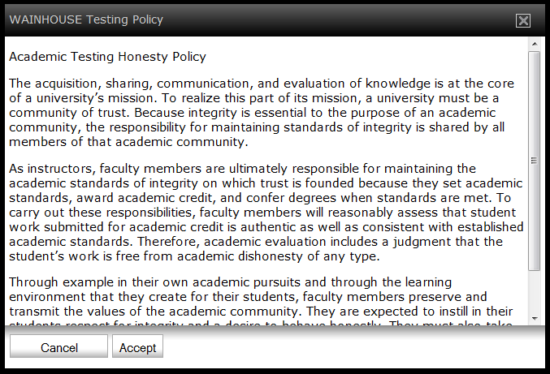
3. The next box that appears is the testing policy that your instructor has created. Students will need to read and accept. If no testing policy has been published, a blank, white box will appear. Students will still need to select “Accept” to continue.
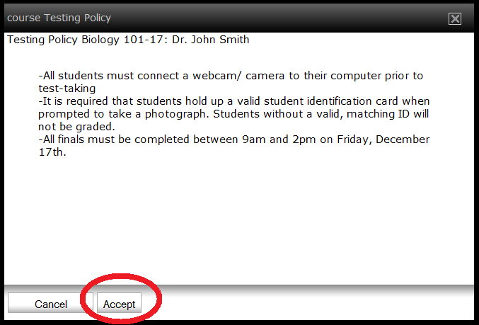

4. The Tegrity Recorder will appear. Select the camera you are using, as well as the audio device, if needed. Select “Next”.
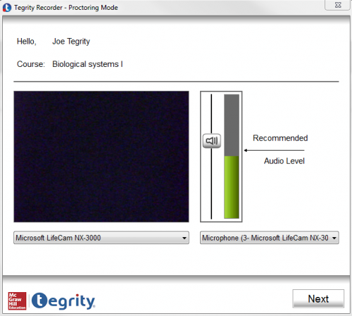

5. Student are then asked to take a photo of themselves, so that the professor can be assured that the person who is taking the test is who they say they are, once completed select next
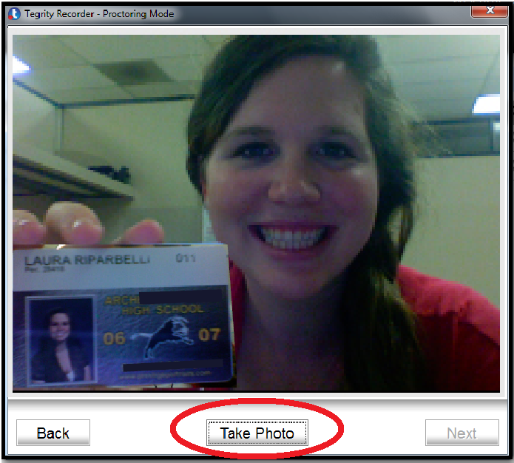
6. Select “Start”.
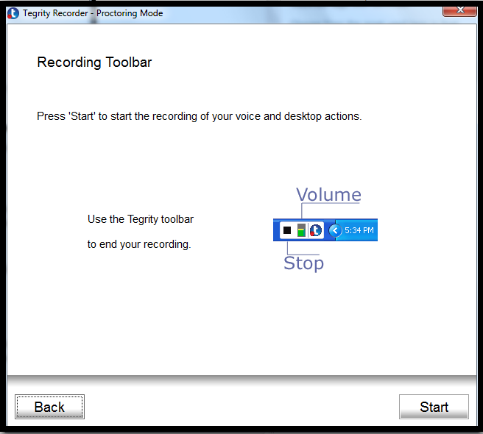

7. If you are using multiple monitors select which monitor you would like to record. Use the left or right arrows to select the correct monitor, and then select “Record this Monitor”
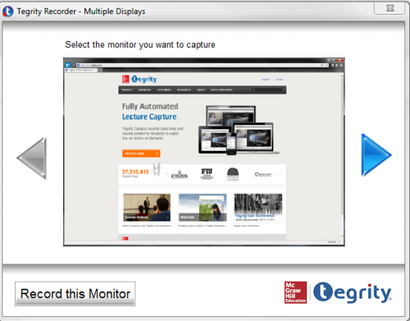
8. Once Recording has started, close the internet browser window and launch Respondus Lockdown Browser. (Tegrity does not require internet access during recording, so it will not conflict with Lockdown Browser)
9. Login to Blackboard, navigate to your exam and click “Begin”
10. Make sure to regularly save your progress during the course of the exam and to submit at the end of the exam.
11. When you finish the exam, click on “Submit” or your answers will not be counted/recorded.
12. Once the exam is completed and submitted, close Lockdown Browser.
13. When finished, press the “Stop” button in the Tegrity toolbar. The following screen appears. Selecting “No” will allow you to continue the recording. Selecting “Yes” will prompt Tegrity to automatically upload the recording.
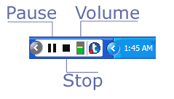
14. Students will be able to monitor the status of their test’s automatic upload from the Upload Queue.
Managing the Upload Queue

