Student Affairs Employee of the Month for March is Kevin Phillips from the Hulman Memorial Student Union

A total of 3 different people nominated three individuals within the division for this honor. Three judges from outside the division read the applications and have selected Kevin Phillips from the Hulman Memorial Student Union as the March winner of the Student Affairs Employee of the Month! Kevin was nominated by Mark Adkins. This is what Mark had to say about Kevin, “He has spearheaded several projects to optimize the processes in HMSU. He developed a way to internally print out sign and door labels. This will save $500 a year while reducing the wait time from 6 weeks to minutes. He also automated the generation of daily/weekly reports from the event scheduling software. Before this, reports were manually printed. This process has reduced the amount of printing by 30% while reducing the manpower hours to manually generate and print these reports. Kevin is currently working on a process to improve the notification of cancelled events. Currently, if an event is canceled within 7 days of the scheduled event there is no formal notification to all the relevant partners. With the new process, an email notification will automatically be generated to all the relevant partners when an event is canceled. He has eliminated 90% of the routine AV issues in the Dede Conference rooms by developing a troubleshooting manual. Team player who delivers results! “

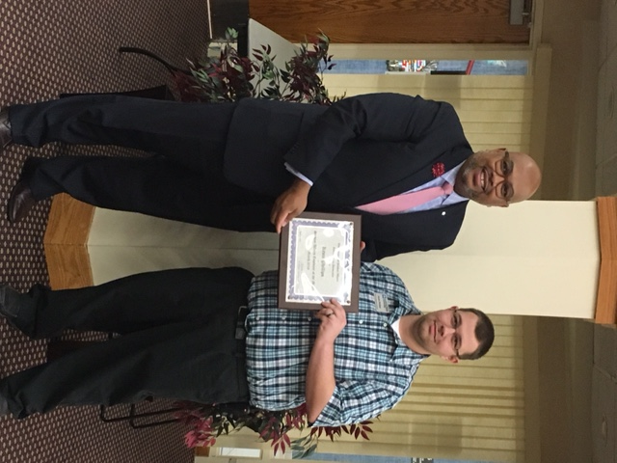

Kevin was recognized April 21, 2016 for this honor and is now eligible for Employee of the Year which will be awarded in June of 2016. Kevin received a framed certificate and a $25.00 gift card to the ISU Barnes and Noble Bookstore. Congratulations Kevin!

