Here is a link to a basic guide to entering information in FAD - https://www.digitalmeasures.com/activity-insight/docs/guide.html

More specifics related to ISU

This is the base screen for ISU. The Workflow tab ONLY shows up if you have a task in Workflow or a history of tasks. The Tools option will only show up for those who have that level of permission.

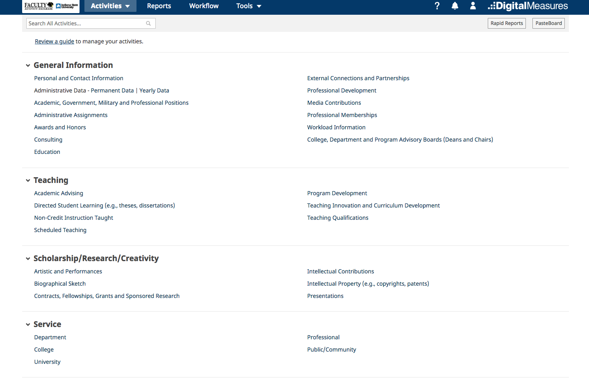

Teaching Screens

Scheduled Teaching – we upload your scheduled teaching twice during Fall and Spring, and once at the end of the Summer Session. In early Fall and Spring, we will upload the courses in Banner, and after the end of the term, re-upload the information to include the grade distribution.
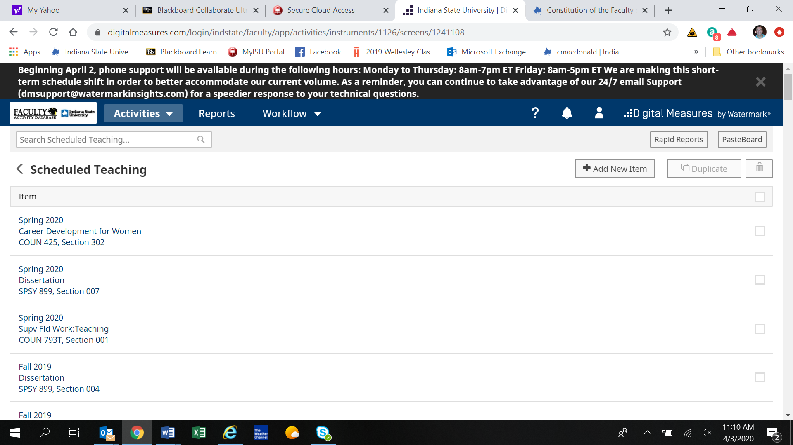
This is what the scheduled teaching screen looks like.

Click on your current course (or the Fall course, if you taught in Fall), and scroll down to File Attachment.

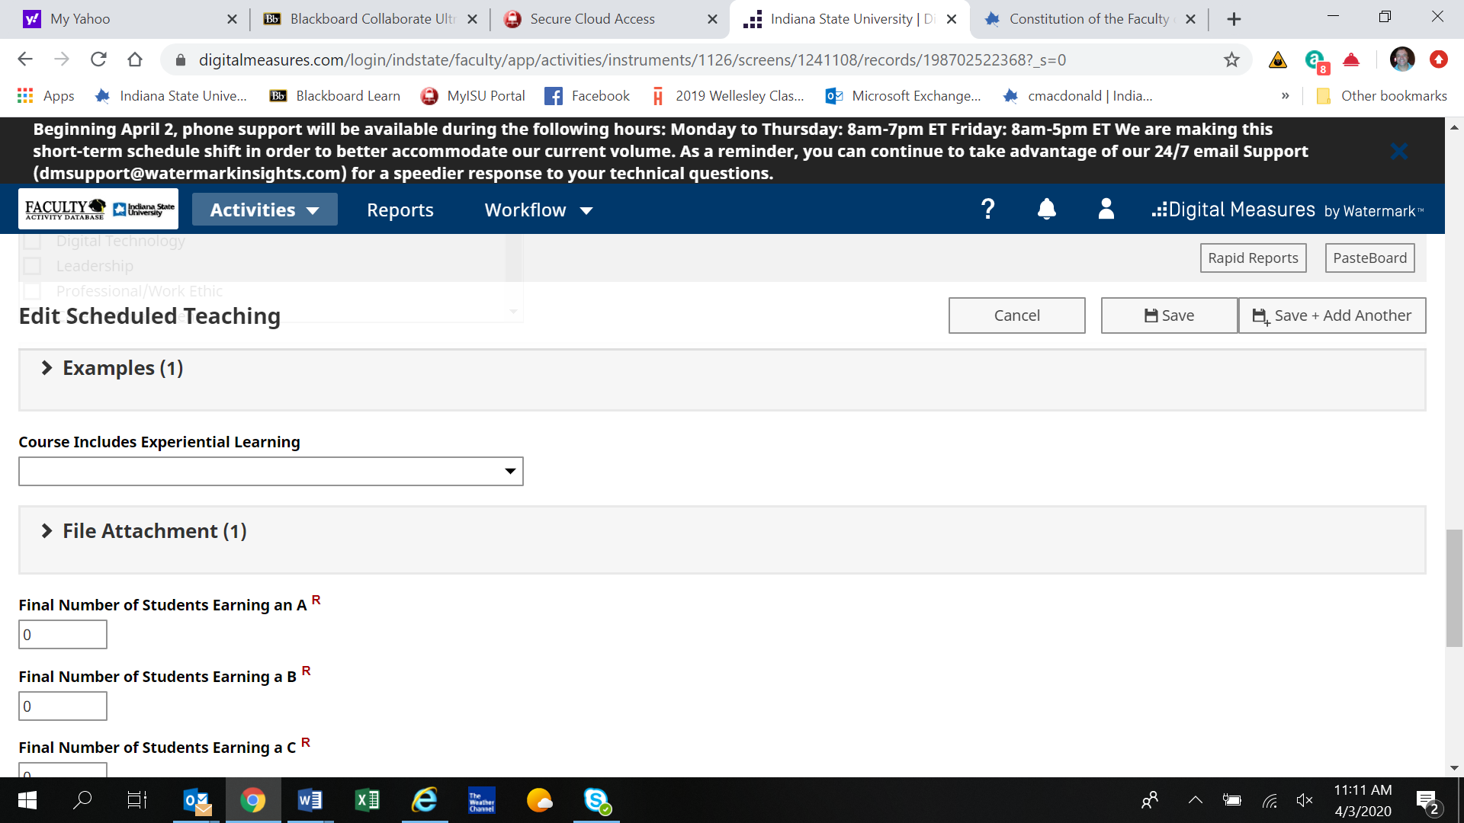

When you click on the arrow next to File Attachment, you get this screen:
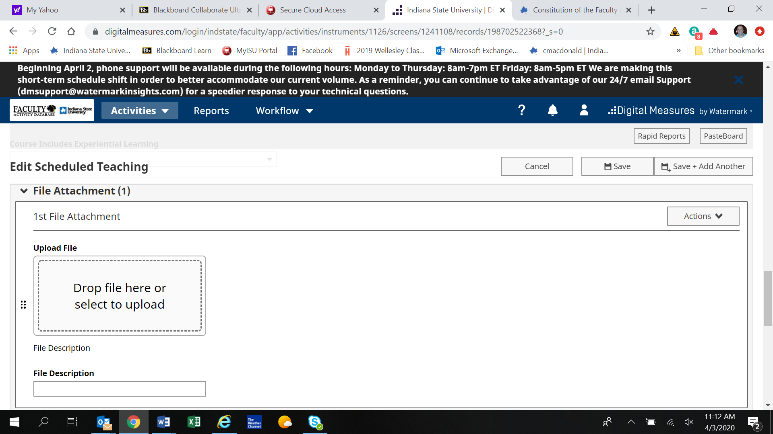

This screen will allow you to upload files. To add more files, Click on “Actions” and add a row.

