Instructions for Submitting SI Applications

- Download the SI Agreement form on the Center for Student Success Website
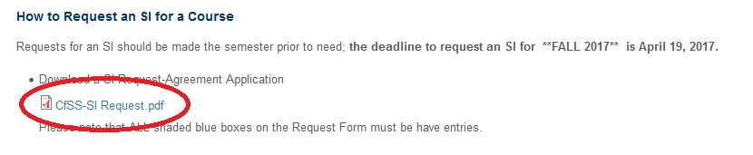
- Fill out the Applications and Save it to your Computer (in a place where you know where to find it)

- Click on Upload Application link on the Center for Student Success Website
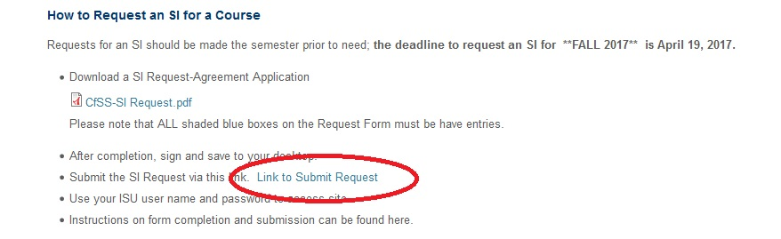
- After clicking “Link to Submit Request”, you will need to enter your username and password.
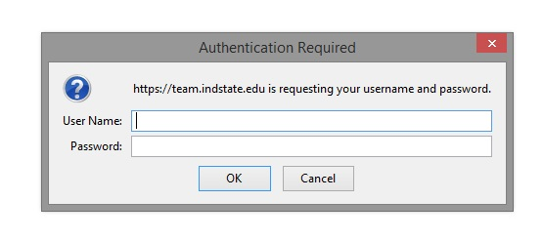

- Click New Document on the SharePoint site
DO NOT DRAG DOCUMENT,
PLEASE CLICK NEW DOCUMENT (as shown below)

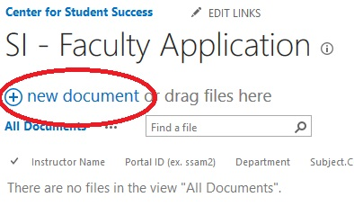
- Click Browse to search for document where you saved the SI Agreement
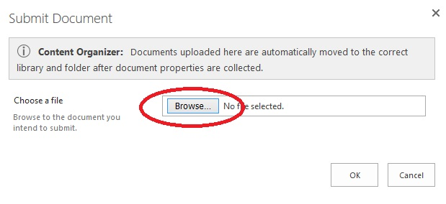

- Find saved SI Agreement and Click Open
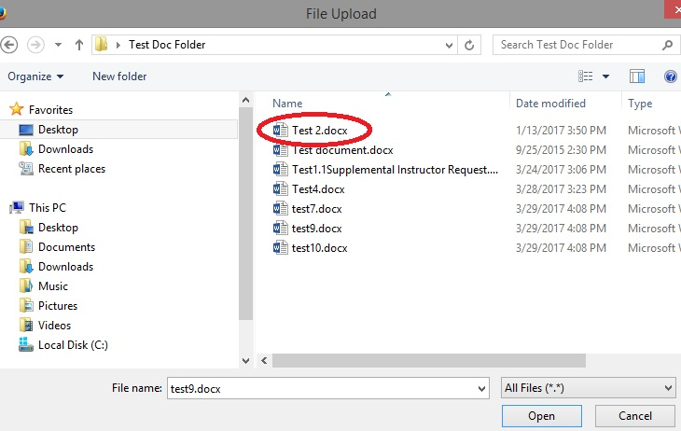

- Click Ok.
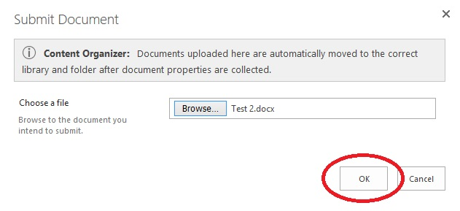
- Fill out the following form and Insert your Name on the Name Field. (James Pond – instead of Instructor Name)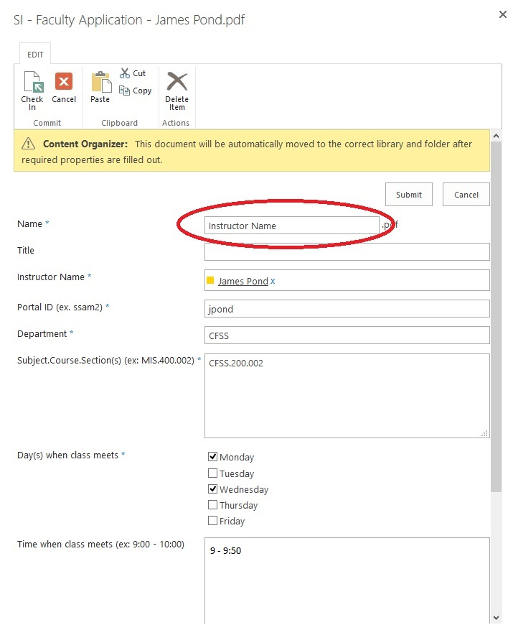

- Click Submit at the bottom of the form.
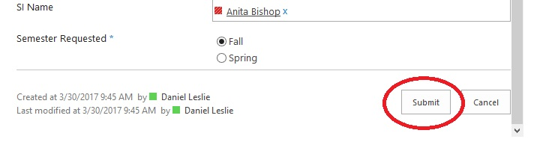

- Click OK on Final Screen to Submit Application and close the web browser.
