CHECKING THE STATUS of EXISTING REQUESTS or ESTIMATES

Log into your portal and click the TMA badge icon to launch the application. When the request form opens, click on the Status tab to show the following screen:

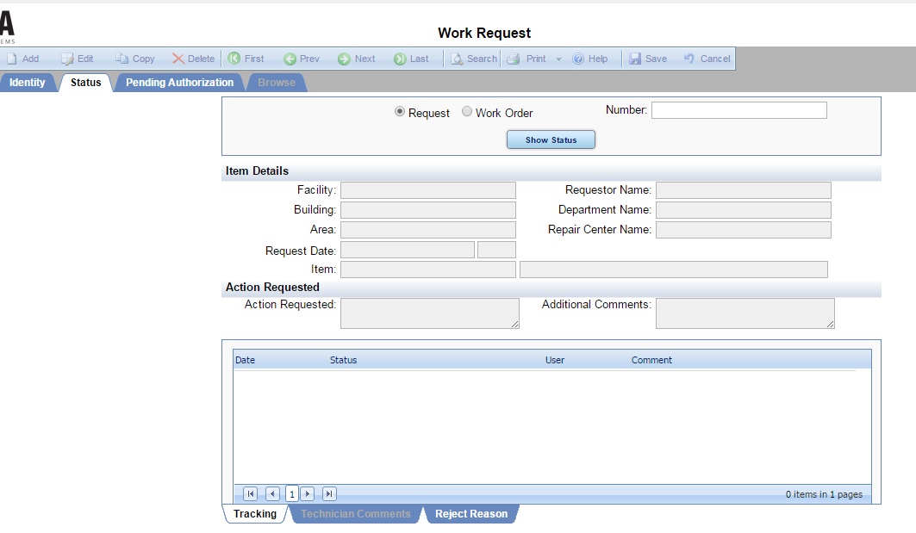

If your request is still pending, choose “Request” and enter the Request Number you received when you submitted your request. If your request was accepted and assigned a Work Order number, choose “Work Order” and enter the work order number you were e-mailed in the acceptance e-mail.

**If you chose not to receive notifications, you will not have the Work Order number and will need to enter the initial Request Number.
Enter your request in the Number box at the top right of the form. Click the button to return your status tracking results.

APPROVING/AUTHORIZING REQUESTS

If your request has a pending estimate or other approval criteria needed to proceed, you will receive an e-mail indicating the action needed. To approve the request, click on the URL included in the status e-mail to take you to the approval screen. Click the Pending Authorization Tab.
Click the Request number requiring authorization.

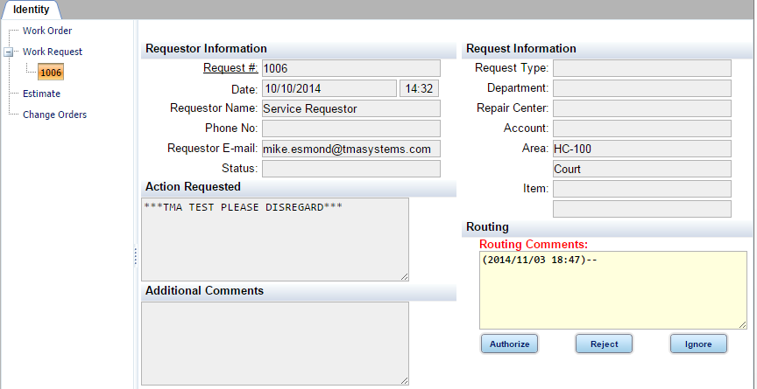

Review the request, add comments in the Routing Comments section (such as initials, date, or any comments needed for further clarification), and click the Authorize, Reject, or Ignore button.

