Flight Academy Flight Fees 2019-2020
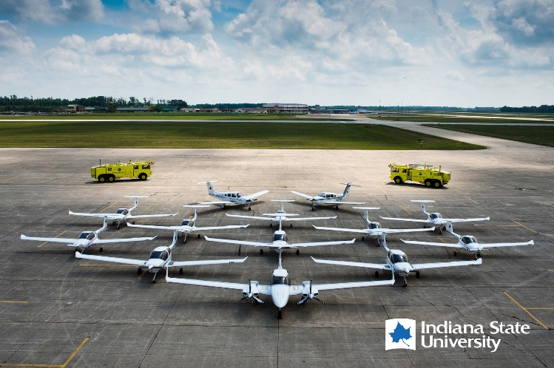

Operational expenses are primarily funded by flight fee income realized through the assessment of flight fees. These fees are non-refundable unless (1) the student drops the respective course for the certification being pursued, or (2) the student completely withdraws from the University. Under these circumstances, unused flight fee income will be refunded as determined by the flying time that was logged. Extenuating circumstances can exist, as may be determined by the Chairperson of the Aviation Department that would allow a student to pay hourly flight fee rates based on aircraft type. An example of an extenuating circumstance would be when a student would need to fly more hours, than provided by the semester rate, for the purpose of correcting deficiencies. Students enrolled in the ISU Professional Pilot Degree Program must accomplish all flight training at the ISU Flight Academy. Additional financial aid that has been granted for flight students through university approved flight courses must be spent for flight training at the ISU Flight Academy.
Freshman AVT 142 & AVT 144 students are required to pay full semester rate. (not eligible for installments)

Certificate Type Semester 1 Rate Semester 2 Rate
Private Pilot | AVT 142 $6,603 | AVT 144 $5,587
Instrument | AVT 242 $8,245 | AVT 244 $9,420
Commercial | AVT 342 $10,748 | AVT 344 $11,037
Multi-Engine | AVT 367 $5,280 | N/A
Certified Flight Instructor 1 | AVT 442-CFI $4,240 | N/A
Certified Flight Instructor 11 | AVT 442 CFII $4,435 | N/A
Multi-Engine Instructor | AVT 446 $3,650 | N/A
Tailwheel Elective | * AVT 365 $2,305

Note: Private Pilot, Instrument, Commercial and Multi-Engine Certificates are the only required certificates. Additional Certificates listed above are optional.
Aircraft Type Solo Flight Rate/Hour Dual Flight Rate/Hour
DA20 | $172 | $211
DA40 | $221 | $260
DA42 | $287 | $326
PA28 | $221 | $256
Super Decathlon | $172 | $211

Ground School
Hourly Instructional Rate | $39

