Uwe J. Hansen
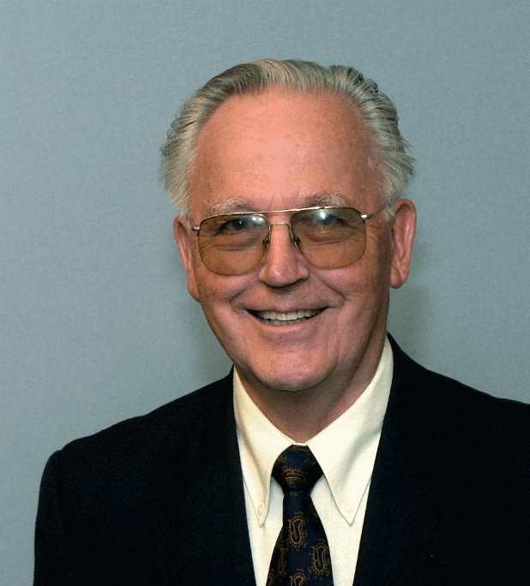
Professor Emeritus of Physics
Indiana State University
Department of Chemistry and Physics
Terre Haute, IN 47809

64 Heritage Dr
Terre Haute, IN 47803-2374

Tel: (812)234-0229
Fax: (812)237-4396
E-mail: uwe.hansen@indstate.edu

Biographical Summary

Uwe J. Hansen., Indiana State University, Professor Emeritus of Physics

Education: Brigham Young University: BS >54, Physics
MA >61 Physics: Thesis: A device for Free Electron Resonance Studies
PhD >66 Physics: Dissertation: Dielectric Anomalies in the Cyclotron Absorption Spectrum of Lead Telluride

NAS/NRC Post-doctoral Fellowship, US Naval Research Laboratory, Washington DC, >66->68
Physics faculty Indiana State University >68 - >98 (Professor 1978)
Adjunct Professor of Mathematics. Indiana State University
Adjunct Professor of German, Indiana State University
Professor Emeritus. ISU May 1998
Adjunct Professor of Physics, Rose Hulman Institute of Technology, 1984
Adjunct Professor of Physics, St. Mary of the Woods College
Visiting Professor, Northern Illinois University, >98, >91, >84
Visiting Scientist. Physikalisch-Technische Bundesanstalt, Braunschweig Germany, >92
Interim Chairperson, Department of Pysics, ISU >80 - >83
Chairperson, Department of Physics, ISU >94 ->97
Executive Director, Central States Universities, Inc. 2002 –
Editor, Proceedings of the Indiana Academy of Science, 2011 –

Consultant: Lockheed Research Laboratories – Electronic Properties of Semiconductors
TRW Research Laboratories – Low density plasma studies
US Naval Research Laboratory – High Pressure studies on Electronic Properties in Semimetals

Research: Lockheed: Cyclotron Resonance in PbTe
BYU: Cyclotron resonance in PbTe
NRL: High Pressure Cyclotron Resonance in Bi
ISU: Alfvén waves in Bi
Mode studies in musical instruments

Major Publications: Acoustics and the Performance of Music, Jürgen Meyer,
translated by Uwe Hansen, Springer Verlag, 2009
Modeling Musical Instruments, Rolf Bader & Uwe Hansen, in
Handbook of Signal Processing in Acoustics, Springer Verlag, 2008
Modal Studien in Musikalischen Instrumenten, in Qualitätsaspekte in Musikalischen Instrumenten,
editied by Jürgen Meyer, Hirtzel Verlag, 1988
Music from Oil Drums: The acaousrics of the steelpan, with Thomas Rossing D. S. Hampton, Physics Today, 49, 1996
Vibrational Mode Shapes in steelpans:1. Tenor & double second.
With TD Rossing & D.S. Hampton; J Acoust Soc Am, 108, 2000
Vibrational mode shapes in Caribbean steelpans, Part II: Cello & Bass
Thomas D. Rossing & Uwe J. Hansen, Applied Acoustics 65, 2004
Caribbean Steel Pans and Descendants, Proceedings of FA, Budapest 2005

Fellow Indiana Academy of Science (IAS)
Fellow Acoustical Society of America (ASA)
listed in Outstanding Educators of America 1971
Listed in American Men and Women of Science
Distinguished service citation ASA 2011

IAS, Chair Research Grants Committee (3 years around 1975)
IAS, Chair amendments committee >97 - 2000
IAS, Chair Physics section
IAS, Chair History of Science Section
IAS, member Science & Society committee
IAS, member fellows committee
IAS, member proceedings editorial board
IAS, member long range planning committee
IAS, Speaker of the Year 1998/99
IAS, Editor of news letter. >00 – 04
IAS, President-Elect 2004
IAS, President 2005

Member, board of directors International Institute of Sound and Vibrations
Science Advisory Committee to Symposium on Speech, Music and Allied Signal Processing, India
Trustee of Catgut Acoustical Society

Chair, Technical Committee on Musical Acoustics ASA ’90 – ‘96
Chair, Committee on Education in Acoustics, ASA ’96 – ‘02
Chair, ASA Committee on On-Line Education, >99 - 02
Member, Technical Council, ASA ’90 – ‘96
General Chair, ASA 132nd meeting, Indianapolis Spring 1996
Member, ASA tutorial Committee
Member, ASA education Committee
Member, ASA committee on meetings
Member, ASA committee on special fellowships
Member, ASA technical committee on Musical Acoustics
Member, ASA long range planning committee
Member, ASA membership committee
Member, ASA Committee on Medals and Awards
Scientific committee of SV 4, St. Petersburg, Russia, >96; and SV5, Adelaide, Australia >97

Chairman, Wabash Valley Chapter, Sigma Xi, (Research Society) ( early >70s)
Chairman Wabash Valley Chapter, American Society for Metals (ASM)( early >80s, 2003, 2004,2010)

Keynote address Mexican Acoustical Society Meeting, Mexico City, Oct. 1994
Section Keynote address, Intl. Congress on Sound & Vibration, SV5, Adelaide, Australia, Dec. 97

Invited presentations at National and International Conferences, Government and Industrial Laboratories, and Universities in Australia, Canada, China, France, Germany, Hungary, India, Italy, Japan, Mexico, the Netherlands, Norway, Trinidad, Russia, Sweden, Switzerland, the USA and Yugoslavia

Math courses taught: at Brigham Young University: Intermediate Algebra, College Algebra
At ISU: Remedial Math, Remedial Algebra, Intermediate Algebra, Quantitative Literacy, College Algebra, Trigonometry, Calculus,
undergrad. Mathematical Physics, grad. Mathematical Physics.

Physics courses taught: at BYU: University Physics laboratory, Physics of Photography
At ISU: Physics in University Studies, Physical Science, College Physics, University Physics, Modern Physics,
Quantum Mechanics, Thermal Physics, Solid State Physics, Optics and Photography, Musical Acoustics
At RHIT: University Physics, Modern Physics
At St Mary of the Woods College: College Physics
At NIU: University Physics

Other courses taught: at ISU: Conversational German and German Literature

ASA Presentations: Short course on Modal Analysis: Boston 1994,
Leavenworth 1998
Tutorial: Musical Acoustics, Science & Performance - Columbus, OH 1999
Salt Lake City 2007
New Orleans 2007
Portland 2009
Demonstrations in Acoustics with Tom Rossing – Chicago 2001

Hands on High School demonstrations in Acoustics: ~ 35 at various ASA meetings between 1987 – 2008

Administrative Responsibilities in the Church of Jesus Christ of Latter-day Saints:

Missionary in Finland 1957-1959, President Jyväskylä District; 2nd Counselor, Mission Presidency
Presidency of Seventy, East Provo Stake 1965, Potomac Stake 1967 - 68
Branch President, Terre Haute Branch 1969-71
2nd Counselor, District Presidency, South Indiana District, 1971 - 73
High Council, Indianapolis Indiana Stake 1973
1st Counselor, Stake Presidency, Indianapolis Indiana Stake, 1973 - 1979
1st Counselor, Stake Presidency, Bloomington Indiana Stake, 1979 - 1982
High Council, Bloomington Stake, 1983
Branch President, Brazil Branch, 1984
Bishopric, Terre Haute 1st Ward, 1986 - 89
Stake Mission President, Bloomington Indiana Stake, 1989
High Priest Group Leader, Terre Haute 1st Ward 1990 - 1992
Branch President, Greencastle Branch, 1993
Executive Secretary, Bloomington Indiana Stake, 1994 - 2004
High Priest Group Leader 2004 - present
Seminary teacher 60-61
Institute teacher

