Faculty-Led Study Abroad in China
May 2016
Take a 20-day study tour with ISU faculty in Economics, Political Science, and Earth & Environmental Systems and see some of the most significant cities and landscapes of one of the world’s most important nations. Students will interact with Chinese students and faculty and ISU partners while focusing on environmentally and culturally sustainable local economic development in the following cities and regions:
Shanghai - The metropolis is undergoing one of the fastest economic expansions the world has ever seen. The skyline is filling with skyscrapers; there are more than 3000 now (more than NYC) and another 2000 under development. The Shanghai Urban Planning Exhibition Center showcases the historical development of Shanghai and includes a huge scale model.
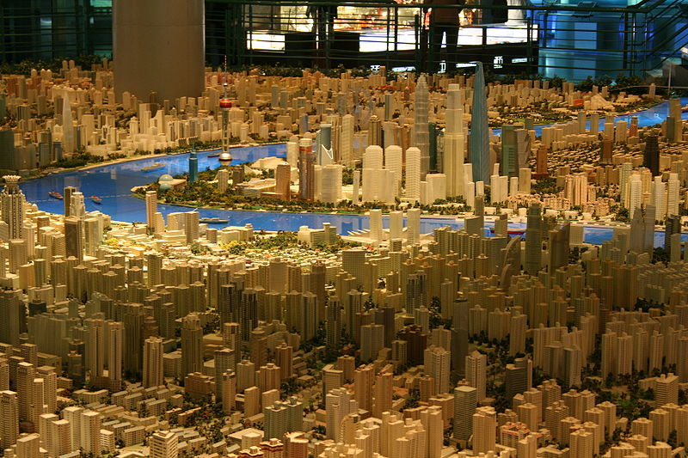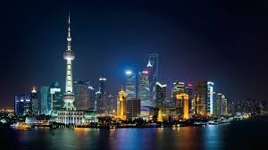
Beijing - For 1000 years, the drama of China's imperial history played out in Beijing and the cities attractions provide a peak into the history and culture of ancient as well as modern China.
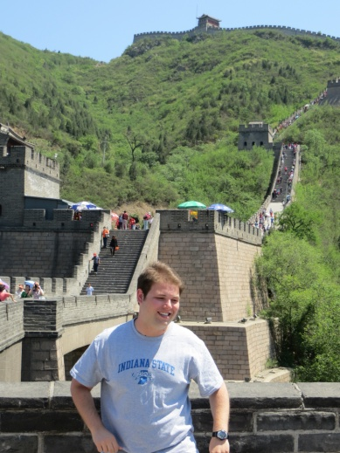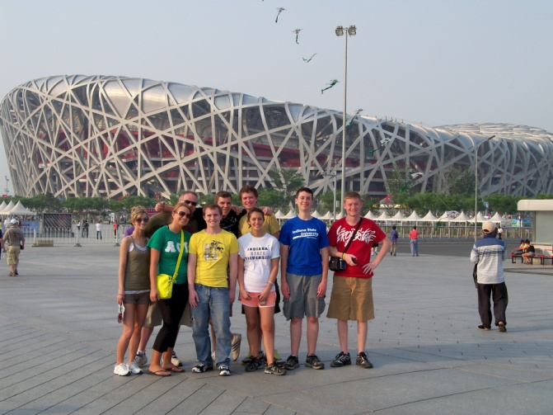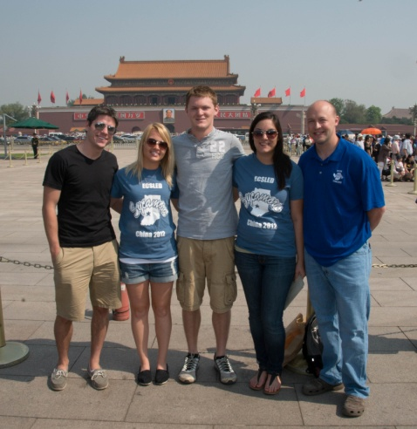
Xi’an and Yan’an - Xian was the Chinese capital for 13 dynasties and 1000 years and is home to many ancient, cultural sites, including the Terra Cotta Warriors. Yan’an is considered the birthplace of the revolution and is the endpoint of the famous “long march”. It became the seat of communist government in 1937 under Mao.
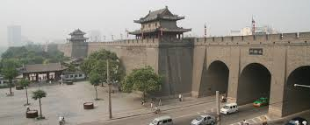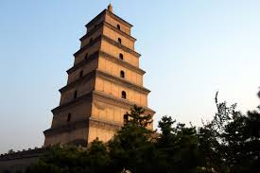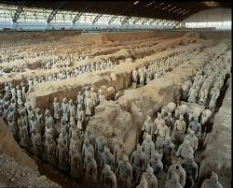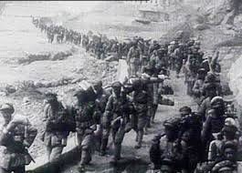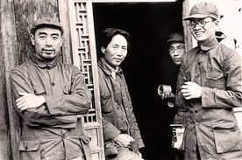
Liaoning Province - Shenyang and Dalian - Shenyang, the capital of Liaoning province and unofficial capital of the Northeast has served as a center for the Manchus, Russians, Japanese, Chinese Nationalists and then Chinese Communists. Shenyang's imperial palace was the model for Beijing's Forbidden City. Shenyang is the home of ISU's strategic partner, Liaoning University. Dalian is the northeast's financial and technology center as well as the Gateway to Korea and Japan. It is home to ISU's strategic partner Liaoning Normal University. Both Shenyang and Dalian are important parts of the PRC's Liaoning Coastal Development Belt project.
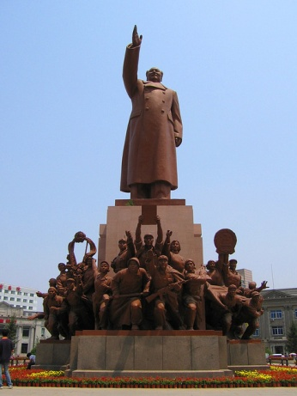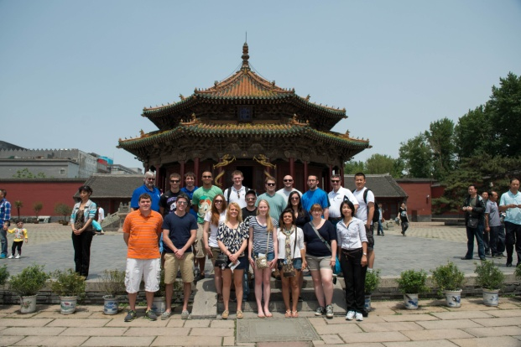
Mao Statue - Shenyang North Tombs - Shenyang Imperial City - Shenyang
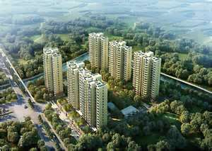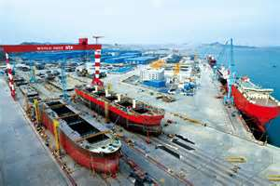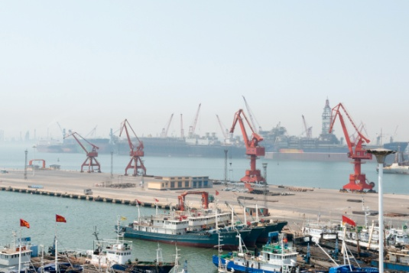
New Condo Development - Dalian Dalian Shipbuilding Company Dalian Port

