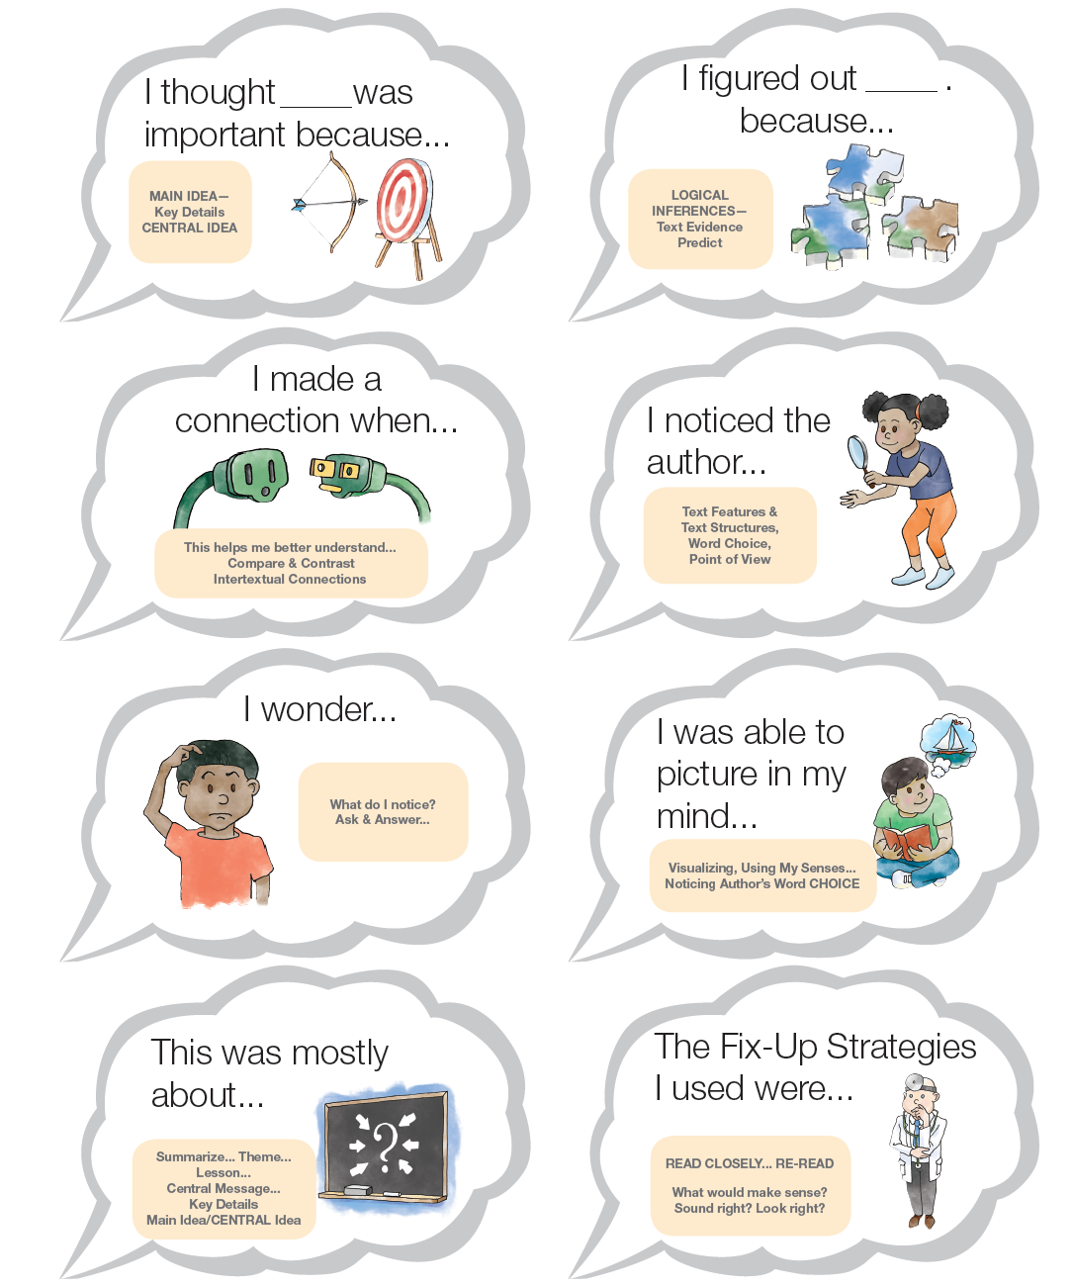

**2016 ©www.kbumreading.com**

**THINK ALOUD CLOUDS**