**Pre K - K-1 Student Editing Wheel**

**How can I correct my writing?**

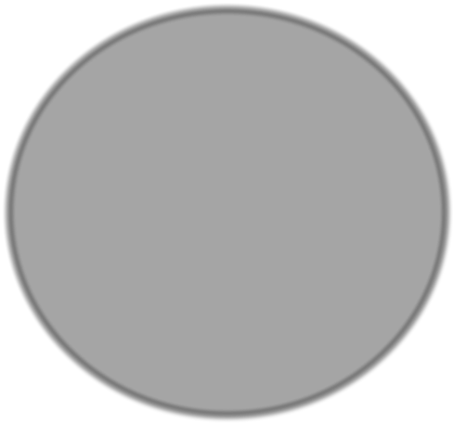

**Editing**

**Wheel**

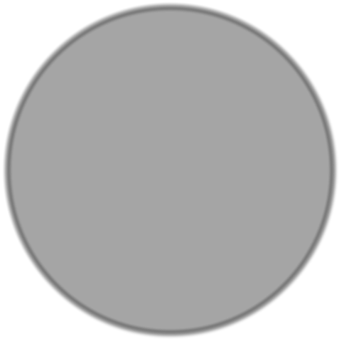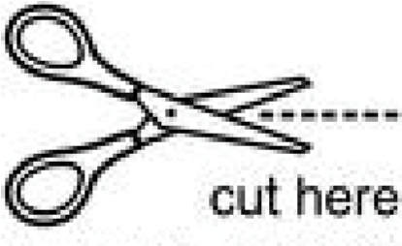

**www.kbumreading.com**

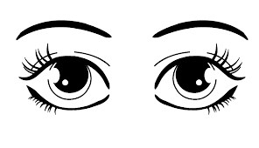

**Are all of my words spelled correctly?**

**Does the first word in each sentence and all proper nouns begin with capital letters?**

**Do I have spaces between my words?**

**Did I end each sentence with correct punctuation?**

**. ! ?**

**Remember to edit with your eyes!**

