|  |
| --- |
|  |
| March 2018 |
|  |

# ISU ECEC

# Upcoming Events

**March 12 – 16**- ISU Spring Break

**March 29** - Preschool Family Literacy night

**April 5** - Infant Toddler Family Literacy night

**April 6** - ECEC closed for staff development

|  |
| --- |
|  |
| Reminders  *It makes our days run smoothly when all children have extra clothing for quick changes, and nap time blankets for children who are toddlers or preschoolers.  * We continue to work with the ISU Public Safety office to review and practice all emergency procedures. Please be sure to sign your children in and out each day so we have an accurate count of how many children are present. |

*Like us on Facebook, and submit a review! [https://www.facebook.com/indstateecec](https://na01.safelinks.protection.outlook.com/?url=https%3A%2F%2Fwww.facebook.com%2Findstateecec&data=02%7C01%7CGail.Gottschling%40indstate.edu%7Caba5bd662ac3487a04c708d56e5de722%7Cfe5ae7b9c7bb433f9c3bd57539ebb655%7C1%7C0%7C636536271945070327&sdata=hSWxcgOtbz16vBvUoydit%2FvBOIPq8DaH4b%2F1%2BMDqDGc%3D&reserved=0)

200 Farrington, Terre Haute, IN

# [www.indstate.edu/ecec](http://www.indstate.edu/ecec) 812-237-2547

|  |
| --- |
|  |
| ECEC Families,  Our spring semester has got off to a great start. Thank you for sharing your wonderful children with us! As always, I've so enjoyed spending time in our classrooms, admiring all of the learning opportunities that our teachers are providing, and so pleased at the social interactions and relationships that are forming. |
|  |

## **Classroom News:**

**Infants 105**

The Infant room would like to welcome all our newer families and Assistant Teacher Melissa Howard. Fun fact about Melissa – she attended our preschool when she was four years old!

As your child's caregivers, we would like you to know that we strive to provide the best care for your child.  Though out our day we encourage language development, social bonds, many sensory activities from wet to dry, and fabrics of different textures.

The older children are working on walking and the use of fine motor skills at lunch time holding on to forks and spoon to feed themselves. The younger

children are developing their skills of rolling and sitting up, reaching for objects that are out of 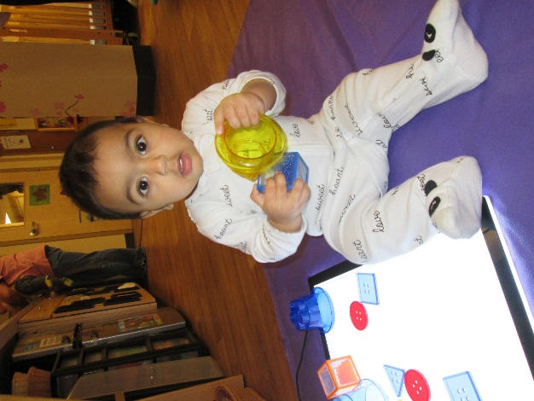reach.  We have been working on putting objects in containers to meet their fine motor skills.

They have been enjoying the felt board and music time.  We have had a few nice days to get outside on a stroller ride, which has been a nice change and makes everyone happy!

We love working with your children and watching them grow in their development.

Wendy Donlan

**Infants 106**

We are happy to have a new friend this month. We would like to welcome Camari and her mother Chandera to our infant room. In February, we read lots of books to the children about our loved ones like moms, dads, grandparents, and siblings. We also sing nursery rhymes like the Itsy Bitsy Spider and Pat a Cake to see if the children will repeat a clap.

The older infants have been working on their fine motor skills by filling containers with toys. We have challenged them more by having them put round discs into a slotted container. We love to see the smiling faces of the children when they master a new skill!

The younger infants are getting lots of tummy time for their large motor development. This is something that the children need to do at home as much as they will tolerate to strengthen their neck and shoulder muscles for crawling and moving to a sitting position.

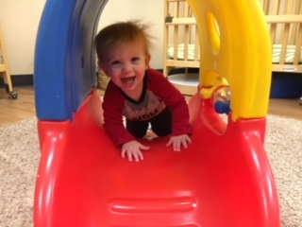Our sensory activities include finger painting, bubble exploration and we explore how light shines through objects with our light table. The children also like to feel different textures. We have bubble wrap on the floor for them to feel and explore. If any of you have another texture that the children would enjoy exploring please share with us!

It is not too late to sign up for a home visit. A home visit is when some of our staff come and visit you and your child in your home environment. This gives us a chance to get to know you and for you to get to know us. We usually visit after hours around 5:30 and spend 20-30 minutes with you and your child. If anyone is interested please let me know. As always, it is a pleasure for us to be a part of your child’s life. If there is anything we can do or if there is any information you need on a particular topic, please let us know. If we do not know the answer, we will research it and find the information that you need. Have a great month!

Lori Mackey

**Toddler 107**

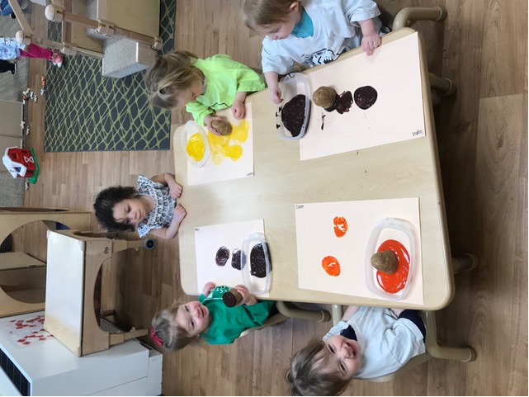This month the children have been interested in a variety of art activities. We have painted with colored ice, puffy paint, made a contact paper collage using tissue paper and wrote with chalk. During art it gives us time to talk about colors and textures we are using, and some of the children have begun to describe what they are making. Feel free to check out our artwork displayed throughout the classroom!   
  
We are so excited for the weather to warm up so we can get outside more. When the weather doesn’t allow outdoor play, we have continued to encourage large motor movement in the classroom by walking on the balance beam, using the climbing mats, the parachute and of course dancing!

Emily Templeton

**Toddler 108**

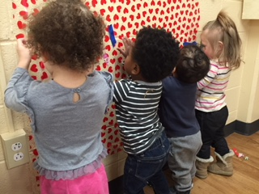If you are a parent of a toddler, you know that toddlers and independence go hand in hand! The toddlers in Room 108 are working on skills such as putting on their own coats/jackets. We put the coat upside down, hood or collar at their feet and they try to put both arms in the sleeves, then flip it over their head. Some of the children have achieved this skill and others are still working on it. There is nothing more rewarding than that smile of success!

Also, we encourage the children to remove their shoes at naptime and also try to put them back on upon awakening. Again, some children can do this and others are working on it. Some children can even remove their socks!

These are skills that you can work on and encourage at home, along with other small tasks. Children are eager to learn, want to please you, and like the success.

Mavis Russell

**2/3’s Classroom**

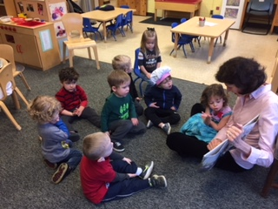I want to thank everyone for making my transition go so smoothly into the 2/3’s classroom. I have had so much fun getting to know your children and seeing them grow daily! We have been learning shapes along with colors in the classroom. The children have also been practicing cutting with scissors, stringing pasta and writing in their journals or at the easel. Our fine motor skills are getting better and better each day!

Some families have signed up for a home visit. We really appreciate you for welcoming us into your homes. It has been great getting to visit with you and your child! If anyone else is interested in signing up for a home visit please let Smilja or me know. Thank you again parents for volunteering to come in and read or do an activity with the children. They love visitors!

Kayla Lydick

**North Preschool**

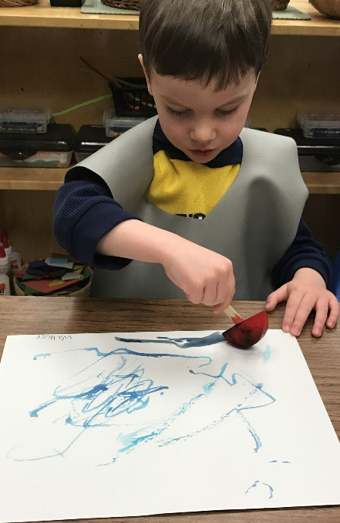Since our return from winter break, we have been learning about changes in the weather and temperature.   We have learned several new songs and poems about winter related topics.  On one of the really cold days, we put a bucket of water outside the window and we estimated how long it would take for the water to freeze.  Walker had the closest guess of 4 hours.  Some of our favorite winter activities have been painting with ice and creating with snow play dough.

 For the month of February, to get ready for our Valentine's Day activities, we discussed friendship, love, and kindness.   We have read many books about showing our friends and families that we care for them.  We have done numerous heart activities.  We have used heart shapes to count, to sort, and to make letters.   Cutting out hearts was a great opportunity to work on scissor skills.

We are looking forward to the month of March.  Spring always offers many new learning opportunities as we observe the changes in our world as the seasons change.  In March, we will continue to focus on weather changes but we will observe how the warmer weather effects the animals, bugs, and plants in the world we live in.

Jenny Ludington

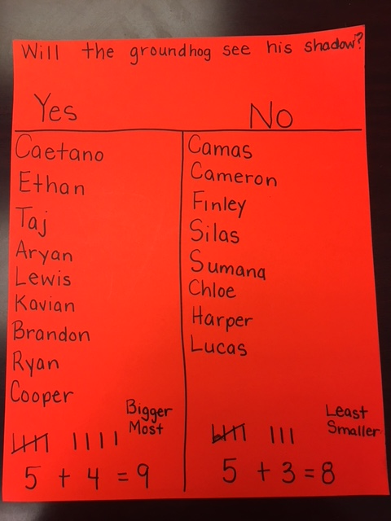**South Preschool**

Groundhog Day was a special day in the south classroom.  The children were really interested in learning about groundhogs.  They were excited to learn that they lived in burrow because they thought they lived in caves.  They made predictions about the groundhog seeing his shadow.  They counted votes using tally marks.  They were assigned homework.  Their homework was to find the name of the famous groundhog.  They were excited to tell me the funny name.

We’re looking forward to monthly visits from the Dobb’s Park naturalist, and are planning a family literacy evening. Details will be shared this week!

Tiffany Cherry

**From the Director**

*Home visits and conferences are important parts of our family/school relationship. Please see your child’s teacher or me if you would like to schedule a time to talk.

*I would like to get volunteers for our Parent Advisory Committee; if you were on the committee last year, or would like to join us, please see me or reply to this email.

Thank you for sharing your wonderful children with us,

Gail Gottschling, ECEC Director