Toddler Room 108
March Newsletter
Mavis Russell, Teacher
Heather West, Assistant Teacher
Lexi Mele, Student Teacher Assistant
We Are Growing & Learning

We have been so fortunate to enjoy a mild winter and be outside most days. We have observed the warmth, rain, a little snow, and a lot of wind. Without even knowing it, the children have had lessons in science!
We have uncovered the flower beds and are seeing new growth already. We raked the old leaves off of the grass and see new grass growing. Soon we will prepare for garden planting and we would welcome ideas for things to plant that we can enjoy for snacks or mealtimes. It is also a learning activity to watch flowers grow so if you have plants or seeds, we will accept those too.

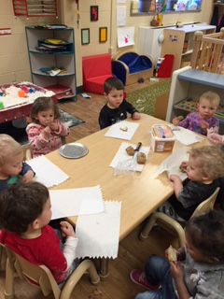
We have seen such growth in our group recently. There is a lot of conversations and communication among the children. They are becoming respectful of each other, asking questions, and showing empathy to others.
Almost all of our children are able to put on their own coats and hats. Many can take off and put on their shoes with a little assistance. We know you are seeing much growth and progress at home too.
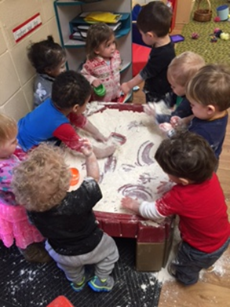

There has been a lot of interest in sensory activities and we have had flour (after our bread baking experience), cornmeal, rainbow or mardi gras rice, and water in our sensory table. The children like to scoop and pour, then pour out and refill. They also feel the materials and push them back and forth to make hills.

We love Visitors

Reading Fun:
We have enjoyed Heather’s Dad coming in to read to us. He uses different voices for animals in the book or makes animal sounds that are funny. We try to make those sounds too.
Bread Activity
Thisbe’s Mom brought in bread dough and we made our own loaf of bread by kneading it, putting it in a pan, then sprinkling our choice of sesame or chia seeds, or both, on the top. We tasted it after it was baked and made a chart of “Who Will Eat the Bread”. The question came up, “would the birds eat the bread?” so we fed some to the birds and they ate it all up. We read the book, “The Little Red Hen” and discussed who will help and who will eat. What a great experience!
Would you like to come for a visit?
If you have a talent or activity that you would like to share, we would certainly enjoy having you come in and spend a little time with us. You can read a book to a group of children at pick up/drop off time, or sing, play an instrument, etc. The possibilities are great. Please see one of us to plan a convenient time. The children enjoy having a “special guest”.

Thank you
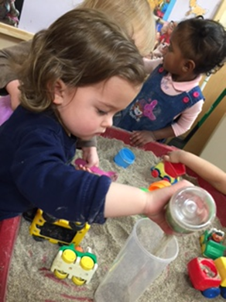
Thank you to those who attended the Potty Training Readiness meeting. The discussion and sharing were so nice. There are still handouts available if you would like them.

