Program Completion Data
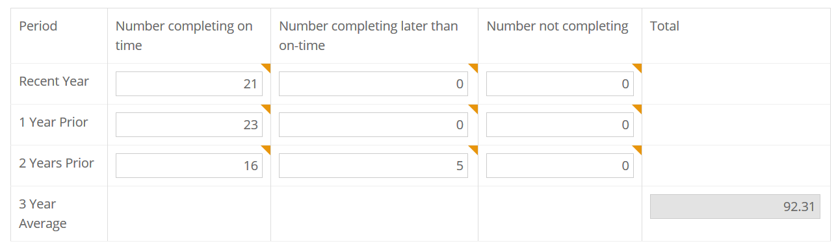
Praxis Subject Assessment Pass Rate Data
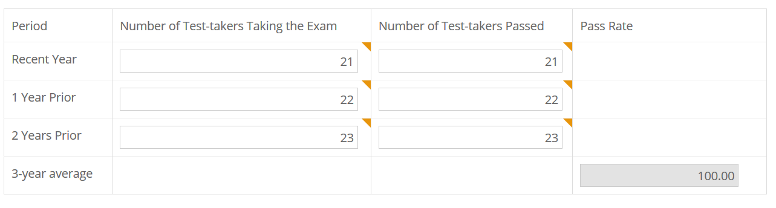
**Our median scores on the exam range from 173-178 over the past three years [passing = 162]

Employment Rate within One Year of Graduation
