Argos 5.1 Upgrade
An upgrade to Argos is planned for installation soon which is intended “to give Argos a more modern-looking user interface that is easy to navigate. Icons and styling have been updated throughout the application, along with many other usability improvements to the user interface”. The most significant changes are to the appearance of Argos icons and screens, beginning with the start-up of the application. This document is intended to show the everyday user the basic differences between the old and new versions of Argos in a side-by-side comparison.
Old (version 4.6) vs New (version 5.1) Argos
The URL to launch Argos Production (https://argos.indstate.edu/argos/) did NOT change, but the appearance did:
Old: New:
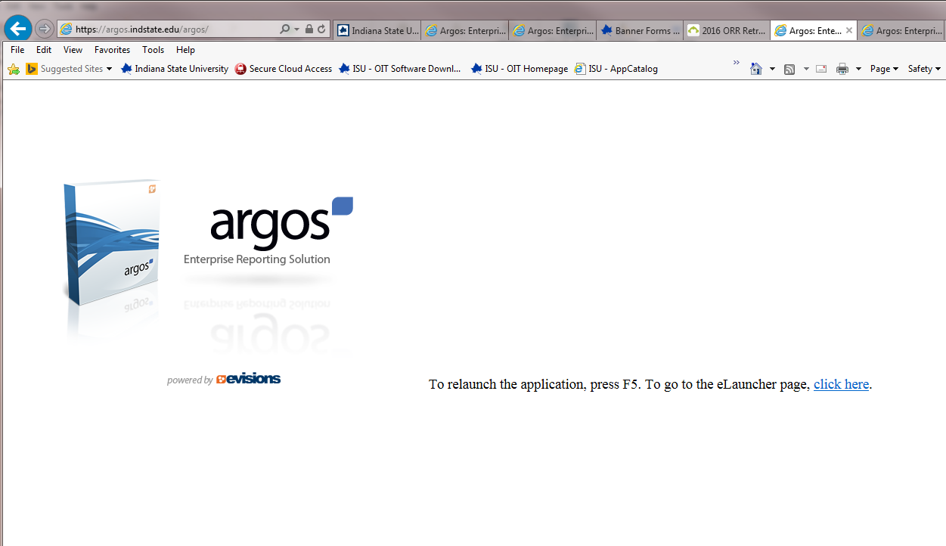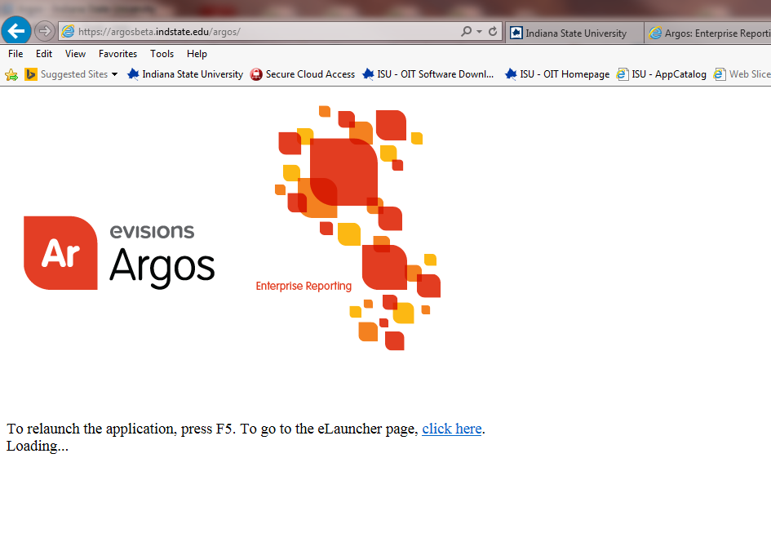
The Log In screen:
Old: New:
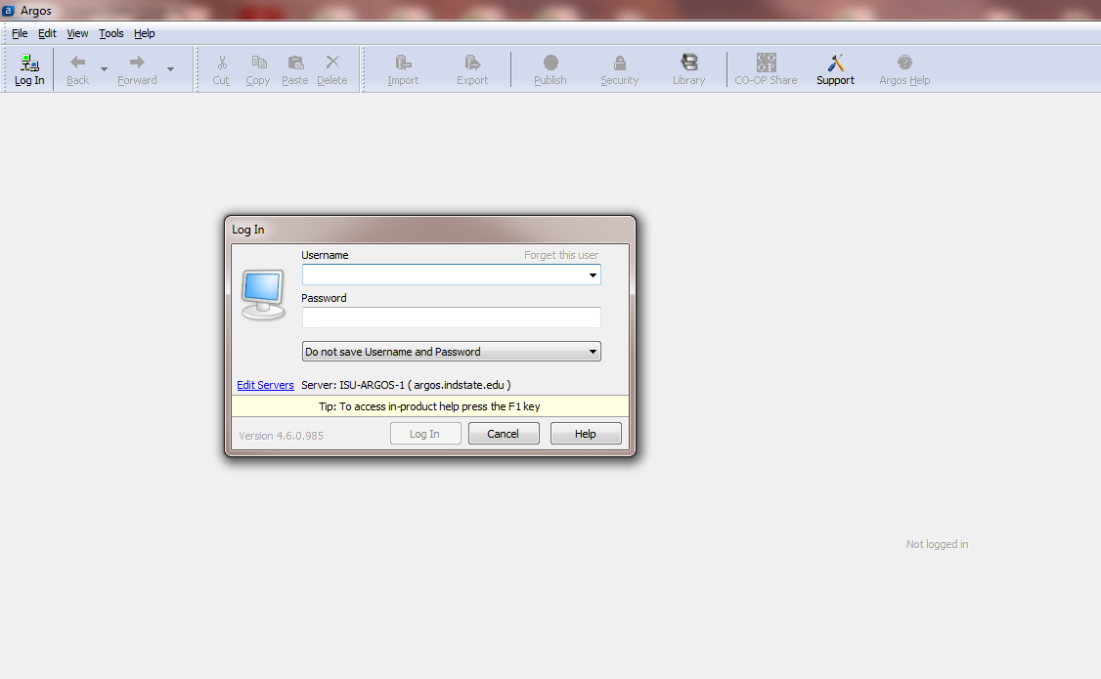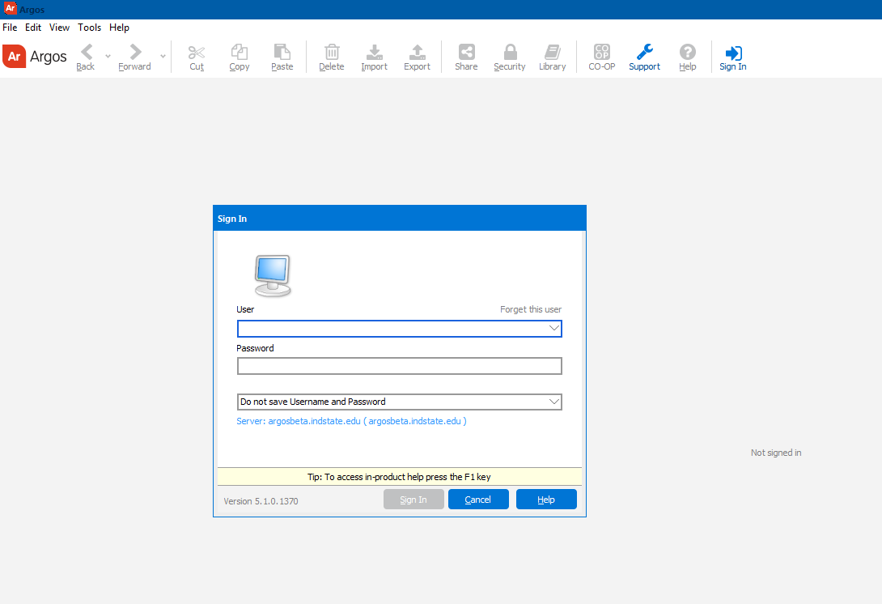

The work area:
Old: New:
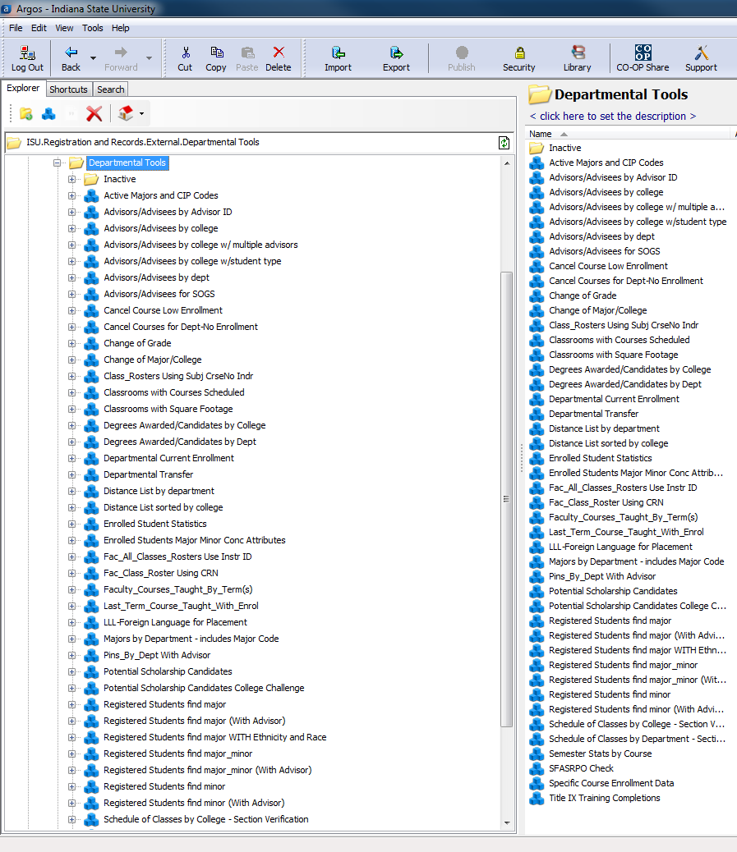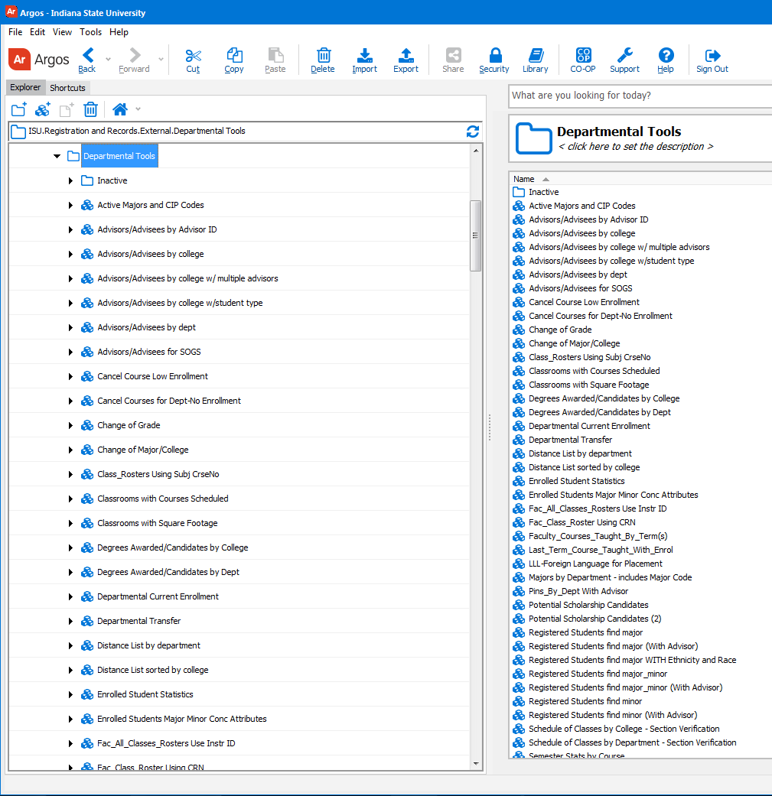

The appearance of the Explorer tree (left side of each screen) and the Action pane (right side of each screen) have changed:
Old: New:
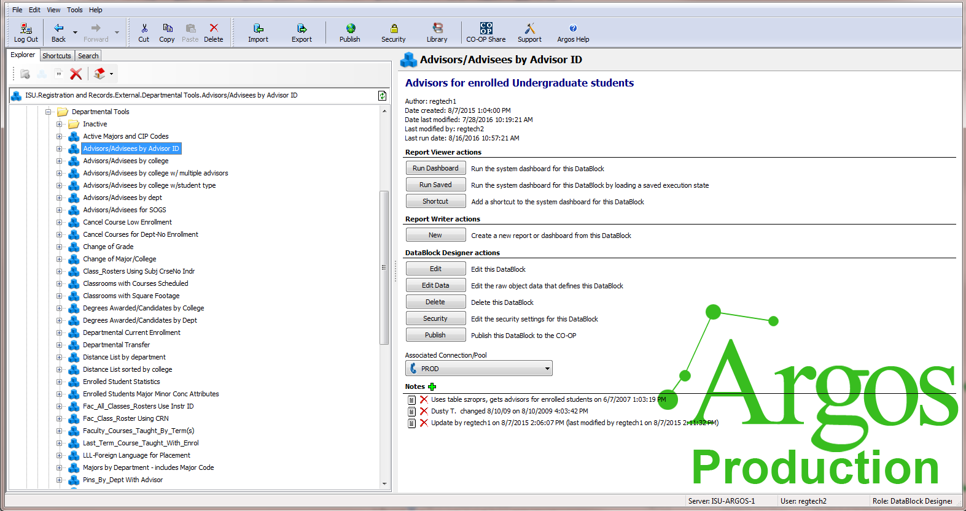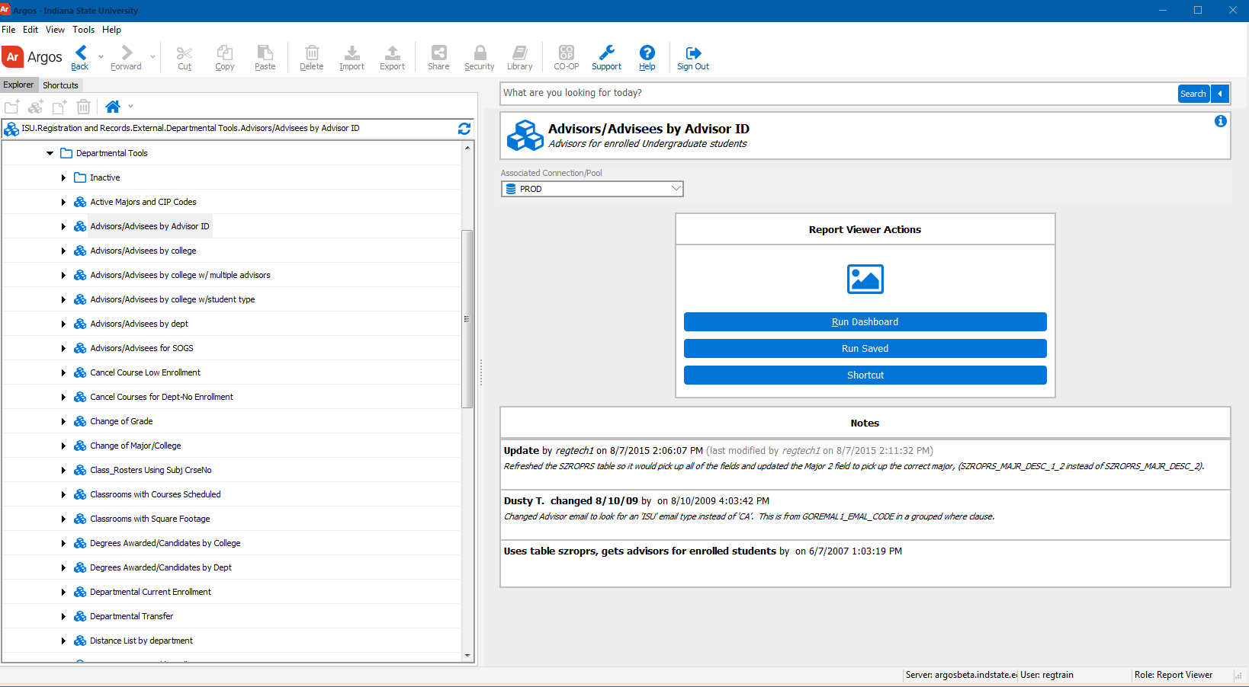

Icon appearance has changed in the explorer tree: the icons for datablock, dashboard, banded report (pdf), csv report (excel-like file) and schedule have changed:

Old: New:
datablock
dashboard
banded report (pdf) 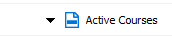
csv report (excel-like)
schedule 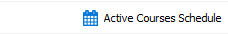

The + / - symbols for expand / contract the folder, datablock or report have changed to a right pointing triangle / down pointing triangle.
The Search function is in a separate tab above the explorer tree The Search function is at the top right of the action pane
Old: New:
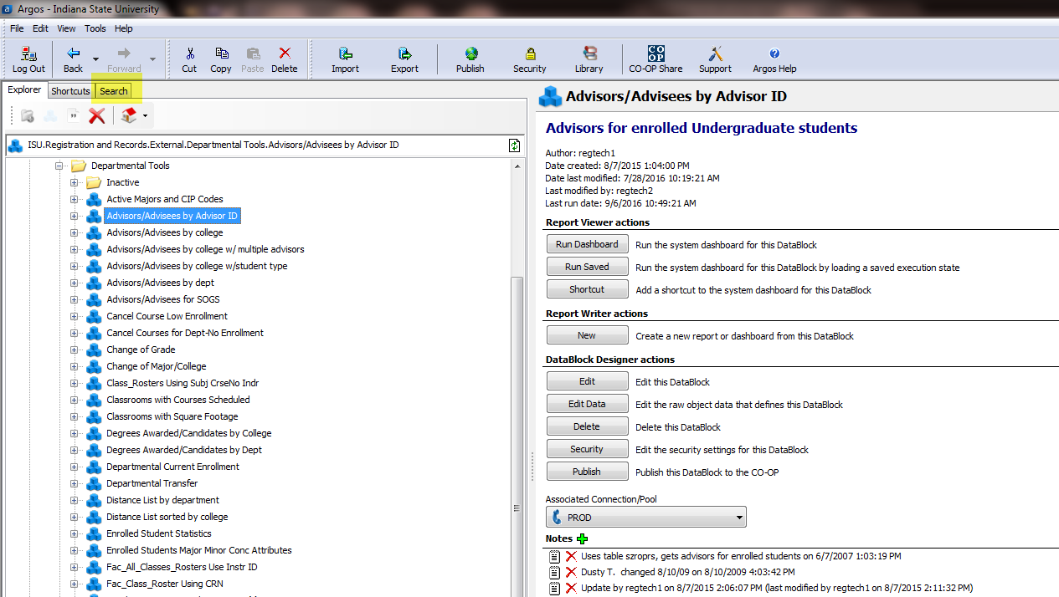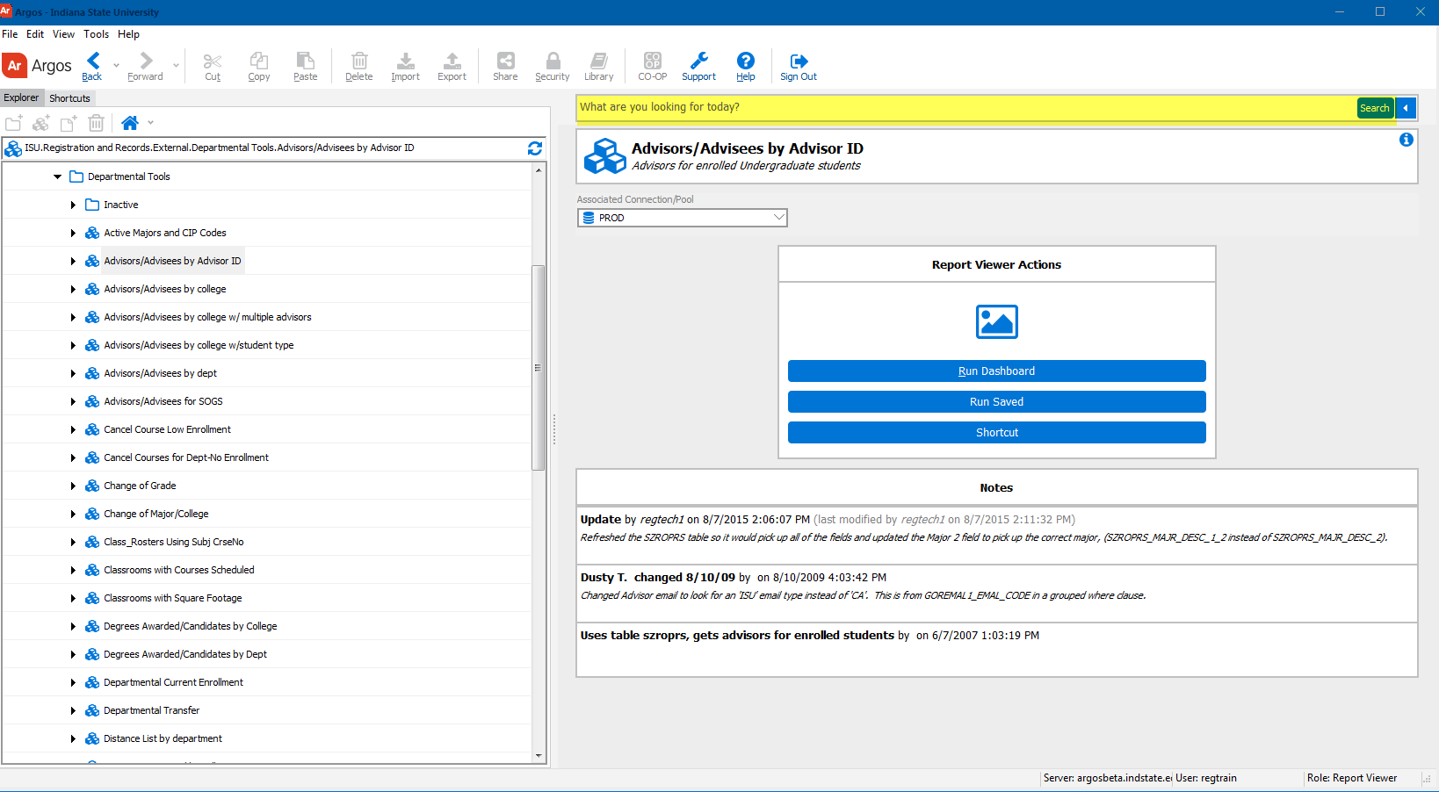

Entering the search string and selecting the magnifying glass (or hitting the Enter key) Entering the search string and selecting Search (or hitting the Enter key)
brought up the search results on the right side of the Argos window brings up the search results on the right side of the Argos window

Old: New:
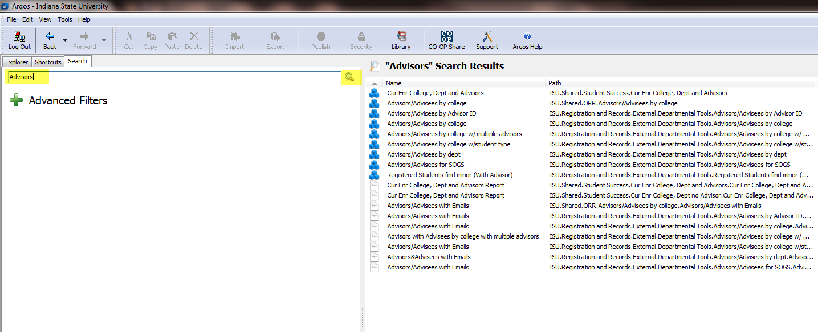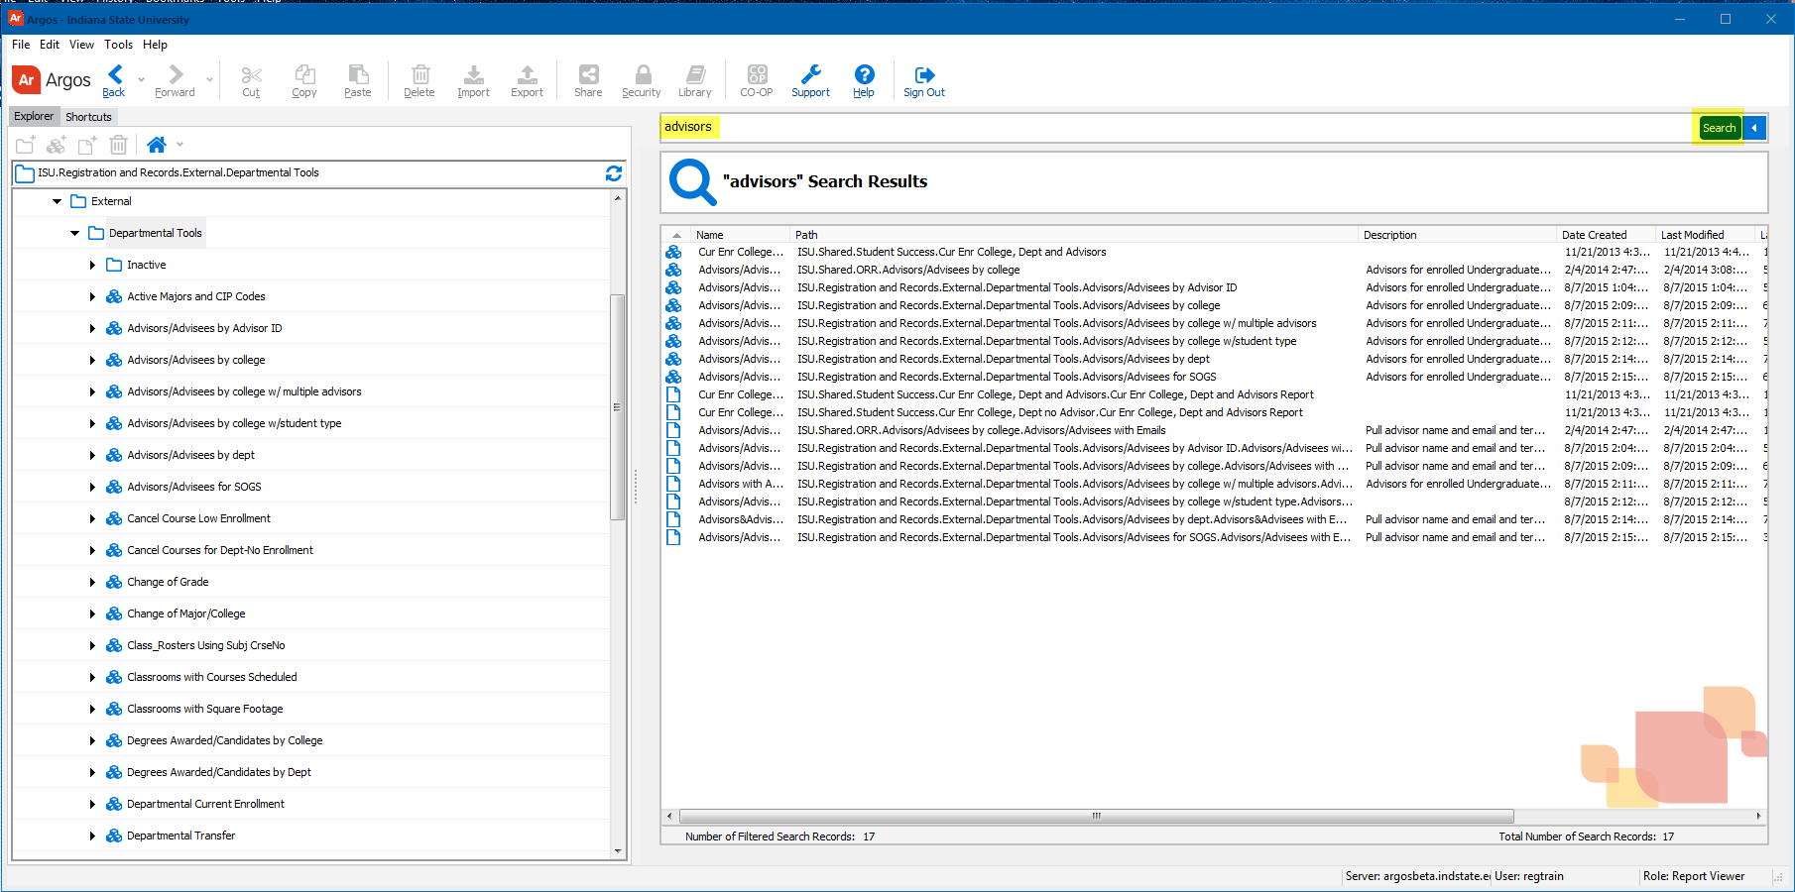

Double-clicking the desired search result… Double-clicking the desired search result…
Old: New:
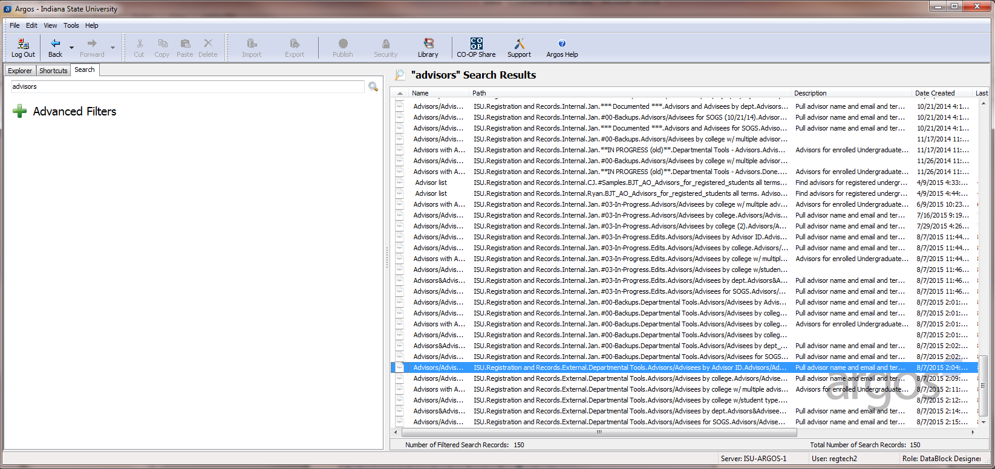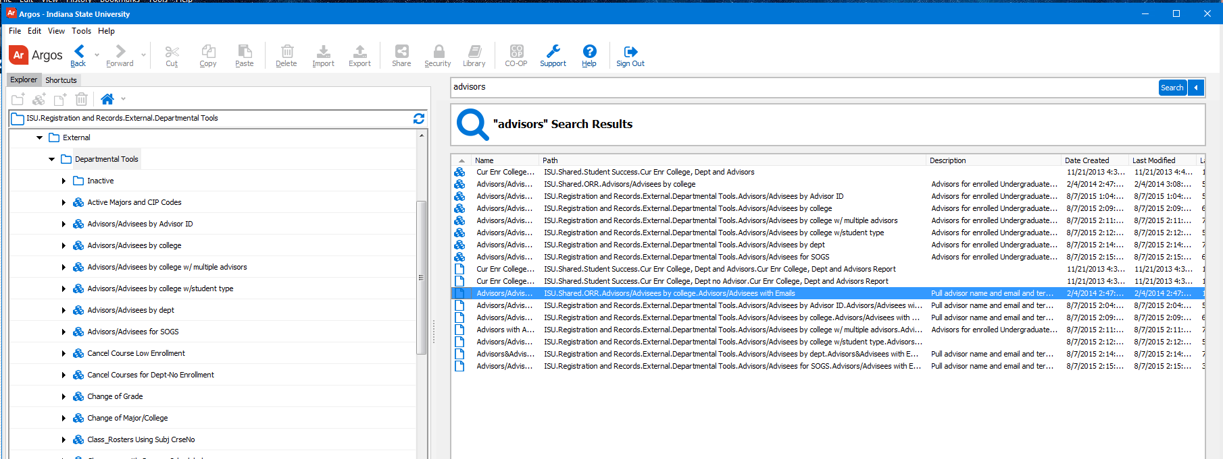
…takes you directly to that item in the explorer tree, with the Action Pane for that item …still takes you to that item in the Argos explorer tree (and now restores the Actions Pane for that
showing in the right side of the screen. item in the right side of the window).
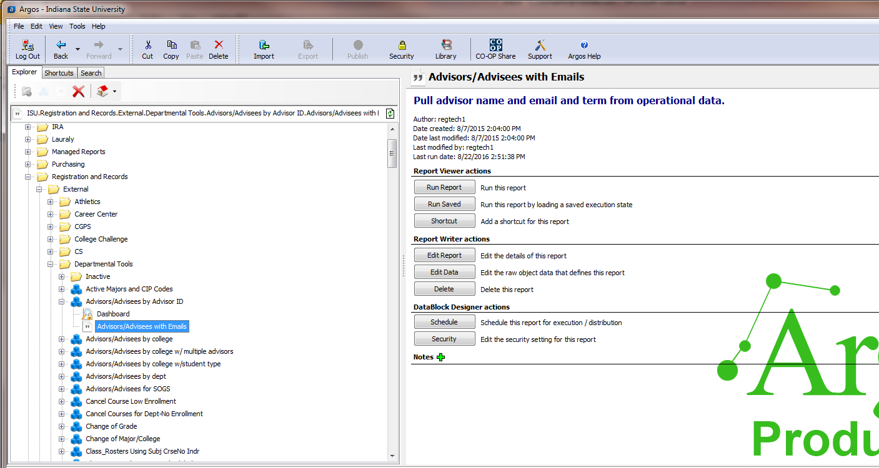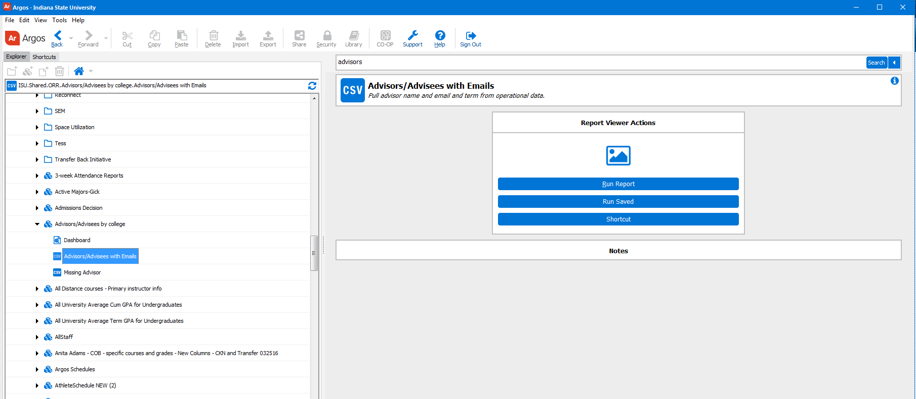
Location of the Information about the Argos object (creation, modification, last run), the Report View Actions, the Associated/Connection Pool (Banner database against which the report is running, PROD or STBY) have changed in appearance and location, but not in content, and in the new Argos you must select the i icon in order to view the information. Location of the user’s name and role are unchanged :
Old: New:
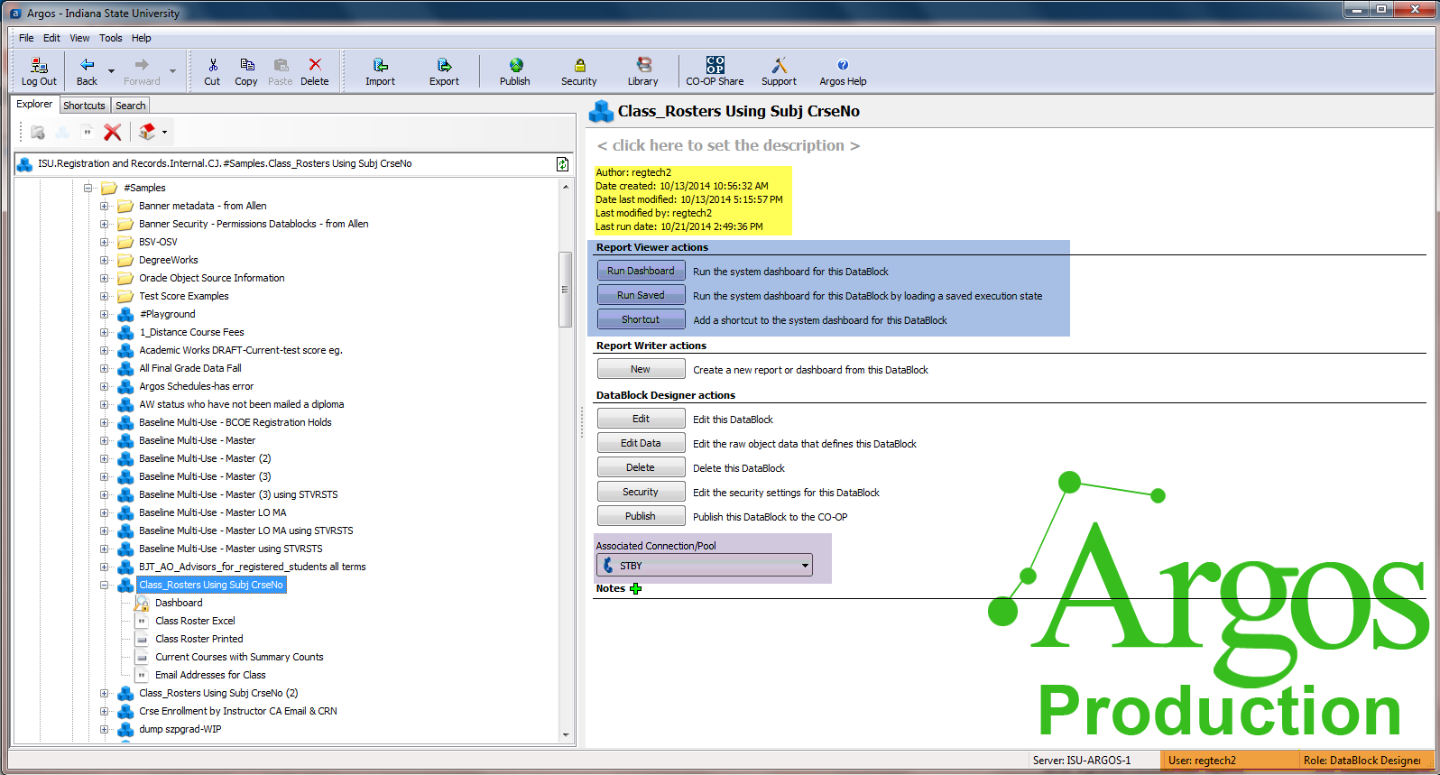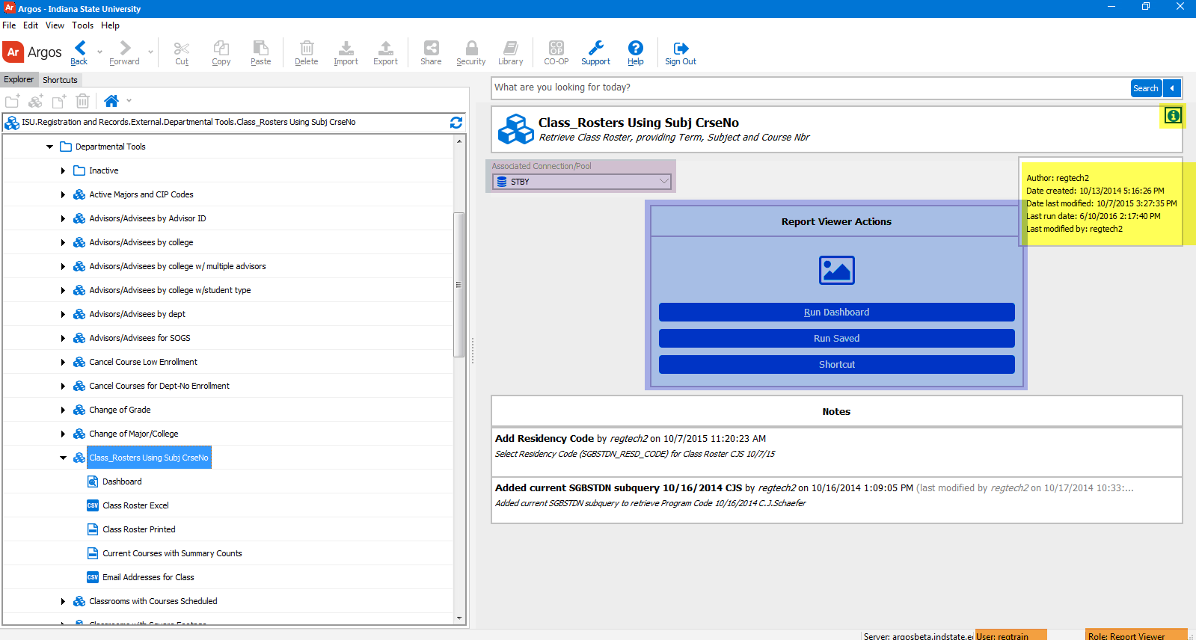

The same actions are necessary to run a report: select the report name and press the Run Report button….
Old: New:
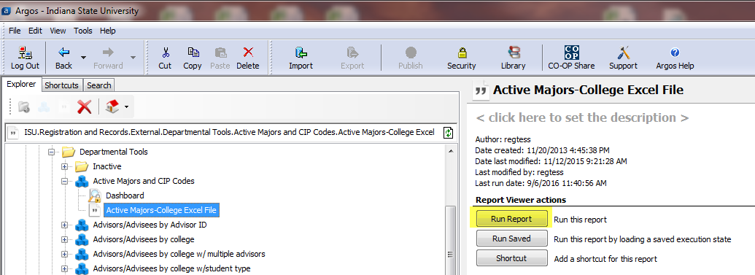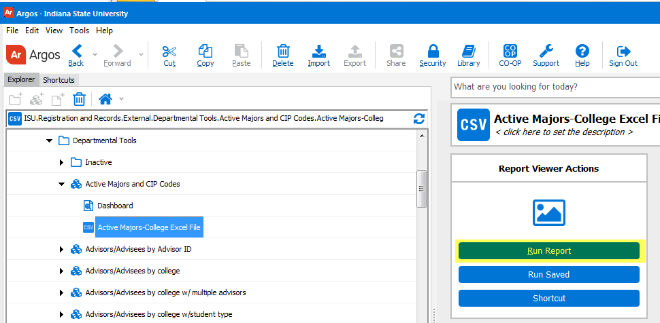
…which will bring up the Dashboard where the parameters are selected or entered. The execution options icons look a little different, but their functions are the same; the cog-shaped icon is still selected to generate and save a csv report file.
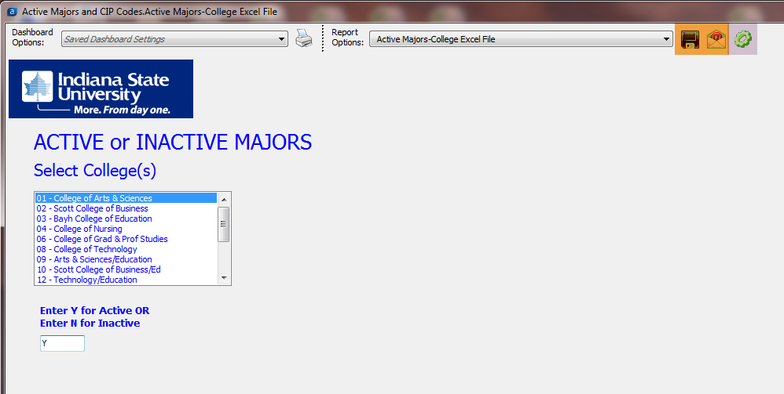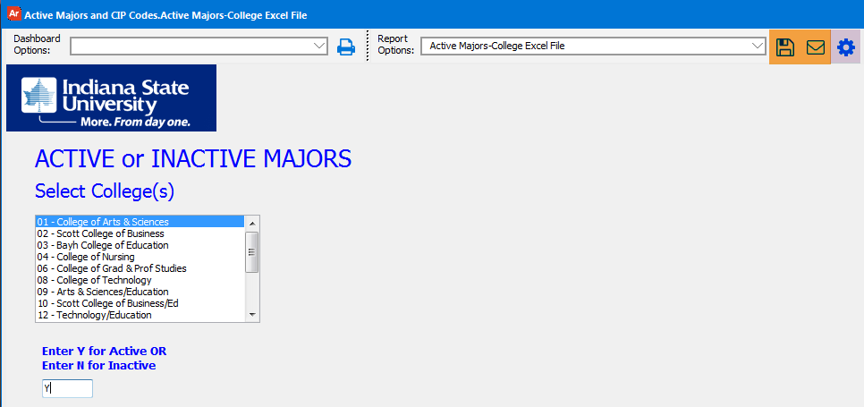
The appearance of the Save Report window has changed slightly, but functions the same.
Old: New:
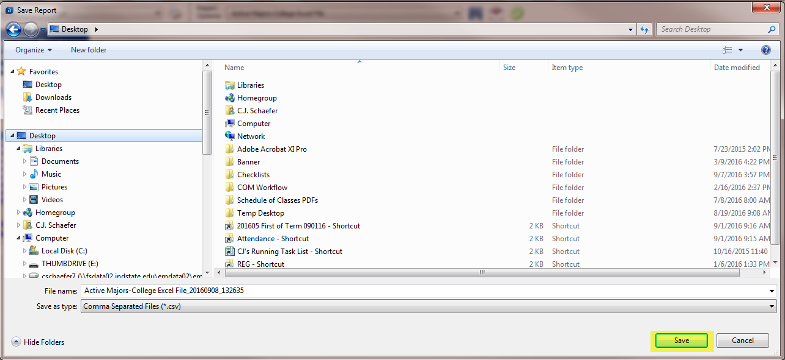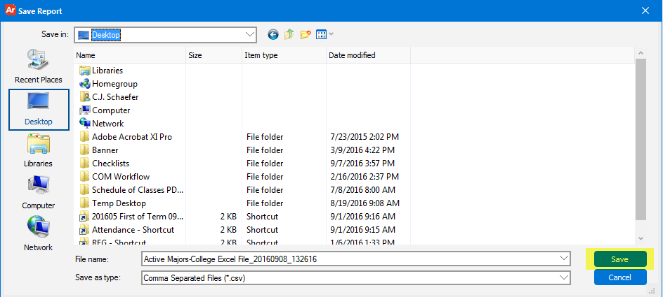
Selecting the Save button still causes the report to run, the csv file to be saved and the report to be opened in Excel.
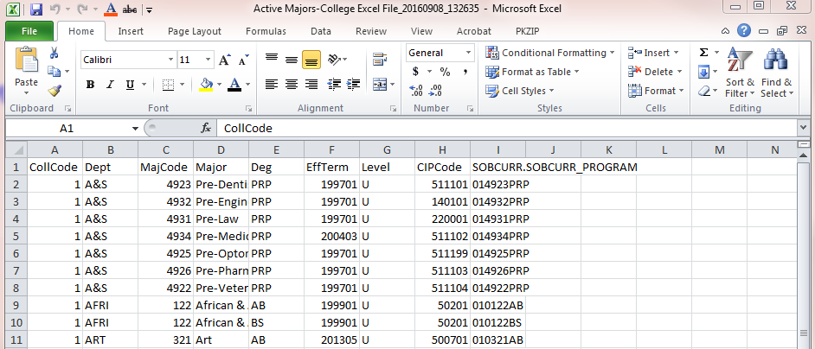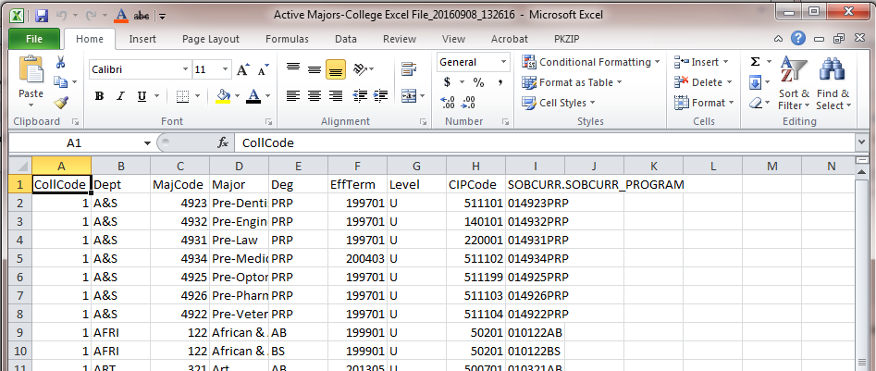
The same scenario is true for running a Banded report, creating a PDF file: the steps in the new version are the same as the steps in the old version. Only the appearance of the screens and the icons has changed.

