Outcome Analysis Reporting
An outcome analysis is a quantitative assessment of Tegrity’s impact of students’ grades and course completion rates.
-Note: These should be performed at the end of each term.
This feature of our program allows you to compare courses that use Tegrity versus courses that do not use Tegrity. For example:
-Average grade point and total enrollment
-Average completion rate and total enrollment
Outcome analyses can calculate:
-the number of students that completed a course with help from Tegrity.
-the number of additional students that would likely have completed a course if they had used Tegrity.
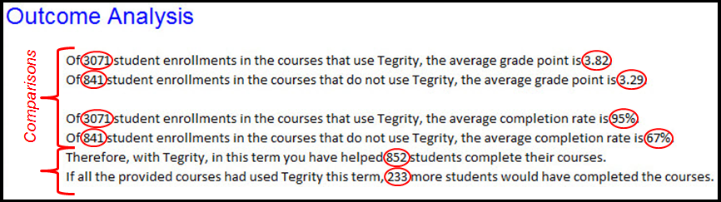

The Outcome Analysis Report shows students’ grades and their completion rate in courses that use Tegrity at your institution and those that do not. This enables you to evaluate the impact that Tegrity has on student performance in the current term.
For information on how outcome analysis reports can help to strengthen your institution, click here.
- Access your Tegrity environment and select “Reports”, squared below in red.
- Select “Outcome analysis”

- You will then be prompted to complete Tegrity’s Excel template. To do so, click “template”.

The document will open (if this does not happen, make sure that Excel is installed on your computer). In order to complete the template, you must know course IDs, course names, the total enrollments for each course, the total completion rates for each course and the average grade point average for each course. Complete the spread sheet.
- Once completed, upload the document. To do so, select “browse” and select the document’s location. Then select upload.
Tegrity will then generate your comparison results.

