Instructors: Getting Started
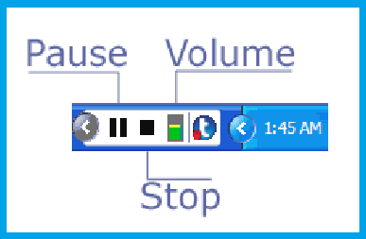
Whether you’re new to Tegrity and ready to begin your first recorded lecture or just want a refresher course, this post will walk you through the ins and outs of recording and posting, and will also illuminate some of Tegrity’s unique features that you may not have known existed!

Recording a class:
Note: If you are recording on a Mac, click here.
- Access your My Tegrity homepage. Select “Record a Class”, located in the top right-hand corner.

2. A box entitled “Tegrity Recorder” will appear. Select the title of your course from the drop-down menu (labeled A, figure 1).
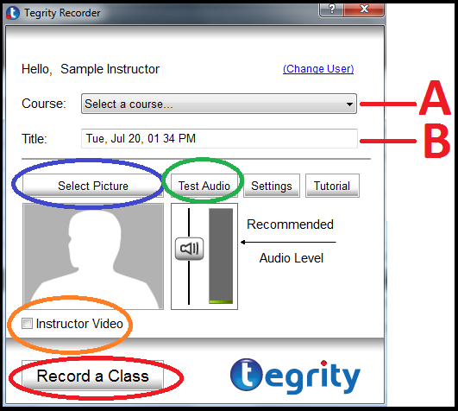
Figure 1

(Steps 3-5 are optional)
3. Type in a title for your course in the space provided (B).
4. You may choose to select a photo from your computer to appear on the recording (circled below in blue), or, if you have webcam capabilities, you may check the box enabling “Instructor Video” (circled below in orange).
5. The “Test Audio” button (circled below in green) allows you to test the strength of the microphone you’re using. Following the on-screen instructions that appear, the green bar will fluctuate up and down as you speak into your microphone, indicating its strength.
6. Click “Record a Class” (circled below in red) when you’re ready to begin recording.

Toolbar controls
Upon clicking “OK”, Tegrity begins recording all actions made on your computer. Not only does Tegrity record all of your actions, but the program also allows you to draw directly onto the screen, and to create onscreen whiteboards. This section will show you how to use those controls effectively.
You’ll know that Tegrity is recording because the Tegrity controls will appear in the bottom right-hand corner of your toolbar. The Tegrity recording controls have been reproduced below, squared in red.
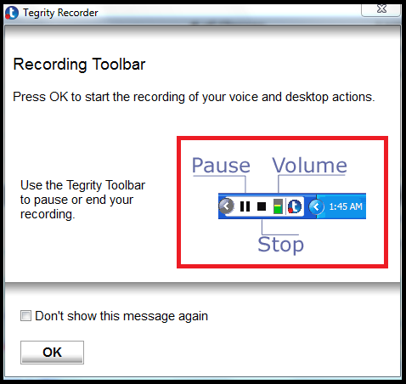
By selecting the left arrow, located to the far left of the control panel, the panel expands illuminating additional controls that will allow you to:

1. Expand your live webcam(s) into full-view mode.
2. Draw directly onto your computer screen using a series of tools (for example, the free-hand tool, shape tools).
3. Enable a full-screen view of a white board.
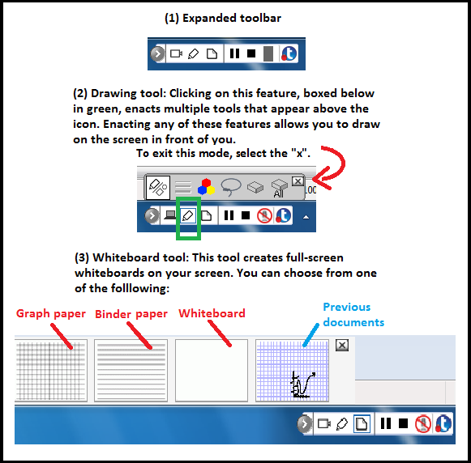

For example, enacting the drawing tool on the whiteboard will look something like this:
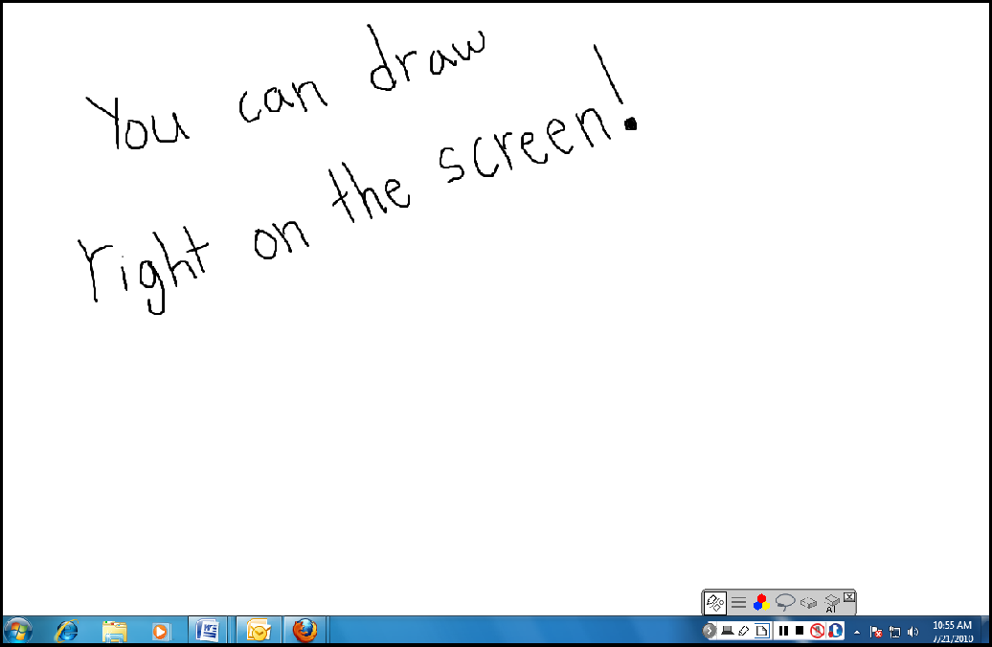

Completing a recording
When you select the stop button, you will be asked to select the action you wish to take. You may either:
-Upload the video to Tegrity (which takes place in the background and does not interrupt any other activities).
-Preview, which allows you to watch and review the lecture you have recorded before posting it on Tegrity.
-Delete the recording.
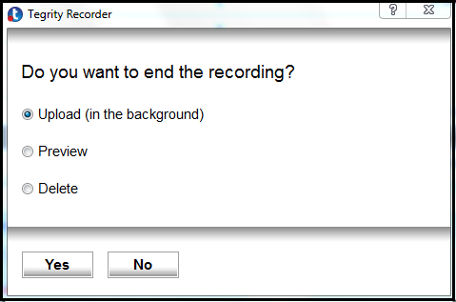

Uploading
The beauty of Tegrity is that there is no need for you to manually upload your recording to the program… Tegrity does it for you, and in the background so you can continue to work on your computer. Once you click “Upload”, the process begins. By accessing your My Tegrity page and clicking on the course where your new recording is located, you can check the status of your upload. Uploading time depends on the length of your recording, but should not exceed 20 minutes per hour (however, with our new real-time processing capabilities, uploading should be significantly faster).
Once Tegrity has completed the upload, your recording is immediately available to your students.

