How to: Create a Student Recording (PC)
Posted in: Students
Student recording is one of the Tegrity “personalization” features. The student recording feature allows students to create recordings as part of a course. Student recordings can be used for self-introductions, contest entries, demonstration or presentation assignments, and peer evaluations/feedback.
Before starting a recording, Tegrity recommends that you have all applications, files, or web sites that you will use during the recording opened and ready for use.
1. Access the desired course in your institution’s Tegrity service. Refer to the access / log in instructions provided by your institution or instructor.
2. Click the “Start a Recording” button to launch the Tegrity Recorder.

Notes: The Tegrity recorder will be installed when the “Start a Recording” button is clicked if it is not already installed. For more information on installing the Tegrity Recorder, click here.
3. When the Tegrity Recorder is launched, the Tegrity Recorder dialog window is displayed.
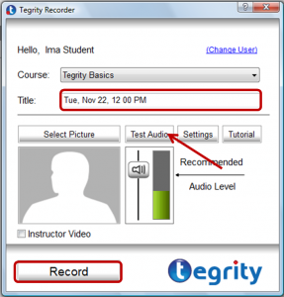
- The course in which you started the recording is preselected in the course drop down list.
- Tegrity automatically provides a default title for the recording (i.e., the day, date and time the recording was started). Tegrity recommends that you change the default title to indicate the recording topic or assignment. You do not need to put your name in the title since your name will automatically be associated with the recording.
- Test your audio by clicking on the “Test Audio” button to access the audio test feature. The “Test Audio” button is available if the “Instructor Video” check box is not selected. For more information on testing or adjusting the audio, click here.
- If both video and computer screen need to be recorded, click the “Instructor Video” check box. The “Instructor Video” check box will only be visible if a camera is connected to your computer. Test your video by clicking on the “Test Video” button to access the video test and settings features.
4. Click the “Record” button located at the bottom of the recorder dialog window to start the recording. The “Recording will start momentarily…” windows is displayed briefly. As soon as the “Recording will start momentarily…” window disappears, the recording is being created. Also, the Tegrity recording toolbar will be displayed in the system tray. Tegrity will record everything that appears on your computer screen.
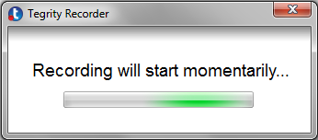
5. When you have you completed the delivery of your content, click the “Stop” icon on the Tegrity toolbar in the system tray.
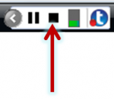
6. When the “Stop” icon on the Tegrity toolbar is clicked, the “Do you want to end the recording?” window is displayed. To confirm that the recording should be stopped and uploaded to the selected course, leave the “Upload (in the background)” option selected and click “Yes”.
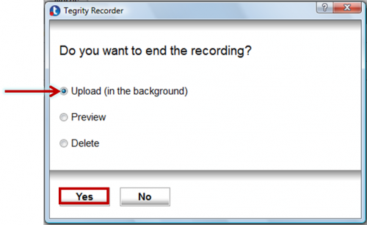
Note: Prior to uploading the recording, you can preview it to make sure that the content was recorded as desired. To preview the recording, select the “Preview” option.
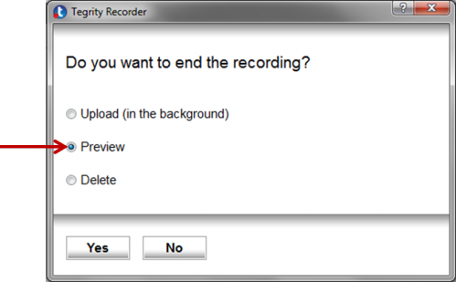
A dialog box will appear that will provide you with a link to preview the recording. Click the link to view the recording.
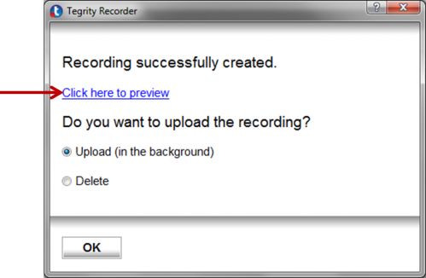
After previewing the recording, leave the “Upload (in the background)” option selected and click “Yes” to upload your recording into the course.
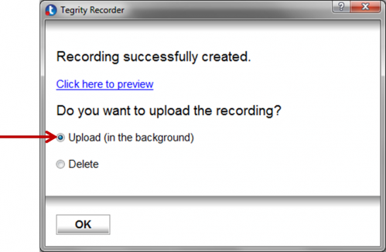
7. When at least one student recording has been uploaded, a “Student Recordings” tab will appear in the course in Tegrity. To view the recording, click the “Student Recordings” tab and then click the name/title of the recording.
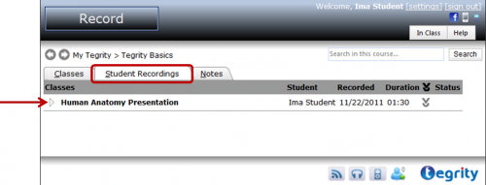
Notes: All student recordings created for the course will be stored in the “Student Recordings” area in the course. Recordings created by other students may not be visible depending on the settings established by the course instructor. Students cannot delete or edit their recordings. Only the course instructor or the institution’s Tegrity administrators have this capability.

