How To: Upload a Video File

“Upload Video File” allows you to upload an existing video file into Tegrity. The video file will appear as an individual recording and will be accessible to users through the Tegrity Player as a standard recording.
1. To initiate the process, launch the “Upload Video File” action from one of two locations below.
a. From the Course Tasks menu within a course

b. From the Tegrity Recorder tray icon.

2. Recorder will launch. Specify the course in which the video should be upload to and the title you desire.
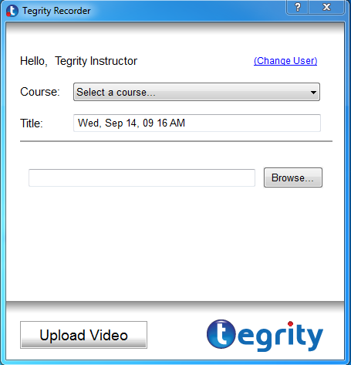
3. Click Browse to select the video
Supported Video Formats | Flash Video Files (*.flv)  Movie Files (*.mpeg, *.mpg)  MP4 Files (*.mp4,*.m4v,*.mp4v,*.3gp,*.3gpp)  QuickTime Movie Files (*.mov)  Windows Media Files (*.asf,*.wmv)  Windows Video Files (*.avi)
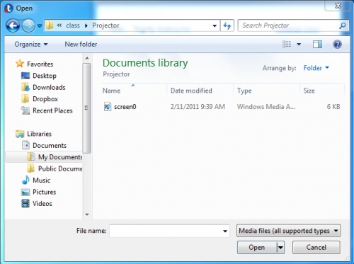

4. Clicking “Open” will select the video file and return you to the Recorder window. Click “Upload Video” to complete the process. The upload will now appear in your Upload Queue. Duration of process may vary depending on size of video.

