How to: Install Recorder (Windows)
To begin recording with Tegrity you will be required to install the Tegrity Recorder. The installation process is simple and will only occur during your initial recording. The installation procedure is outlined below:
1. Access your “My Tegrity” page. Click on the “Start a Recording” button (Circled in red).
2. Depending on your browser settings you may be prompted to manually approve the installation. If you see the following prompt, simply right-click on the information bar (outlined in red) and select “Install Add-On”. (If you are not prompted skip to Step 4)
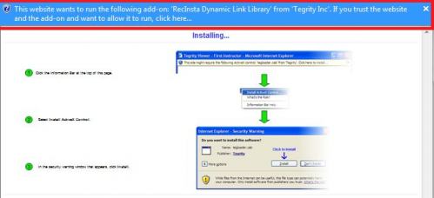

3. You will then be prompted to Run the “Active X Add-on” and Install the “recinstaller.cab”. Select “Run” and “Install”. Upon doing so the installation will begin and progress will be shown as follows.
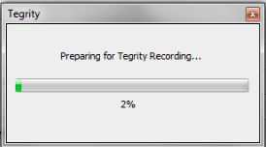
4. Once progress reaches 100% the Tegrity Recorder will automatically launch and you are now ready to record. If the installation does not reach 100%, please contact the Instructional Tools Support Desk.
