It’s On Blue Student Training

Faculty and Staff Documentation

Overview
http://www.indstate.edu/itsonblue/
The It's On Blue sexual misconduct prevention and education initiative launched on Thursday, August 13, 2015. It's On Blue is a campus-wide initiative designed to create a culture of care, safety, and support within the ISU campus community. One aspect of the It's On Blue initiative is an online prevention and education program with specific online education programs for undergraduate and graduate students.
Effective Fall 2015, all degree-seeking undergraduate students whose main “role” within the university is a student (excludes faculty and staff) will be required to complete the It’s On Blue Online Training. Failure to complete the training will result in a registration hold (T9-Its on Blue Required Training) after the last day to drop/withdrawal for the Fall 2015 semester. November 4th is the anticipated date the holds will be assigned to student accounts.
Campus Clarity is the software utilized to invite, provide, and record completion of the training. Integration between Campus Clarity and Banner has been implemented to assist with completion reference and registration hold requirements.

Data Exchange

Outbound student data file is sent from ISU to CC: 7pm nightly
Inbound completion file from CC to ISU: Hourly process (25 past the hour) will run to download the completion file and update banner (SEADETL) and automatically remove the T9 Hold.

Contact for Assistance

For It’s On Blue questions, please contact: itsonblue@mail.indstate.edu ; 812-237-8954
For Banner questions, please contact: ISU-ORR@mail.indstate.edu; 812-237-2020

Banner Forms

How to look up your student in Banner
SEADETL: Identifies who is required to take the It’s On Blue Training by individual student
To look up student:
- ID: key the student id into this field {Tab}
- Term: key the current term (201505 for Fall 2015) {Ctrl+PageDown or Next Block }
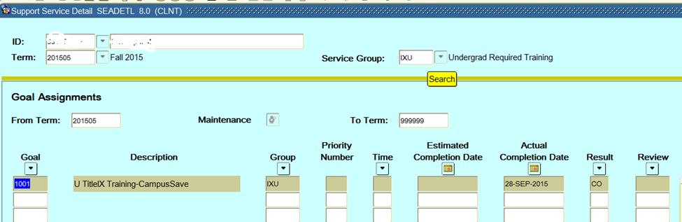
IF Goal Code = 1001, student is required to complete the It’s On Blue Training Fall 2015
IF Goal Code = anything other than 1001, student is not required to complete the It’s On Blue Training Fall 2015
IF Result Code = CA (Completed-alternative training), CO (Completed), or EX (Exemption-not required), student has completed the training and a T9 registration hold WILL NOT be placed on their account.
IF Result Code = Blank and Goal Code = 1001, student HAS NOT completed training and a T9 registration hold WILL be placed on their account.
If training has not been completed, training is accessed by logging into: https://www.campusclarity.com/signup

SEAQGNS Support Services Query form - Displays everyone who is required to take the It’s On Blue Training.

To look up all students:
- Term: key the current term (201505 for Fall 2015 {Tab}
- Goal Code: key 1001 (U TitleIX Training-CampusSave) {Ctrl+PageDown or Next Block }

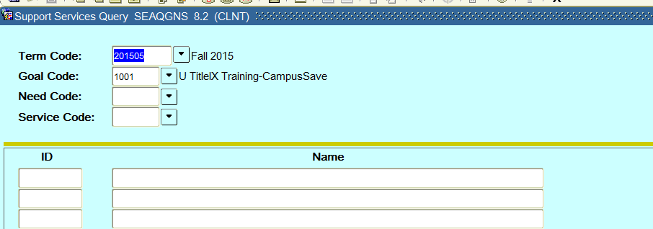

To then look up individual student, while in the ID field:
- F7 to clear list
- Key ID of individual student
- F8
- If student has been assigned the goal of 1001, their name will display. If no name shows up, that student id has not been assigned the goal code.
- Select the Options Menu, click on the Assigned Detail Services SEADETL. Refer to the information above referencing SEADETL to identify if the student has completed the training

It’s On Blue Training Completions Argos Report

CRITICAL NOTE: The report must be filtered first before it can be used

Argos Report Location: ISU.Registration and Records.External.Departmental Tools.Title IX Training Completions.Title IX Training Completions Report

Overview: This report will pull all students who were registered as of the first day of the identified term. This report will require filtering to identify the students who are required to complete the It’s On Blue (Title IX) Training.

Students included in this file will meet the following criteria (when filtered), which indicates It’s On Blue Training is required for fall 2015.
- Currently registered degree-seeking undergraduate student
- Main role at ISU equals student (not staff)

To run the It’s On Blue Argos Report:
- Log into Argos: https://argos.indstate.edu/argos/
- Open the Departmental Tools Folder, located in: ISU.Registration and Records.External.Departmental Tools
- Select the Title IX Training Completions DataBlock
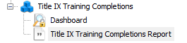
- Run Title IX Training Completions Report
- Select Term=2015
- Select Desired Report Options {3 icon options available}

FILTER CRITERIA: The Report must be filtered in the following way to identify who is required to complete the training for fall 2015 and has not yet done so. These students will have a registration hold placed on their account before Spring Priority Registration begins in November:

In Excel, Turn on filtering {Ctrl+Shift+L or Home Tab: Editing, Sort & Filter, Filter}. When the drop down appears, filter on the following:
- Level = U or U2 (graduate students are not required to complete the training fall 2015)
- Reg2015 = Y (undergraduate student must still be registered for training to be required)
- SSDGoalCode = 1001 (students who are required to complete the It’s on Blue training, have been pre-populated in banner with the assigned goal code of 1001)
- SSDResultCode = blank (students who have not yet completed the training, will not have a completion code assigned)
- You can then filter using the remaining column identifiers to narrow down the list according to your needs (e.g. by major, college, dept, etc…)

Report Column Identifiers:
- Term = reflects the term selected at the beginning of the report. All reports should currently be ran for Fall 2015=201505
- Id = Students University Identification Number
- Name = Students Last, First Name
- College1Code = Students 1st Major College Banner Code
- College1Desc = Students 1st Major College Banner Description
- Major1Code = Students 1st Major Banner Code
- Major1Desc = Students 1st Major Banner Description
- DeptCode = Students 1st Major Department Banner Code
- DistPgm = Y-Student is in a distance program; N-Student is in an on-campus program
- LOStreet1, LOStreet2, LOCity, LOState, LOZip, LOPhone = Local Address and Phone Information
- MAStreet1, MAStreet2, MACity, MAState, MAZip, MAPhone = Mailing Address and Phone Information
- Email = Student ISU Email
- Student Type = G-New Graduate; C-Continuing Student; F-New Freshman; H-Returning Graduate Student; N-Non-Degree; R-Readmit or Returning Undergraduate Student; T=New Undergraduate Transfer; X-Graduate Student, 1 Term Only.
- Level = G-Graduate Student; U-Undergraduate Student; U2-Undergraduate Student pursuing 2nd ISU baccalaureate degree
- Citz_Code = N-Non-Resident; Y-Resident; PR-Permanent Resident
- Advisor = Advisor listed in Banner
- AdvisorEmail = Advisor’s ISU Email
- Class = GRD-Graduate; SR2-Senior (105+Ehrs); SR1-Senior (90-104.9Ehrs); JR2-Junior (75-89.9Ehrs); JR1-Junior (60-74.9Ehrs); SO2-Sophomore (45-59.9Ehrs); SO1-Sophomore(30-44.9Ehrs); FR2-Freshman (15-29.9Ehrs); FR1-Freshman (0-14.9Ehrs)
- 21CEN = N-Not 21st Century Scholar; Y-Is a 21st Century Scholar
- UCAttribute = If UC, in the UC College; if blank, not in UC College
- HONAttribute = If HON, University Honors Student; if blank, not a University Honors Student
- OnCampus = If 0, doesn’t live on-campus; if 1, lives on-campus
- Athlete = If N, not an athlete; if Y, athlete
- Reg201505 = If Y, is still currently registered for fall 2015; If N, no longer registered for fall 2015
- REG201601 = If Y, is still currently registered for spring 2016; If N, no longer registered for spring 201601
- SSDEffTerm = Term code student was assigned required training
- SSDGoalCode = 1001-It’s On Blue Required Undergraduate Training Course Code; 1002-It’s On Blue Graduate Training Course Code; 1300/1500-Think About It Training Course Code
- SSGroupCode = IXU-It’s On Blue Required Undergraduate Training Banner Group Code
- SSDActualDate = Date Student completed the It’s On Blue Training
- SSDResultCode = CO-Completed Required Training Online; CA-Completed Required Training by alternative method; EX-Exempt from required training
- SSDOrigCode = AUTO, REGS-identifies how the completion information was loaded into banner
- T9 = If date reflected in this column, Registration Hold is currently assigned to students record
- GradDate = If undergraduate student has applied to graduate, graduation date will display
- GradApTerm = If undergraduate student has applied to graduate, graduation term will display

