Community-Based Learning & Scholarship Award Procedures
Accepting or Not Accepting the Nomination

Congratulations! You have been nominated for the Community-Based Learning & Scholarship Award. All aspects of the award process are being managed through the FAD Workflow. First, you need to decide if you will accept the nomination.

If you choose NOT to accept the nomination.

You will receive an email invitation on or shortly after December 4 from Digital Measures indicating that you have been nominated, example below. Please note these are screen capture examples and the dates and names may not be exactly the same as you will receive.

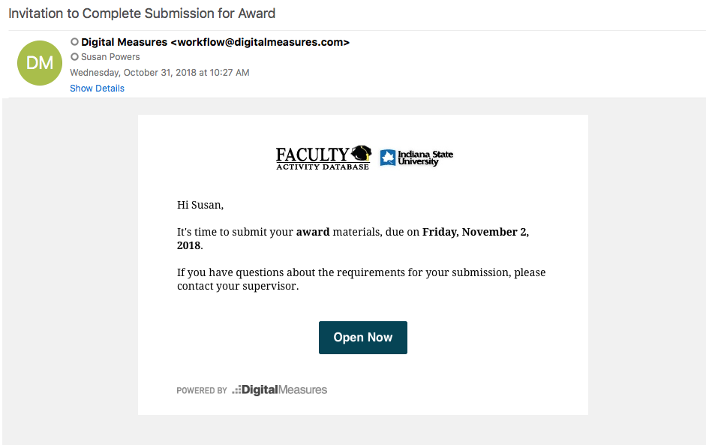

You can click on the link in the email to and log into FAD. Alternatively, you can go into FAD, click on the Workflow Tab, and you will see your task in your Inbox.

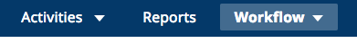

Click on the task, and you will see the following form (please note that these are sample screens and the names of the award may be different):

If you do not want to accept the nomination, click on the Route button, and choose Do Not Accept Nomination. You will get a warning to make sure this is the decision you wanted. Click OK if this is correct.

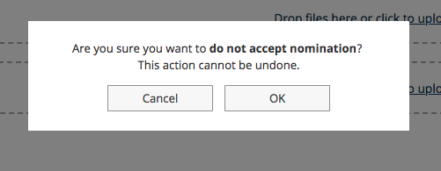

You are now done. You will see that this task has moved under the History Heading and that you didn’t accept the nomination.

If you choose to ACCEPT the Nomination

You will receive an email invitation on or shortly after December 4 from Digital Measures indicating that you have been nominated, example below.

You can click on the link in the email to and log into FAD. Alternatively, you can go into FAD, click on the Workflow Tab, and you will see your task in your Inbox.

Now you need to make sure your FAD is up-to-date. The award report will pull data from the system from January 1, 2018 through December 31, 2018.

If you want to make sure everything is in the database that you want and that it shows up accurately in your report, click on the red PDF icon in your task.

If you see something is missing that you expect to be there, click on the words Refresh Report next to the icon. This forces the report to go back to the database and pull the latest information. Then you click on the PDF icon again to see if your changes are included. You will get a warning when you refresh. Click on Yes.

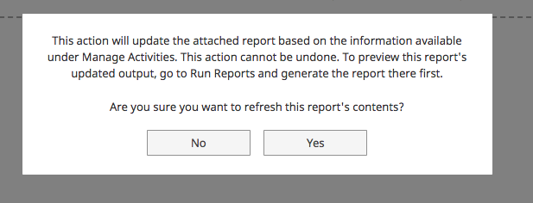

For this award, you can also add a brief summary statement and you need to provide the name and contacts for 3 references.

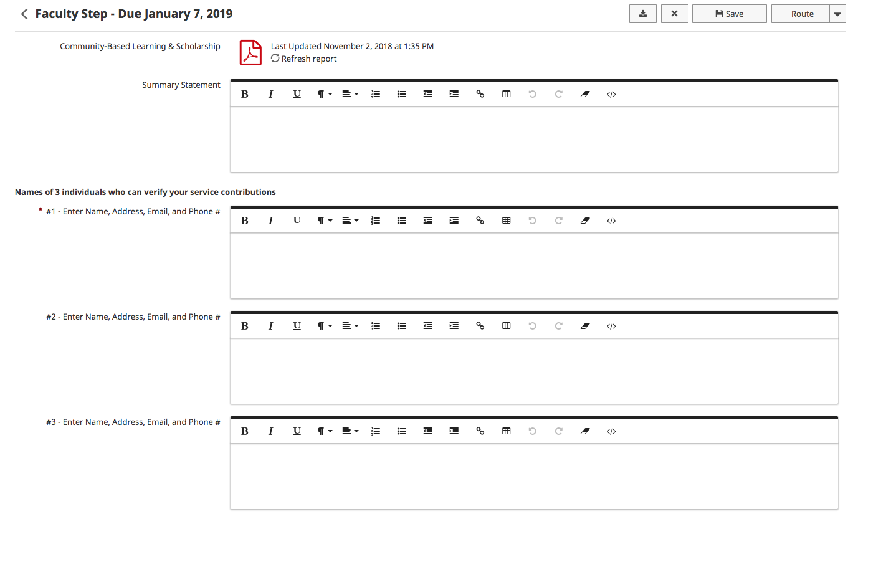

At any point while you are editing and adding documents, you can click on SAVE and it will save your progress to date. When you are ready to submit, Refresh Report one last time, click on Route and select Submit to Univ Engagement. Confirm you are submitting if you are indeed ready.

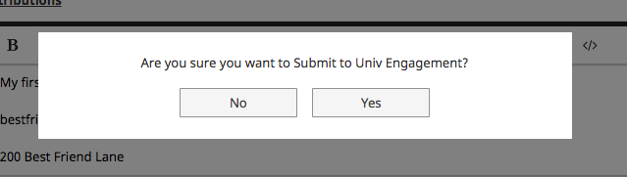

Congratulations! You have now submitted your materials for this Award! Your task will now show in the History header of Workflow. You will be able to track the progress of your workflow through the different stages of review.

