**Accessing the Course Ratings from Summer 2018 to Present**

Faculty can do this themselves.

Go to the portal and click on the tile below:



If they don’t see the tile, click on the search button and type in Blue Course Ratings



Summer 2019 show up on the screen immediately. To see prior terms, click on Archived.

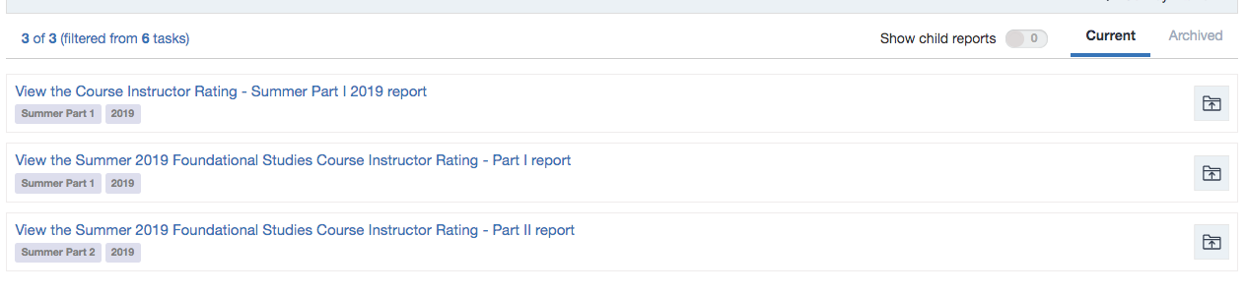

If it says Threshold Not Met, the means that no students responded. The threshold is 1.

**Accessing the Course Ratings from Spring 2018**

Faculty who did not download these will need to contact me.

**Accessing the Course Evals from Fall 2017 and Before**

These files have been shared with chairs and deans’ offices. You can click on the link sent to you in an email, or follow these steps.

Log into portal.office.com (Office 365). Remember, you will need to authenticate.

Click on One Drive

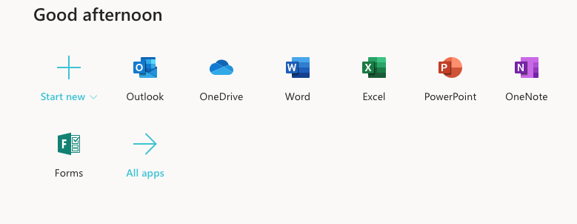

Click on Shared on the left-hand side

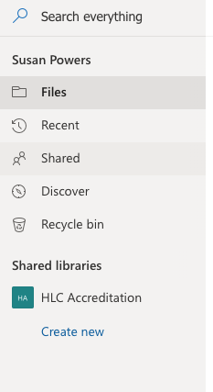

Then at the top, click on Share With You

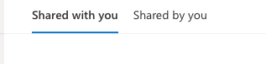

And you should see the file.

Click on MyClassEvals

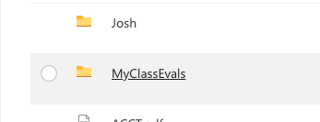

Remember, the course may possibly NOT be under your course prefix. For example, a course that is a UDIE will be found under FS UDIE.pdf. The PDFs are the reports on everyone – I would not recommend just sharing the PDF with a faculty member to find his or her own.