Steps to Create Your Biennial Review Report

- Log into FAD through the Portal

- Update your information in FAD for the August 1 2015 – July 31 2017 time period.

- Run the Biennial Review report by clicking on Rapid Reports on Manage Activities. (Note: you may have to click on Manage Activities to see the Rapid Reports on option. Also, depending on our security level, all of the options below may not be viewable to you).

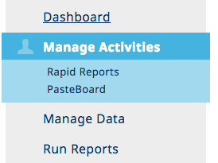

- Once you selected Rapid Reports, selected Revised Biennial Review Report and enter the appropriate dates. Select Run Report

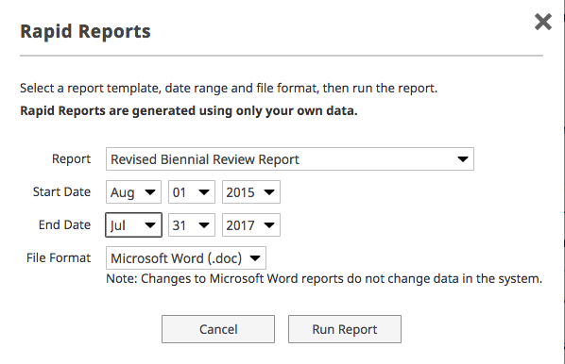

- Open your report after it downloads.

- Save your report somewhere you can find it again and Save As a Word document. (Note, the report may have downloaded as an RTF).

- Check your report and update it.

  - Check that the dates are accurate.
  - The first page(s) that has the Teaching Data does NOT count in your page total.

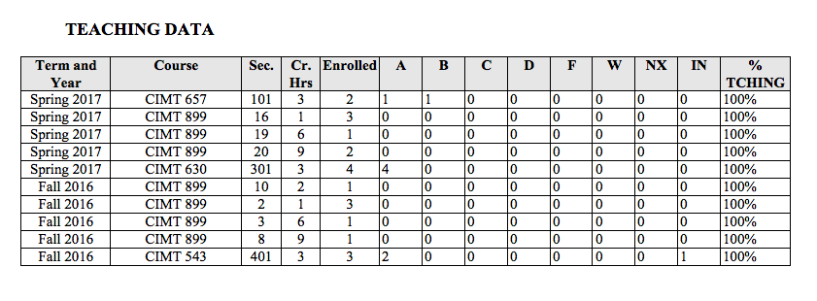
  - There is a page break before the section called Teaching Effectiveness. The page count for the BR starts with this section.
  - Highlight or otherwise edit the ranking that you want to use for the Teaching Effectiveness Section. Do NOT leave it as shown below. Select a 1 or a 2 (unless you have your academic Dean’s approval for a different rank).
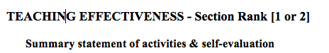

  - Change the rankings for Scholarship, Service, and if appropriate, Administrative Assignments.
  - Under each section where you see the heading of Summary statement of activities and self-evaluation, you may type in a summary if it falls within the page length allowance.
  - You may need to edit your document if the sections following Teaching Data exceed the page limits set in the BR Procedures.
  - Insert the documentation of your teaching effectiveness (course evals, analysis of course evals, etc.) at the end of the report. You need to have everything as a single document.

- Prepare your document for submission
  - Save the document as a PDF. You can submit it as a Word doc, but if it is a PDF, no one can “accidentally” delete anything when reviewing your report.

- Submit your Biennial Review
  - We are NOT using the workflow in Digital Measures for the Biennial Review.
  - Email the PDF of your report to the Department Chair.
  - The SENT copy of your email with the attachment will be your documentation that you submitted the report on time.

- The Department chair will confirm the report and forward it to the members of the review committee. Once Department review is completed, the Chair will forward the email to the Dean’s office designee for distribution to the College Committee (if appropriate) and Dean.

Trouble Shooting

Q. I have activities that are being shown that fall outside the time period.

A. This happens when you have not entered an END DATE in FAD for that activity. Please go back to FAD to that item and enter an END DATE. While you could just delete it in the report, this means that the data in FAD will not be accurate.

Q. Where do I put my teaching evaluations?

A. These will be entered as part of the attachments you can submit. You will probably have to download and summarize your teaching evaluations because there will not be enough pages to attach/insert each MyClassEvaluation into your report.

