Here is a link to a basic guide to entering information in FAD - https://www.digitalmeasures.com/activity-insight/docs/guide.html

More specifics related to ISU

This is the base screen for ISU.

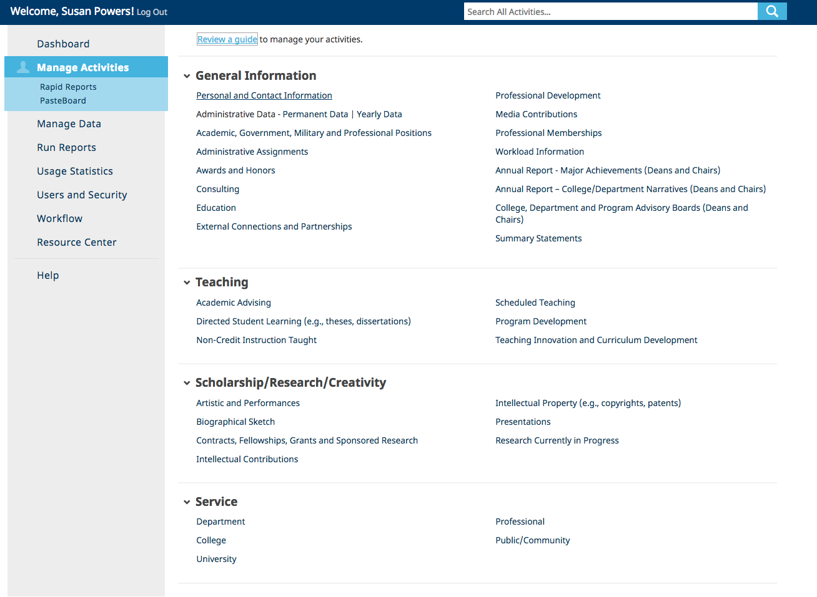

General Information – Important Screens
Under Personal and Contact Information, you can enter and upload

- Your teaching philosophy (PDF)
- PDF of your appointment letter
- PDF of previous reviews
- If you need to upload a copy of your vita, add it to the generic File Attachment (at the end) and where it says File Description, type Vita.

Under Awards and Honors, be sure to indicate the Purpose.

Under Professional Development, be sure to indicate the Development Type and the Activity Type
You do NOT need to enter anything under Workload Information, Annual Report – Major Achievements, Annual Report - Colleg/Department Narratives, or College, Department and Program Advisory Boards. Only Deans and Chairs need to enter information on the last one.

Under Summary Statements, you can enter a brief statement, attach a PDF. You can enter a summary for different types of reviews:

- Biennial Review
- Annual Review (for pre-tenure faculty NOT in a promotion or tenure year)
- Caleb Mills Award
- Dreiser Award
- Community Based Scholarship Award
- Faculty Distinguished Service Award
- Promotion (for faculty seeking Promotion only)
- Tenure (for faculty seeking Promotion only)
If it is your Promotion AND Tenure year, choose either Promotion OR Tenure, it will not matter for the report.

For Summary Type, this is where you can indicate if you are uploading a:
- Cover letter (as per College of Arts & Sciences requirements)
- Or a summary for a particular purpose (i.e. Teaching, Scholarship, Service, Librarianship)

Teaching Screens

Academic Advising: We do a once per semester data capture from Banner of all advisee information in Banner at that particular moment. If you have additional information (minor advisees, advisee evaluations, etc.) and PDF files can be uploaded. Click on the semester to add information. You can also enter the approximate number of hours spent advising for the year.

Directed Student Learning covers the following types (as well as a place to enter “other”):

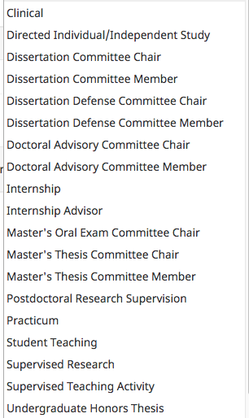

Non-Credit Instruction Taught includes instruction types of:

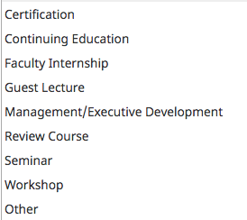

Schedule Teaching – we upload your scheduled teaching twice during Fall and Spring, and once at the end of the Summer Session. In early Fall and Spring, we will upload the courses in Banner, and after the end of the term, re-upload the information to include the grade distribution.

We recommend you enter/upload information about curriculum and course development/modification under the Teaching Innovation and Curriculum Development screen, NOT the Program Development screen. The reports will pull from both however.

Scholarship/Research/Creativity

Artistic and Performances – The following types of activities are found at this screen. Please note that there is an “Other” option as well. These are screen captures from FAD.
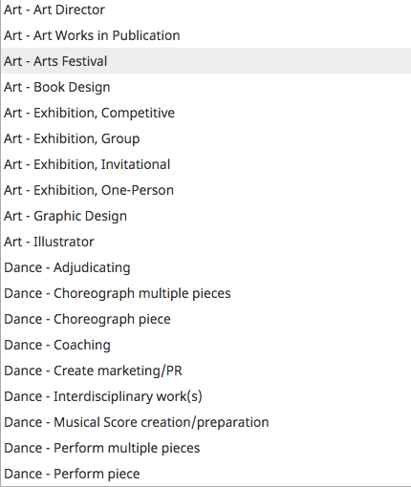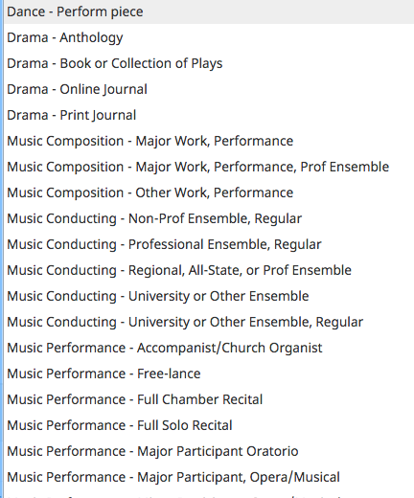
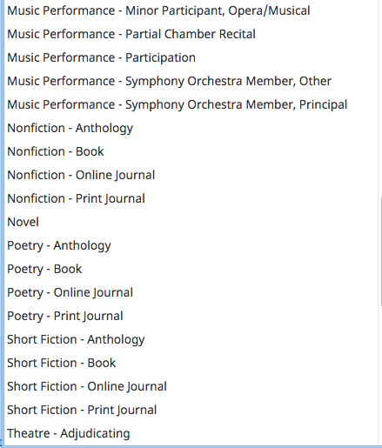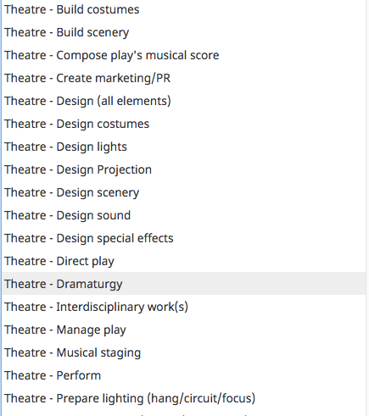

Intellectual Contributions – The following types of activities are found at this screen. Please note that there is an “Other” option as well. These are screen captures from FAD.

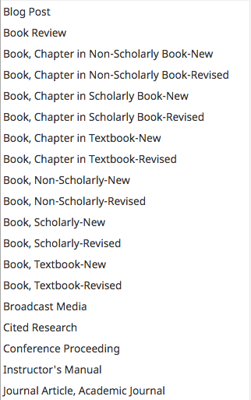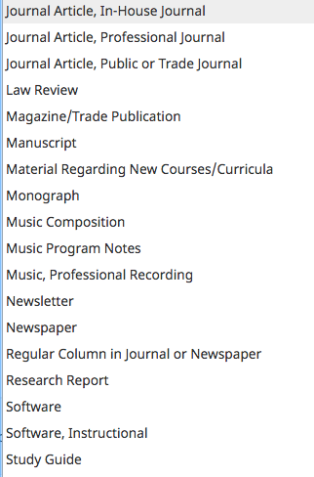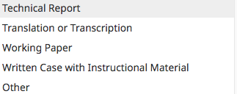

Any of these contributions can have the following Current Status:

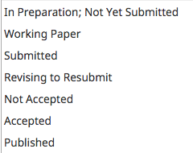

You can also import from some bibliographic services. On the Intellectual Contribution Screen, select Import

These are the various services you can use for import:

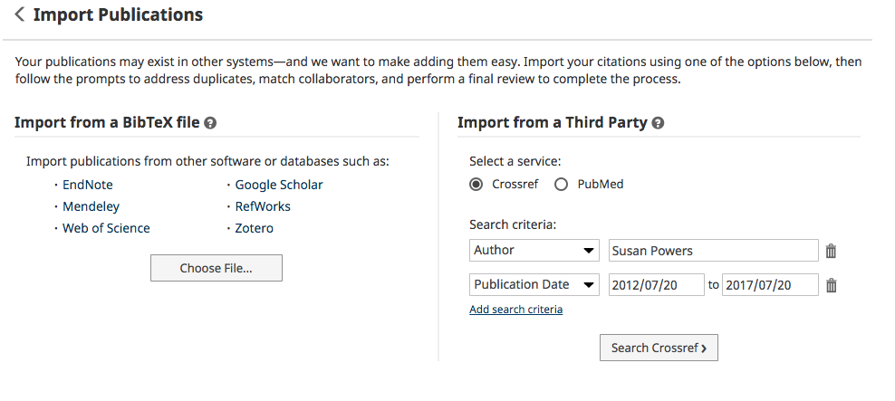

Presentations – The following types of activities are found at this screen. Please note that there is an “Other” option as well. These are screen captures from FAD.

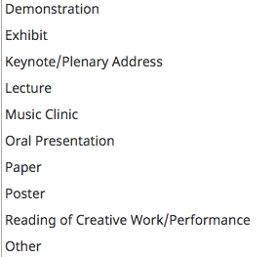

Research Currently in Progress – We are no longer using this screen but it is still visible because some faculty have entered information here.

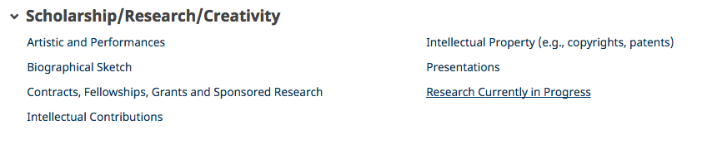

Service

Academic Affairs will enter Faculty Senate committees into FAD as per the information given to us by Senate Officers in Fall. Check with your Dean’s office if they will be entering College level committees.

Other Entries in FAD

We are using FAD to collect information for many other reports. The goal is for you to enter once, and the University be able to use it many times. For example, on a number of screens you will see an opportunity to list community engagement activities as shown below. Look for the spots where you can indicate how your work contributes to community engagement and experiential learning.

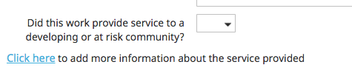
If you click where indicated, a pop-up screen appears where you can add specifics.

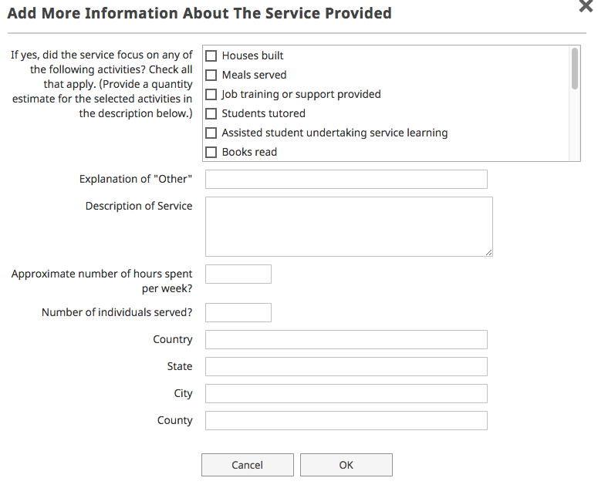
Q&A

Q. I am not the first author, but it defaults to me as first.

A. Click to enter an additional author/presenter. On the far right hand side are up and down triangles (directional arrows) and you can re-order the authors/presenters that way.

