SUBMITTING YOUR REQUESTS FOR SERVICE or ESTIMATES to FACILITIES MANAGEMENT

Log into your ISU portal, using your login ID and password. Click on the TMA badge icon to launch the application.

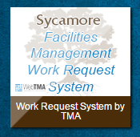

**If you are submitting a request for the first time, you will need to locate the TMA badge icon after you log in by simply typing “TMA” on your keyboard (your mouse arrow does not need to be positioned anywhere specific). The badge pictured above will appear. Click to launch TMA. Click “Always Allow pop-ups” if you get a blank screen. You will only need to do this once and the badge will now be pinned to your portal page for quick access in the future.

Enter your information in the corresponding fields. Red fields are required. Your name and e-mail address will auto-populate as the requestor. It is recommended to also provide any other information in the remaining fields that may be pertinent to your request. Repair Center Name will always be ‘Facility Maintenance’ and Facility Name will always be ‘Campus’, and these fields will auto-populate with those defaults. If you wish to receive status change updates on your request, please make sure the checkbox is selected.
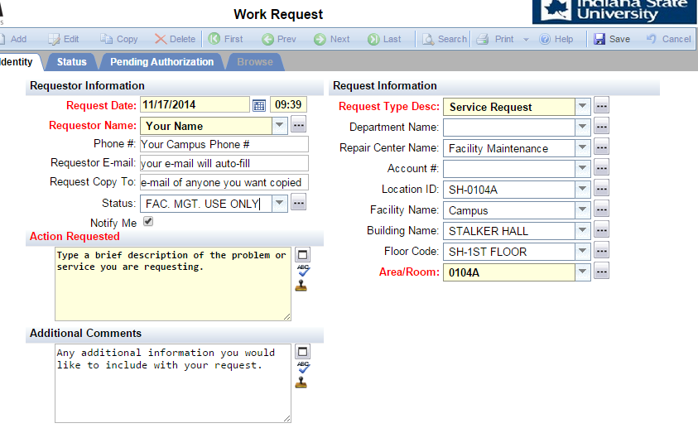
Request Type default is “Service Request” but if you would like to receive an estimate prior to the start of a job, click the ellipsis to the right of the Request Type box and choose “Estimate Request.”

The quickest way to provide your information is to start from the required Area/Room field. Once it is populated, the building and floor information fields above it will auto-fill with the correct information. To find your area, click the ellipsis button to the right of the field. (You can also start searching for your area from the Building Name field using the same lookup method, but you will then have to manually fill in the fields below it to continue filtering your selections.)

Click on your building from the list on the left. Now choose a room number or area from the available filtered selections for the chosen building. You may further filter your choices by selecting a floor in the dropdown choices below the buildings. If you do not see your room or area listed, please contact the Work Control Center (x-8192) to have your area added to the list.

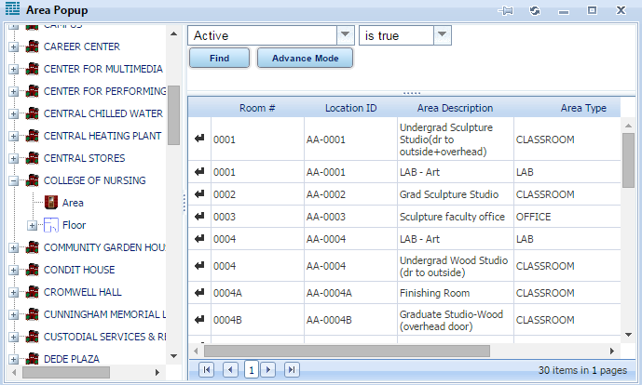

When all information is entered correctly, click the button at the top of the toolbar to submit your request. You will then see an acknowlegement with your request number above your Requestor Information.

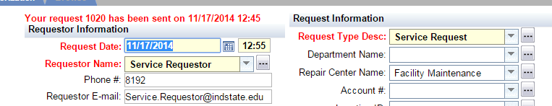

If you selected request notifications, you will receive an automated e-mail acknowledging receipt of your request. You will also receive status updates throughout the timespan of the request, including an e-mail when the job has been completed. Your request submission is complete at this point and you may close the application to exit.

