ISU Homecoming 2023
Homecoming Tailgating

Greetings from the Indiana State University Homecoming Committee! We are excited for Indiana State University’s Homecoming celebration on Saturday, October 21, 2023 at Memorial Stadium. Homecoming is one of the largest and oldest traditions at Indiana State!
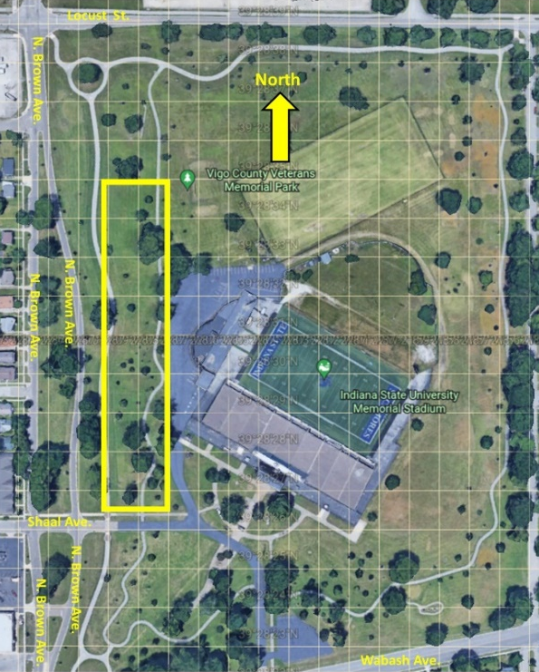
This year, ISU registered student organizations can reserve a tent for Homecoming Tailgating in the general tailgating area on the west side of Memorial Stadium. This will provide dedicated space for alumni, students and fans to gather and celebrate STATE at Memorial Stadium. Homecoming Tailgating will take place within the yellow rectangle (subject to change based on the number of tents).

General Tailgating and Homecoming Tailgating will open at 11:00 a.m. EST on Saturday, October 21, 2023 and will end one hour after the conclusion of the game.

Please read and understand all Homecoming Tailgating Registration and Tailgating Guidelines that are provided below. By completing, signing and submitting the required forms, organizations agree to abide by all policies related to Homecoming Tailgating and other applicable local, state and federal laws. In addition, the representative submitting the form will inform all members, guests, etc. of their organization of Homecoming Tailgating Guidelines. Failure to abide by Homecoming Tailgating policies will result in your organization’s Homecoming Tailgating participation being terminated and denied in the future.

Registration:
- Only registered student organizations are permitted to register for Homecoming Tailgating. Registered student organizations are encouraged to partner/collaborate with their alumni groups to decorate, host or support participation in Homecoming Tailgating.
- Approved registered student organizations are provided a 10’x20’ space. The cost for the tent is $175.00. This includes 2-8’ rectangle tables and 6 chairs. This price includes setup/takedown of tent and delivery.
  - No electricity will be available.
- Registered student organizations must provide name and contact information of member(s) who will be in charge of their reserved Homecoming Tailgating tent.
- Reservations are due via The Treehouse by Friday, September 22, 2023 at 5:00 p.m.
  - Student Affairs will review your reservation.
  - If approved, the registered student organization’s Homecoming Tailgating contact(s) and alumni contact(s) that are on the registration form will be emailed a registration approval and given directions on how to pay for your tent reservation with the Office of the Vice President for Student Affairs.
- After your reservation is approved by Student Affairs, your payment is due by Friday, September 29, 2023 to the Office of the Vice President for Student Affairs.
  - Tents will be set up only when signed contract and payment arrangements are in place.
- The placement of all tents will be coordinated by the ISU Homecoming Executive Committee with the tent vendor.
  - Only organizations who have made their payment and attend the Homecoming Tailgating safety meeting in early October will be provided their tent location and final approval to have their tent.
  - A detailed map of ISU Homecoming Tailgating tent locations will be available by Monday, October 9, 2023.
- Registered student organizations must provide name and contact information of member(s) and/or alumni who will serve as sober monitors throughout Homecoming Tailgating by October 6, 2023. These individuals will be contacted regarding a safety meeting where they will learn Homecoming Tailgating Guidelines and that they are to be present throughout Homecoming Tailgating to inform all their members, alumni, guests, etc. of Homecoming Tailgating Guidelines.
- Please place your reservation & make your payment soon. Orders will be accepted on a first come first served basis. Only 20 tents are available this year.
- All organizations occupying a reserved space in the Homecoming Tailgating designated area must have a registration form on file with the ISU Homecoming Executive Committee. Failure to do so will result in the organization being asked to vacate the reserved tailgating area.
- All Homecoming Tailgating/tailgate areas may close at the discretion of University Officials.
- Indiana State University students and organizations are subject to conduct policies as outlined in the Indiana State University Code of Student Conduct.

Tailgating Guidelines: https://gosycamores.com/sports/2021/8/3/tailgating-guidelines.aspx
General:
- Individuals who interfere with others' enjoyment using loud, abusive language and/or behavior may be asked to leave.
- Noise amplification and music must be kept to a reasonable level. Music and noise that is disturbing other tents and/or participants is prohibited.
- In keeping with Indiana law, persons under 21 years of age shall not, under any circumstances, have possession of alcoholic beverages. Minors must be accompanied by a parent or responsible adult.
- Soliciting or selling goods/services will not be permitted on stadium grounds without prior approval from the university.
- Weapons of any kind are prohibited.
Homecoming Tailgating/Tents/Parking:
Tailgating is to take place in the area designated by Indiana State University. General Tailgating and Homecoming Tailgating will open at 11:00 a.m. EST on Saturday, October 21, 2023 and will end one hour after the conclusion of the game.
- Tailgating participants are responsible for keeping Memorial Stadium and the surrounding area clean. Trash bins are located throughout the grounds.
- Buses and RVs are to park on the east side of Memorial Stadium and are subject to the same rules and regulations of the tailgating area.
Food/Beverage:
- No open containers of alcohol will be permitted outside the designated tailgate area.
- Glass bottles and containers are prohibited. Alcohol beverages must be limited to a maximum container size of one gallon.
  - Beer kegs and party balls are prohibited in any parking area.
  - Please review the Alcohol Policy below.
- All beverages should be consumed from plastic or paper cups or aluminum cans.
- Fires, unless contained in a fire pit, are prohibited. Propane and charcoal grills are permitted. Please properly dispose of all hot coals.
- Organizations are responsible for providing their own drink and food. Catering can be provided through ISU Catering through Sodexo or other caterers of your choosing.
Alcohol Policy:
- Please keep in mind that Excise Police will be actively enforcing state alcohol laws throughout the entire tailgating area during Homecoming. If you are planning to dispense alcohol at your tent whether you charge for it or not, you must have the applicable alcoholic beverage permit or have the event catered by a vendor licensed through the Indiana Alcohol Commission. Permit types vary based on the type of alcohol (beer and wine and/or mixed drinks) that you will be dispensing. Applications and information regarding the permits can be found at the Indiana Alcohol & Tobacco Commission website: www.in.gov/atc/. Alcohol for strictly personal use is allowed without a permit, however, it is a violation of state law to sell or give that alcohol to others or to leave alcohol in an unattended location where anyone could have open access to it.
  - Anyone having questions regarding alcohol laws or enforcement should contact Excise Police at 812.882.1292 or ISU Police Chief Michele Barrett at 812.237.7829.
Individuals who violate the above Tailgating Guidelines will be asked to leave the property and could be subject to legal penalties.

Dates to Remember:
- Friday, September 22: Reservations are due by 5:00 p.m. via The Treehouse.
- Friday, September 29: Payment is due to the Office of the Vice President for Student Affairs.
- After Monday, October 9: map of ISU Homecoming Tailgating tent locations will be available
- Saturday, October 21: Homecoming Tailgating will open at 11:00 a.m. and will end one hour after the conclusion of the game.
If you have questions regarding Homecoming Tailgating Registration, please contact Dr. Michele Soliz, Vice President for Student Affairs, at Michele.Soliz@indstate.edu or at 812-237-3888.

