Sabbatical Application Workflow Procedures

Starting in 2019, sabbatical applications will be processed through the workflow in FAD. By September 15, 2019, faculty who wish to have a sabbatical during the 2020-21 academic year, must notify their department chairperson of their intent to apply. The dean’s office of each college will give those names to Academic Affairs by end of business on September 16 and the workflow will be launched for everyone by the end of the week.

Once your workflow is launched, you will receive an invitation email from the Faculty Activity Database (@watermarkinsights.com) that will have a link for you to access your workflow and the due date. All due dates can also be reviewed in the Key Activities Calendar available at: https://www.indstate.edu/academic-affairs/faculty-resources/deans-and-chairs

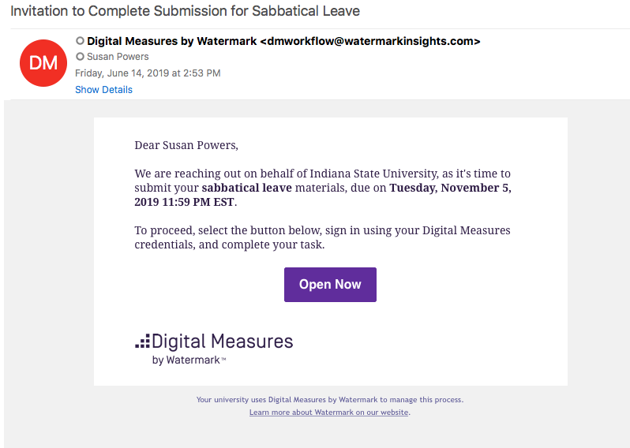

You can click on the link in the email to and log into FAD. Alternatively, you can go into FAD, click on the Workflow Tab, and you will see your task in your Inbox.

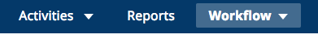

Click on the task, and you will see a task in the inbox (please note that these are sample screens and the names of the task and dates may be different):

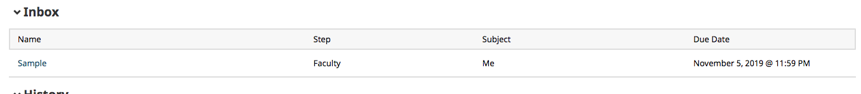

If you then click on the task, you will see the following (or similar):

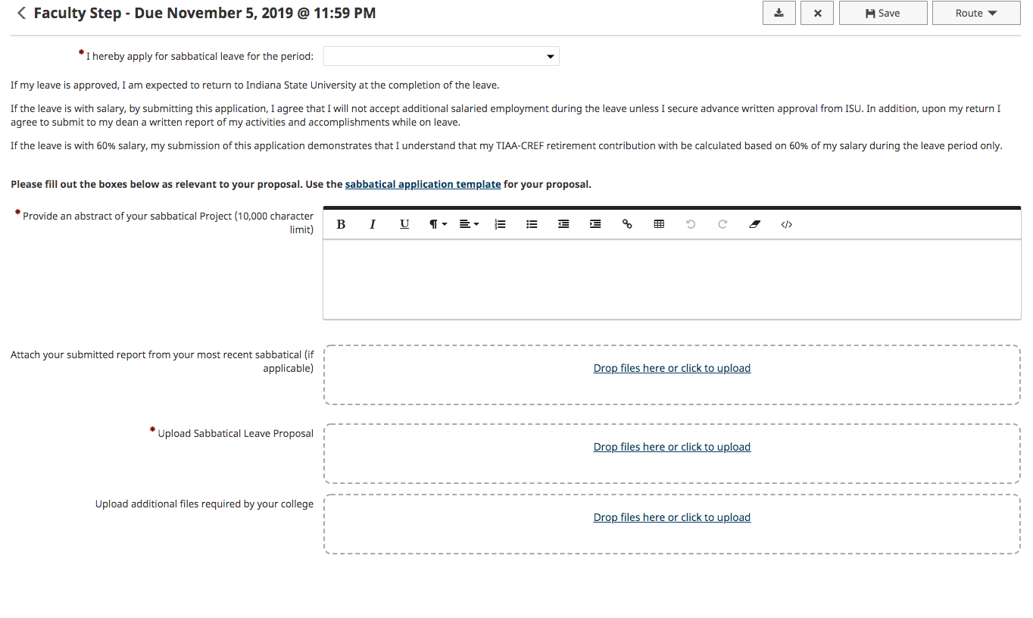
You need to select the period you are requesting for your sabbatical, provide a brief abstract, upload your previously sabbatical report if applicable, and upload your leave proposal. Templates for the leave proposal are available at: https://www.indstate.edu/academic-affairs/faculty-resources/sabbatical-leaves

By the due date, click on the Route button and choose submit.

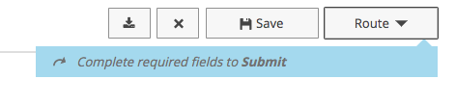
Congratulations! You have now submitted your materials for your sabbatical! Your task will now show in the History header of Workflow. You will be able to track the progress of your workflow through the different stages of review.

After the department has completed its review, you will receive another task email. This step is for you to be able to respond, if applicable, to the departmental review. You have 7 calendar days to complete that task or your materials will be autoforwarded to the Dean’s office. At this step, you can also choose to withdraw from the process. That option will be available under the Route Button.

That process will be repeated again after the College review before going to Academic Affairs.

Following Academic Affairs review, you will receive the Provost’s recommendation in workflow. If your sabbatical request is denied, you will have 15 calendar days to appeal to the University Leaves Oversight Committee (10 working days) within the workflow. If you do not complete the appeal within that timeframe, your application will be withdrawn.

