Keynote Speaker
Maria Woltjen
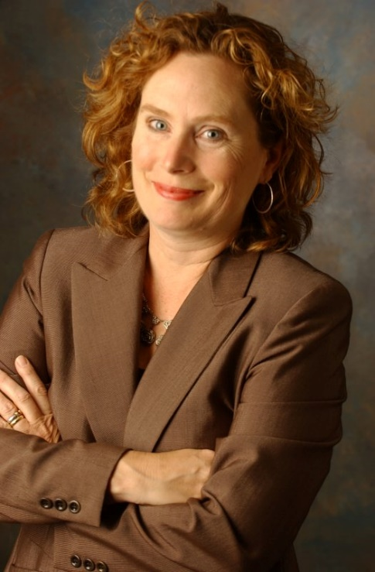
“In These Times: Advocating for the Best Interests of Immigrant Children Using the Convention on the Rights of the Child”
Each year, thousands of unaccompanied immigrant children arrive at the borders of the United States. These children travel on their own, without their parents. They come from all over the world: Central America, Mexico, China, India, Sierra Leone. Many are teenagers. Some are much younger — 11-years-old, 5-years-old, 18 months. Today many children come from El Salvador, Guatemala and Honduras, countries suffering epidemics of cartel violence, political instability, and extreme poverty. In the fall of 2017, the Department of Homeland Security began forcibly separating children from their parents at the border. The adults are sent to immigration jail. Their children, some as young as 12 months, are placed in shelter facilities, often thousands of miles away. All of these children, even children forcibly separated, are charged with breaking the law and placed in deportation proceedings. U.S. Immigration Courts do not recognize immigrant children as distinct from adults. Unlike state court proceedings involving children—where judges are required to consider the best interests of the child— immigration judges are not required to consider the best interests of the child. This is where the Young Center comes in. The Young Center is appointed as Child Advocate, and our role is to advocate for the best interests of the child—even though there is no such standard in immigration law. The Young Center uses the Convention on the Rights of the Child to argue for the best interests of immigrant children. The Young Center’s long-term goal is to change the immigration system to require that decisions about are made in consideration of the child’s best interests, the core two pillars of which are the child’s wishes and the child’s safety. This presentation will provide (1) an overview of unaccompanied and separated children and what’s happening today; (2) how the Young Center created a Framework for Considering the Best Interests of Unaccompanied Children in partnership with federal officials; and (3) theory of change—first changing practice, advocating as if there was a best interests standard, second, government adoption of written policy, and finally changing the law to require consideration of best interest.

Maria Woltjen is the founder and Executive Director of the Young Center for Immigrant Children’s Rights at the University of Chicago Law School. The Young Center is a national organization that advocates for the best interests of unaccompanied and separated immigrant children. These are children from all corners of the world—Mexico, Guatemala, Honduras, El Salvador, India, China, Romania, Somalia. They are apprehended as they cross the border and then detained around the country. The federal government appoints the Young Center to serve as Child Advocate – similar to a guardian ad litem – for the most vulnerable of these children. The Young Center now has offices in Chicago, New York, Washington, D.C., Los Angeles, Phoenix, Houston, San Antonio, and Harlingen, Texas. Throughout her 30 years as an attorney, Ms. Woltjen has focused on children’s rights, at the Chicago Lawyers’ Committee for Civil Rights, the ChildLaw Center at Loyola University of Chicago School of Law, and for the past ten years at the University of Chicago Law School. Ms. Woltjen’s focus is on reforming the immigration system—in which children are treated as adults—into a justice system that recognizes children as children, with rights and protection needs all their own. Ms. Woltjen is the recipient of the American Constitution Society 2013 Ruth Goldman Award, the 2017 UNICEF Chicago Humanitarian Award, and one of Chicago Magazine’s 2018 Chicagoans of the Year. For more information, please see www.TheYoungCenter.org

Shane Scarlett
“Hunger in Indiana”
Hunger in Indiana- Vigo County and how MMM helps curve that need. Hunger as a whole - State of Indiana. Ways we can come together and help with hunger in our community.
We exist for those who are hungry—hungry for a warm meal, hungry for a mission, hungry to make a difference. We pack more than meals. We pack compassion. Give us your support, and we’ll give you an Indiana where everyone can hunger for something greater than their next meal. Hoosiers Helping to feed Hoosiers.

Stephen Ferry
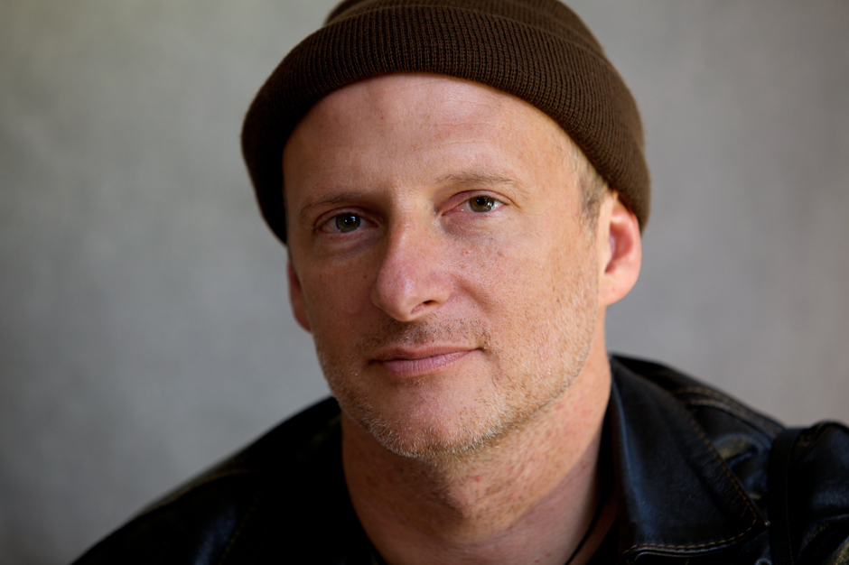
“Gold mining community’s vs criminal organizations and multinational corporations in Colombia”
This lecture and photographic presentation is based on the book entitled La Batea, fruit of a six-year collaboration between photographer Stephen Ferry and his sister, the anthropologist Elizabeth Emma Ferry. La Batea documents the struggles of gold mining communities in Colombia to defend their way of life against armed criminal organizations and multinational corporations seeking their gold. Colombia reflects the situation of local Community’s worldwide who face violent repression for opposing large-scale mining projects in their territories. While exploring the complex social terrain around gold mining, La Batea engages with the charismatic nature of both gold and mercury. The title refers to the wooden pan used in traditional mining since Pre-Columbian times.
Since the late 1980s, Stephen Ferry has traveled to dozens of countries, covering social and political change, human rights, and the environment, on assignment for publications such as National Geographic, GEO, TIME and the New York Times. A fluent Spanish speaker, Stephen has developed an understanding of Latin America from over twenty years of covering the region. Stephen’s first book, I Am Rich Potosí: The Mountain that Eats Men (Monacelli Press, 1999), documents the lives of the Quechua miners of Potosí, Bolivia. His second book Violentology: A Manual of the Colombian Conflict (Umbrage, 2012) has become a referential work for the study of Colombian history, armed conflict and human rights. Stephen has won honors from the World Press Photo, Picture of the Year, and Best of Photojournalism contests. He has also received grants from the National Geographic Expeditions Council, the Fund for Investigative Journalism, the Alicia Patterson Foundation, the Howard Chapnick Fund, the Knight International Press Fellowship, the Getty Images Grant for Good, Open Society Foundations and the Magnum Foundation.

Stuart Mora
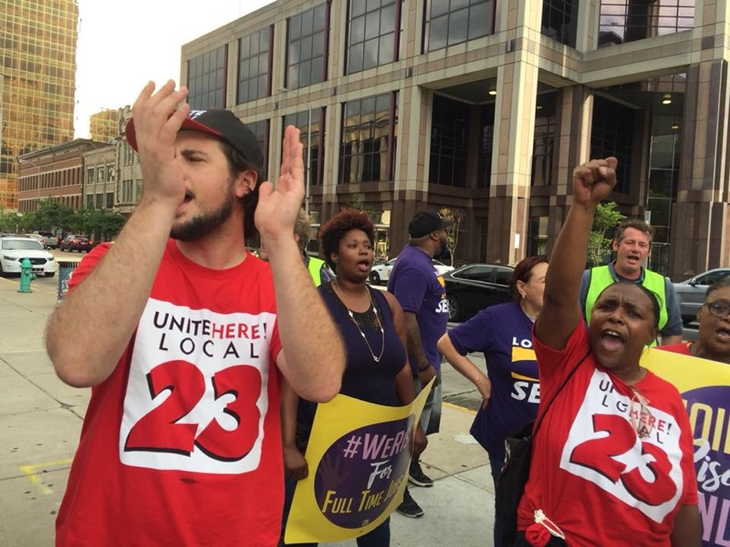
“Why Working People in Indiana are Poor & What We Are Doing To Fight Back”
Why are working people poor in Indiana? What can working people do for themselves and their families to fight for a better life? What victories have already been won in this struggle and how you can get involved moving forward?
Stuart Mora is a labor movement leader from Indianapolis. He is the president of the service industry workers' union (Unite Here Local 23) in Indiana. Over the past ten years, Stuart has helped build a union from having no presence to now representing over 1500 workers in Central Indiana. These workers have fought and won higher wages, better benefits, seniority and scheduling rights, and, most importantly, RESPECT! The union Unite Here represents nearly 300,000 workers across North America and is the fastest growing union in the US. Unite Here takes great pride in being a progressive, militant union that is led by its members who are mostly women and people of color.

Dada Maheshvarananda
“Cooperative Games for a Cooperative World: Facilitating Trust, Communication, and Spiritual Connection”
The author of a new book with this title will lead a workshop of cooperative games that create powerful, safe learning experiences. These exercises help participants interact and share, gain self-confidence, improve collaboration, and develop a genuine compassion for others. Bill Ayers writes, "These are cooperative calisthenics, little exercises to prepare us for the huge changes that are essential to our survival on this earth." We need a new cooperative paradigm in our lives that promotes kindness, honesty, trust, and teamwork. We need to develop cooperative ways of learning, working, and creating a better world together. Many adults and even young people don’t play games anymore because of negative experiences they had with physical education classes in school and with competitive sports. They feel left out, not good enough, like losers. Yet play, laughter, and friendship are therapeutic for everyone. When doing group activities, it’s normal to feel a bit of fear of being judged by others. However, it is possible to overcome one’s fears—of failure, of change, of looking bad. When participants feel safe working together for a common goal, and see that ‘we’re all in the same boat’, this anxiety lessens. If people can find the courage to try new games in a supportive group, they can consider trying new activities and adventures in their lives. In the process, they learn to lighten up, have fun, and realize that the best things in life are not for sale.
Born in 1953 in Philadelphia, USA, during studies at Earlham College he was active in the protests against the Vietnam War. In 1978 he traveled to India and Nepal where he became a yogic monk and studied the Progressive Utilization Theory (Prout) under its founder, Prabhat Ranjan Sarkar. He has taught meditation and organized for social justice for four decades in Southeast Asia, Europe, and in South America. He is the author of six books, including "Tools to Change the World" (Proutist Universal, 2019), "After Capitalism: Economic Democracy in Action" (InnerWorld, 2013) and Cooperative Games for a Cooperative World" (InnerWorld, 2017). His books have been published in ten languages. He has given hundreds of seminars and workshops around the world at international conferences, colleges, high schools, cooperatives, yoga centers and prisons about social activism and spiritual transformation.

Dr. Georgianna Duarte and Jhansi Chagalakonda
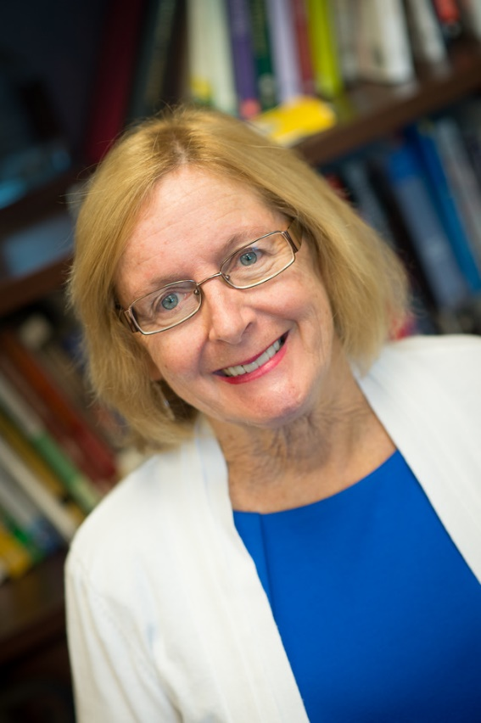
“Convention of the Rights of the Child”
This interactive session will focus on the Convention on the Rights of the Child. The presenters will provide extensive information about the specific document of the CRC, why it is important, and specifically describe the rights of the children which are frequently overlooked. These rights are important to high school and university students in these very politically charged times where women, men, and children’s rights are being denied. The participants will have opportunities to share their perceptions challenges, and how they can protect their rights. They will learn about what does the CRC provide? How will this affect their daily life? And why is it so important to know about CRC?
Dr. Georgianna Duarte is the Adams Endowed Professor at Indiana State since 2016. She has a PhD in Early Childhood Education and teaches ECE undergraduate and graduate courses. She has been engaged in teaching, service, and research in the areas of diverse languages, migrant education and international cultures. As a researcher, she has examined the perceptions of children, and how they view their rights as defined by the Articles of the UN Rights of the Child. She has served as a previous Head Start Teacher, Administrator and National Reviewer and Consultant. She continues to train, consult and review Migrant, Regional and Native American Head Start Programs. She has been involved in international work for over 30 years, and over 18 years of collaboration in Peru. She has been a consultant, trainer, and program reviewer for the Office of Head Start for over 20 years. She has worked with programs in over 40 states. She has written in international journals, and most recently wrote two articles about the importance of fostering outdoor play in the International Journal of Early Childhood Education. She is currently working on a chapter on global service learning.
Jhansi Chagalakonda is pursuing her PhD in Curriculum & Instruction. She is in her second semester. She has worked as a resource person in many schools in India, as curriculum developer and also supervised the implementation part of the curriculum. She also led teacher training sessions in many schools in India.
Thomas Frank
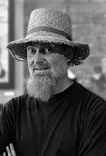
“Toxic Tour”
The Toxic Tour is a story of an Environmental and Climate Justice community. Throughout the 20th century East Chicago was known as Steel-town. It was a bustling city on the southern shores of Lake Michigan that boasted of being the most industrial city in the world. Now, after 40-years of neoliberal policies and the flight of capital, industrial capitalism has left behind a legacy of toxic land, water, air and politics. East Chicago faces the urgent need to clean up this legacy while our politic economy continues to concentrate industrial threats in the community. As a result East Chicago is an economically disparaged community of color forced to carrying the economic, health and environmental burdens of large scale industrial projects. Learning Outcomes: 1) The Struggle for Environmental and Climate Justice. 2) The Harm of a Toxic Political Economy 3) Building a Culture of Resistance
Thomas Frank is an Artist / Organizer working for environmental and climate justice in the Calumet and Great Lakes regions. Thomas is a lead organizer with the Community Strategy Group in East Chicago, a board member of the Southeast Environmental Task Force, founder of 350 Indiana and the Dunelands Environmental Justice Alliance, and a member of the Southeast Chicago Coalition to Ban Petcoke. He has worked with at-risk teens, in a Boating, Aquatics and Marine Science program (B.A.M.S.) through Purdue University NWI, and served as the executive director of the Indiana Harbor Shipping Canal, considered the most polluted body of water in the country. Thomas became active in environmental and climate justice with the announcement that BP would be building the largest Tar Sands refinery in the country in his community of East Chicago. Frank provides “Toxic Tours” and presentations to students, lawyers, lawmakers, and renowned experts on the serious environmental issues that have plagued the East Chicago and the NWI community.

Caitlyn Cantrell, Rocky Roberts, and Gabby Fullhart
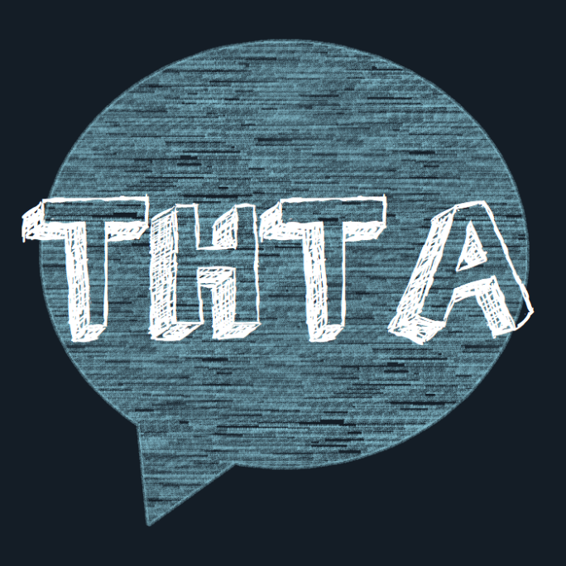
“Forgotten Graves”
Terre Haute Teens for Action will be speaking about how gun violence affects the LGBTQ+ community. Since March of 2018, THTA has been advocating for gun violence prevention. This session will include a brief presentation on gun violence in the LGBTQ+ community, connecting with state legislators, and how to propose a bill at the local level. Following the presentation, the speakers will open the floor to question and answer.
Terre Haute Teens for Action is an organization focused on gun violence prevention and amplifying youth voices in the Terre Haute community. The co-founders, Rocky Roberts, Caitlyn Cantrell, and Gabby Fullhart established this organization on March 22, 2018 and since then have been learning more about advocacy from the local level to federal level. The organization has held post card events, town halls, and is on their third campaign. They started with a social media campaign called "Never Again", moved to a three day long campaign called "Say Their Names" over the summer, and now are in the midst of their "Forgotten Graves" campaign that focuses on hate crimes, and more specifically the LGBTQ+ community.

Mounika Ragula
“The #MeToo Movement. Speak Up? or Stay Silent?”
#MeToo movement has had an unbelievable impact on people throughout the world. The stories and experiences that came into light ever since the movement began might have been different but the trauma in each story was/is similar. But, what is #MeToo movement? How and when did this movement start? In light of this movement, should I stay silent or speak up? This session will attempt to give answers to who, what, when, where, and how of the #MeToo movement. In addition to answering the key questions regarding the movement, this session also provides the impact of #MeToo movement around the world.
Mounika Ragula is a doctoral candidate at Indiana State University working towards getting her PhD in Curriculum and Instruction. She is from the southern part of India and moved to Terre Haute in 2012. She currently works in the Human Resources office at ISU and also teaches Indian dance at and around ISU community. Her passion lies in a broad range of areas which are completely different from one another. She is passionate about educational technology research, fictional books, dance fitness, and protecting the environment among many other interests.

Erin Elizabeth Smith
“Bringing Crowdfunding Into the Classroom”
This session will focus on learning the ins and outs of crowdfunding for nonprofits including writing a crowdfunding call for different platforms, the do's and don’ts of producing a campaign video, and how to promote the campaign once it is live through social media, press releases, and engaging with the local business community. This panel is taught by Dr. Erin Elizabeth Smith from the University of Tennessee who has helped her students raise over $150,000 for the Knoxville nonprofit community.
Erin Elizabeth Smith is the Creative Director at the Sundress Academy for the Arts and the Managing Editor of Sundress Publications and The Wardrobe. She is the author of two full-length collections and the editor of two anthologies; her third collection, Down: The Alice Poems, is forthcoming from Agape Editions. Her poems have appeared in numerous journals, including Ecotone, Mid-American, Crab Orchard Review, Cimarron Review, and Willow Springs, among others. She teaches in the English Department at the University of Tennessee, and in 2017 she was inducted into the East Tennessee Writers Hall of Fame.

Melissa Reed
“Inclusive Thoughts that Drive Action”

This presentation will help participants focus on the meaningful destination where everyone understands that bias thinking occurs in everyone but we can become conscious of those biases to help drive inclusive actions to make safe spaces for everyone. Interactive activities will be explored to make learning easy and fun. Together we will discuss ways to intentionally question implicit assumptions, explore tools to adjust automatic patterns of thinking and how to actively reject information that reinforces stereotypes. These topics are increasingly important as safe spaces are necessary because some among us insist upon making public spaces unsafe!
Driven by the thought that one person can change the world, Melissa started her work in the area of serving the community in 1995 at Gibault Children’s Services as a youth treatment specialist. From there she went on to perform many duties for the Vigo County School Corporation where she was an Educational and Health Assistant. Upon finishing her Bachelor of Science degree at St. Mary of the Woods in Human Services with a minor in sociology she became the Director of Legal Services for the Council on Domestic Abuse, Inc. Her time at CODA was dedicated to providing successful legal advocacy for a five county service area, while creating and delivering various primary prevention programs to eliminate violence in our communities. In January 2018 she accepted the position of Director for the Terre Haute Human Relations Commission. She conducts screenings and intakes of discrimination complaints and investigates claims to seek a solution. Melissa provides cultural competency and sensitivity training to housing providers, corporations, non-profit organization, social clubs and institutions of education. She promotes equal rights to ensure the community and workforce are aware of the need for inclusion. She is trained in violence prevention, trauma informed care, mental health first aid, sexual assault victim advocacy, LGBTQ+ competency, motivation self-worth in others, childhood trauma, crisis counseling and bystander intervention. Melissa is affiliated with many community organizations such as the Homeless Council of the Wabash Valley, Wabash Valley Diversity Council, Interfaith Council of the Wabash Valley, Campus Board Member for Ivy Tech, member of the Greater Terre Haute Chapter of the NAACP, member of the Lost and Found Suicide Prevention Coalition, Vigo Co. Systems of Care, and works closely with the Vigo County School Corporation. She is an energetic facilitator and enjoys public speaking.

Dr. Georgianna Duarte and Mounika Ragula
“Human Trafficking: What You Can Do?”
Trafficking in persons is a serious crime and a grave violation of human rights. Every year, thousands of men, women and children fall into the hands of traffickers, in their own countries and abroad. Yes, trafficking is also a serious problem in Indiana. Almost every country in the world is affected by trafficking, whether as a country of origin, transit or destination for victims. United Nations Office of Drugs and Crime (UNODC), as guardian of the United Nations Convention against Transnational Organized Crime (UNTOC) and the Protocols thereto, assists States in their efforts to implement the Protocol to Prevent, Suppress and Punish Trafficking in Persons (Trafficking in Persons Protocol). Once you’ve learned more about the myths and realities of human trafficking and the courageous organizations working to end it, you may be inspired to take action. You may be overwhelmed by the magnitude of the problem, but you have more power than you might think. This session is about seven ways that you can make an impact in the fight against modern-day slavery.
Dr. Georgianna Duarte is the Adams Endowed Professor at Indiana State since 2016. She has a PhD in Early Childhood Education and teaches ECE undergraduate and graduate courses. She has been engaged in teaching, service, and research in the areas of diverse languages, migrant education and international cultures. As a researcher, she has examined the perceptions of children, and how they view their rights as defined by the Articles of the UN Rights of the Child. She has served as a previous Head Start Teacher, Administrator and National Reviewer and Consultant. She continues to train, consult and review Migrant, Regional and Native American Head Start Programs. She has been involved in international work for over 30 years, and over 18 years of collaboration in Peru. She has been a consultant, trainer, and program reviewer for the Office of Head Start for over 20 years. She has worked with programs in over 40 states. She has written in international journals, and most recently wrote two articles about the importance of fostering outdoor play in the International Journal of Early Childhood Education. She is currently working on a chapter on global service learning.
Mounika Ragula is a doctoral candidate at Indiana State University working towards getting her PhD in Curriculum and Instruction. She is from the southern part of India and moved to Terre Haute in 2012. She currently works in the Human Resources office at ISU and also teaches Indian dance at and around ISU community. Her passion lies in a broad range of areas which are completely different from one another. She is passionate about educational technology research, fictional books, dance fitness, and protecting the environment among many other interests.

Ashley Toruno
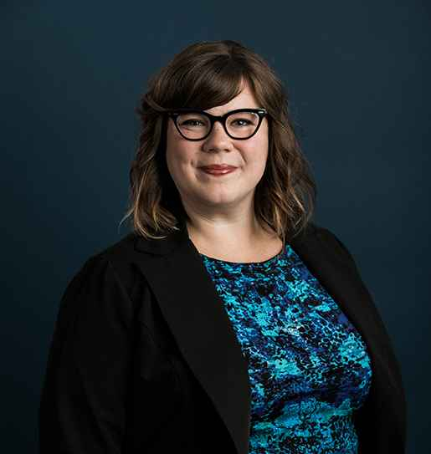
“Change starts with you.”
The ACLU of Indiana is dedicated to defending individual rights and enhancing and preserving liberties that are guaranteed in the U.S. and Indiana Constitutions and civil rights laws. Through advocacy, education and litigation, our attorneys, advocates and volunteers work to preserve and promote civil liberties including the freedom of speech, the right to privacy, reproductive freedom, and equal treatment under the law. A culture of punishment, combined with race- and class-based animus, has led the United States to rely on incarceration more heavily than any other country in the world. Far too many prisoners are held in conditions that threaten their health, safety, and human dignity on a daily basis. The ACLU of Indiana has long fought in the courts for the protection of prisoner’s rights; monumentally through our representation of the Indiana Protection and Advocacy Services Commission (IPAS) to defend the rights of mentally ill prisoners who were placed in isolation instead of being given the medical treatment that they needed. Every one of us can help make a difference in our community, in our state, and in our nation. The ACLU Activist Training will cover how the power of community can effectively generate social change on issues including criminal justice reform, voting rights, immigrants’ rights and more. We invite you to learn more about getting involved in people powered movements and becoming part of something bigger than yourself.

Ashley Toruno is a Community Engagement Associate at the ACLU of Indiana. As a recent graduate from Indiana University, she earned a Bachelor of Science in Public Affairs with a focus in community development. Born and raised in central Indiana, Ashley is a first generation American and comes from a family of resilient Nicaraguan immigrants. Her passion to pursue a career in community organizing comes from her previous work advocating with immigrant communities. In her current role, Ashley works to develop and implement a variety of advocacy strategies to build support for the ACLU's work, further its programmatic goals, and increase public awareness and appreciation of civil liberties.

Cameron Stice
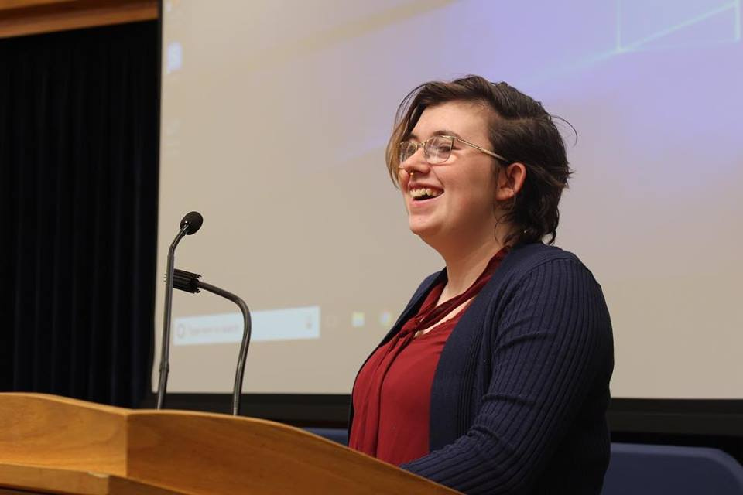
“The ABC's of LGBT”
The session is an educational presentation on the ABC's of LGBTQ and how someone can be involved in activism. There will be a panel of Queer identifying people at the end, who will be willing to answer any questions the audience might have. Anyone who attends the session should be able to walk away with an understanding of LGBTQ terminology, information on LGBTQ history, and ways to be an activist for the LGBTQ community.
Cameron Stice is an openly queer, sophomore Psychology student at ISU. They are the President of Spectrum, Indiana State's LGBTQ club, and they are an advocate for LGBTQ rights. They have previously also served on Spectrum's exec board and is currently the president of The Student Coalition for Social Justice. They also previously served on Student Government Association as a senator representing Spectrum. Cameron has dedicated their life to educating others and fighting for human rights. Their main initiative is to create a safe and open environment on their campus and in their community.
Gina Hope
“Overcoming - Surviving Trafficking”
(No cell phones or cameras during presentation)

Gina will share her personal story of being sold by her mother and held for over four years by a gang until escaping only to be trafficked by those she thought were her rescuers. Her road to healing has created a desire in her to help others find healing & restoration. She has begun additional research and will speak about possible causes that can make children vulnerable to traffickers with one such example of how some abusers are using PAS to get away with, and in some cases, be able to continue abuse in domestic violence cases (DV being an instance that can lead to vulnerability in our youth).

Gina is a survivor of human trafficking striving to bring awareness & prevention while inspiring all to truly reach their full potential. We all have trials in life but there is nothing on this earth that cannot be overcome and “Everyone should have someone to watch them shine”. Gina strives to her experiences as stepping stones of Hope to help others find their way.

Dr. Ralph Leck and Brian Bunnett
“Social Justice Awards”
In conjunction with the Social Justice and Sociology B.A. (Department of Multidisciplinary Studies) and Citizens for Better Government in Vigo County, social justice awards will be given to ISU students and faculty. Please join us in celebrating the activists and public intellectuals who have made a positive social impact on our community. The event will be hosted by Ralph Leck and Brian Bunnett.
Ralph Leck teaches Gender Studies and Asian philosophy in the Department of Multidisciplinary Studies and teaches social justice courses in the University Honors Program. Brian Bunnett is the Chair of Public Services at Cunningham Memorial library and is a founding member of Citizens for Better Government in Vigo County.

